<https://www.youtube.com/watch?v=2xudPOBz-vs&list=PLblh5JKOoLUICTaGLRoHQDuF_7q2GfuJF&index=51>



Today we're going to continue our series on gradient boost.

Specifically we're going to dive into the algorithmic details of how gradient boost is used for regression.

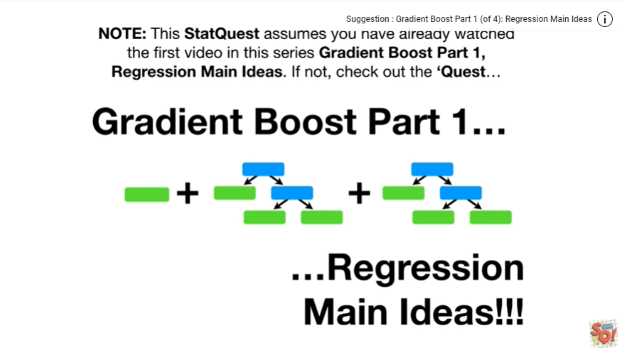

Note : this stat quest assumes who have already watched the first video in the series gradient boost part 1 regression main ideas, if not check out the quest.

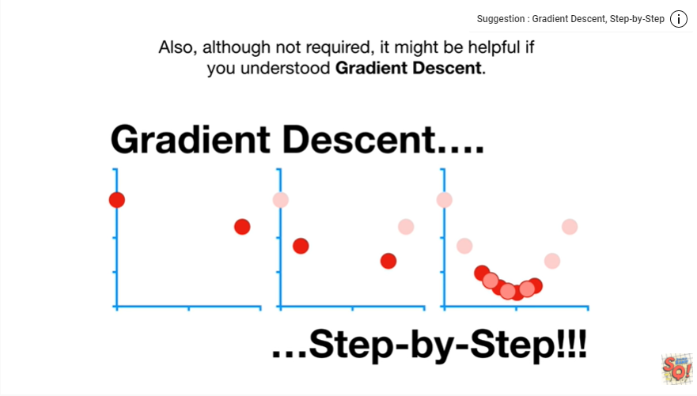

Also, although not required, it might be helpful if you understand gradient descent.

So check out that quest if you haven't already.

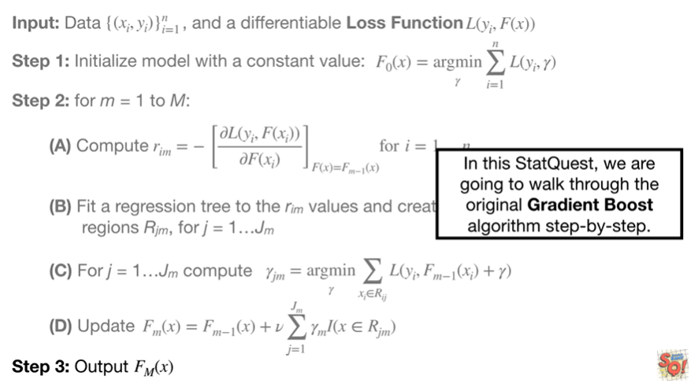

In this stat quest, we are going to walk through the original gradient boost algorithm step by step.

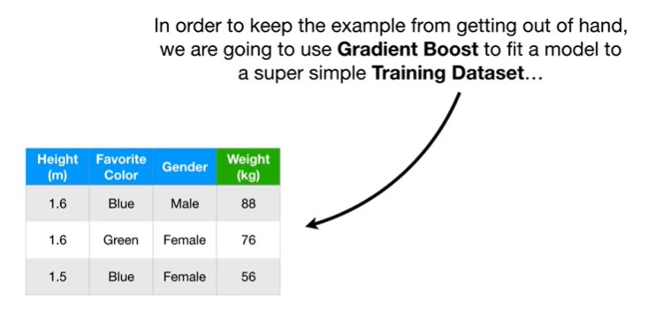

In order to keep the example from getting out of hand, we are going to use gradient boost to fit a model to a super simple training data set

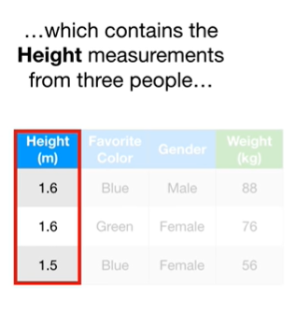

which contains height measurements from three people

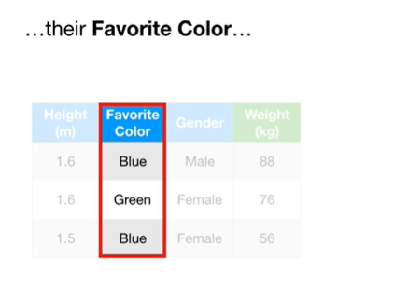

their favorite color

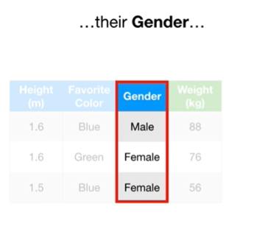

their gender

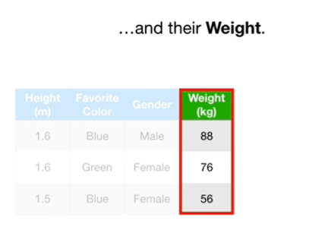

and their weight.

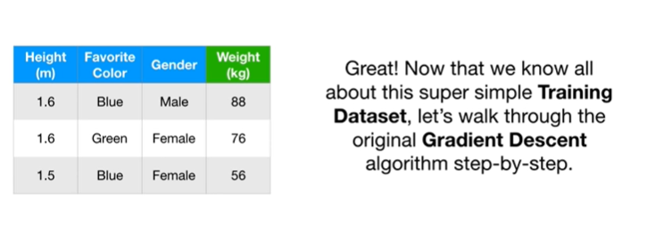

Great !

Now that we know all about this super simple training data set, let's walk through the original gradient descent algorithm step by step.

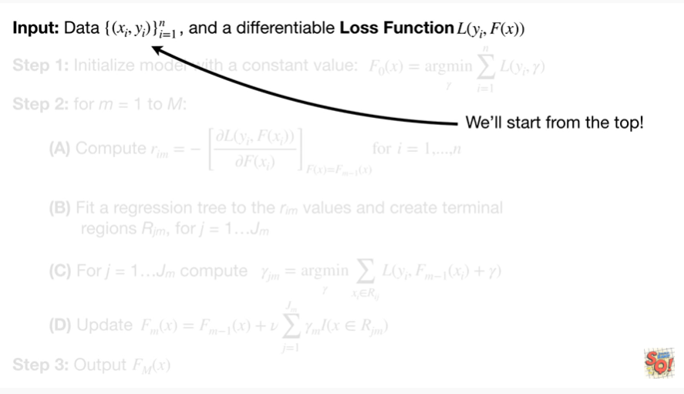

We'll start from the top !

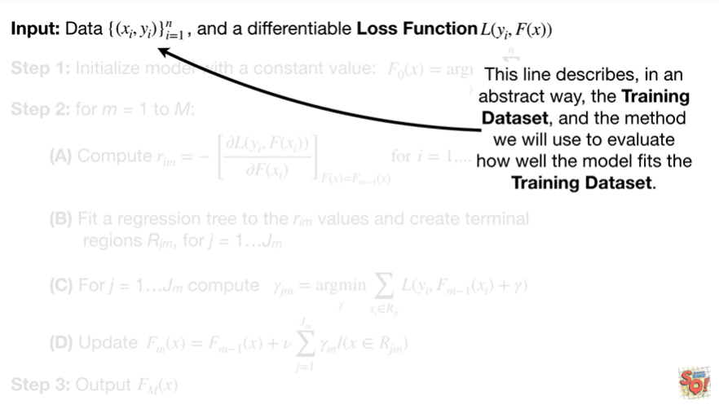

This line describes, in an abstract way, the training data set and the method we will use to evaluate how well the model fits the training data set.

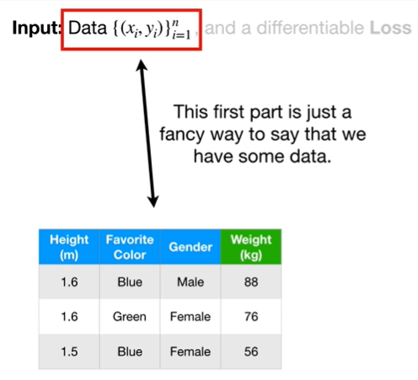

This first part is just a fancy way to say that we have some data.

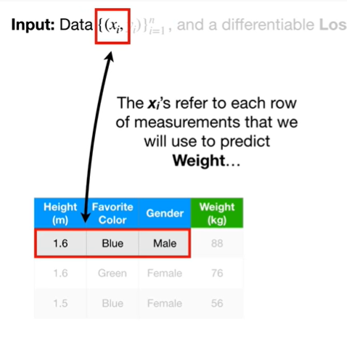

The X sub i’s refer to each row of measurements that we will use to predict weight

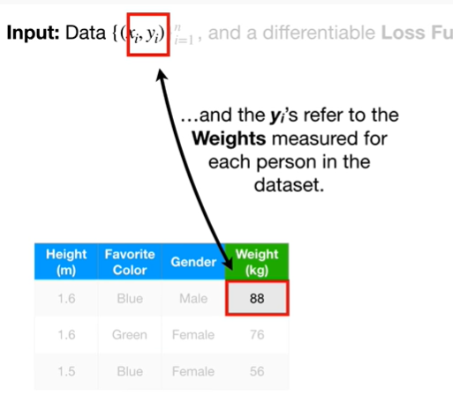

and the y sub i’s refer to the weights measured for each person in the data set.

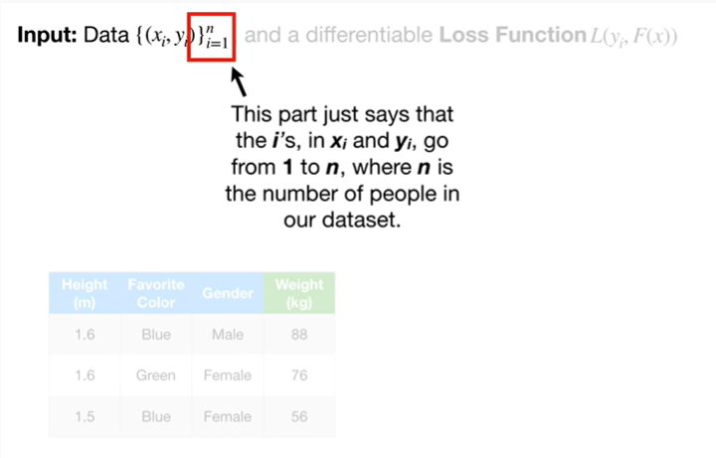

This part just says that the i’s in X of i and Y sub i, go from 1 to n, where n is the number of people in our data set.

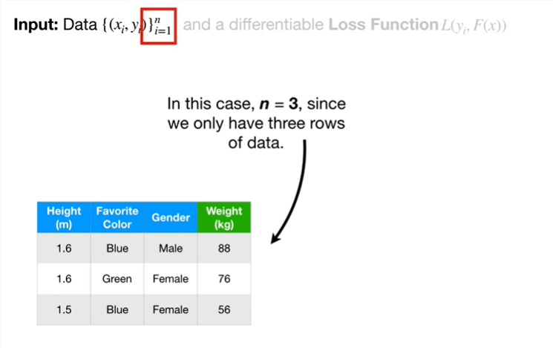

In this case N equals three since we only have three rows of data.

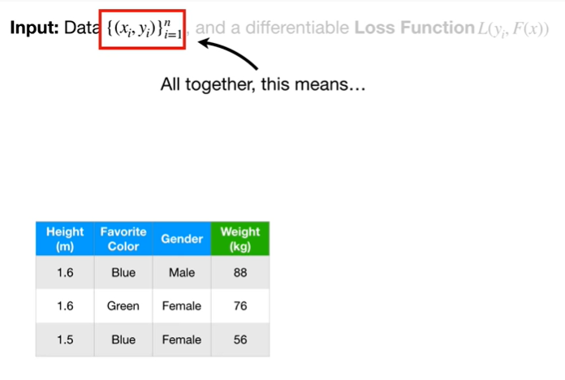

All together, this means

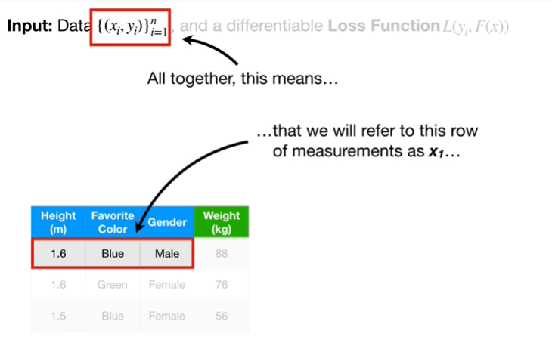

that we were referred to this row of measurements as X sub 1

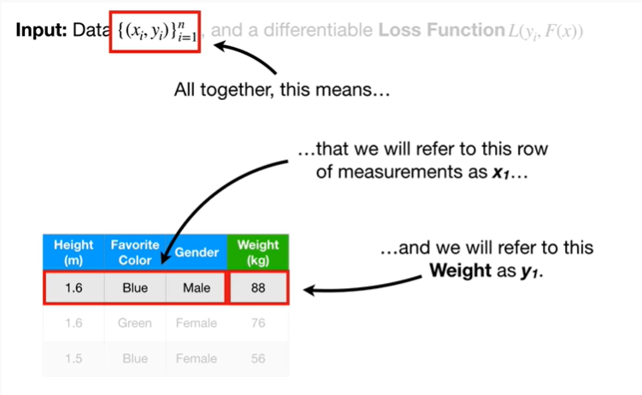

and we will refer to this weight as Y sub 1.

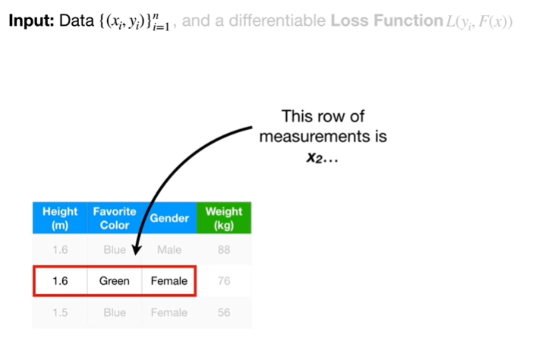

This row of measurements is X sub 2

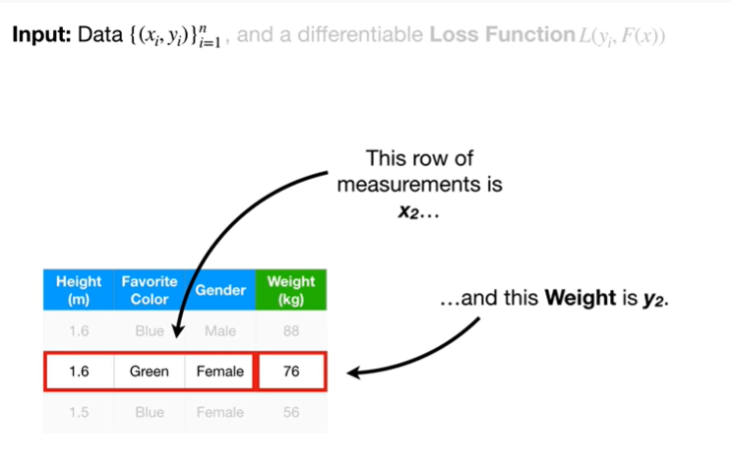

and this weight is y sub 2.

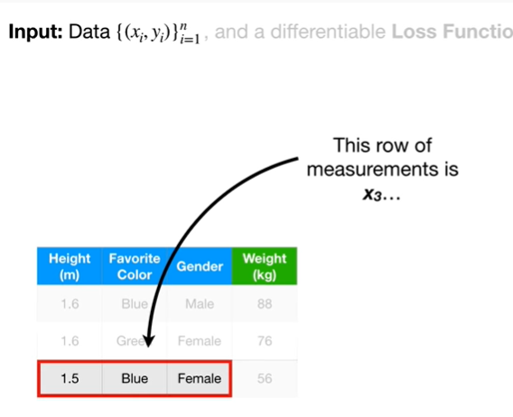

This row of measurements is X sub 3

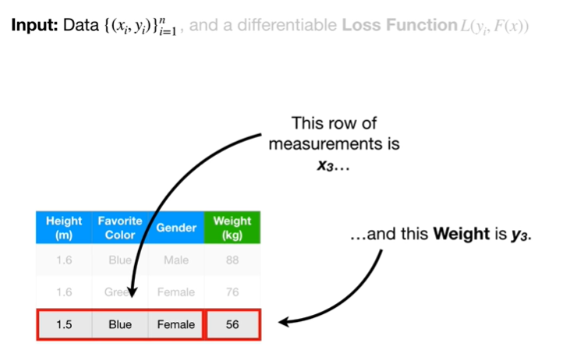

and this weight is y sub 3.

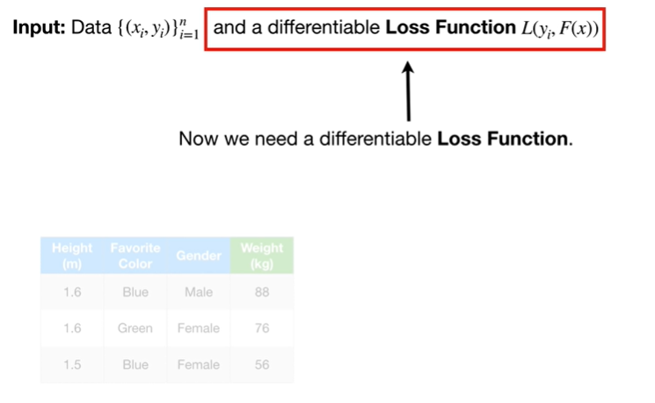

Now we need a differentiable loss function.

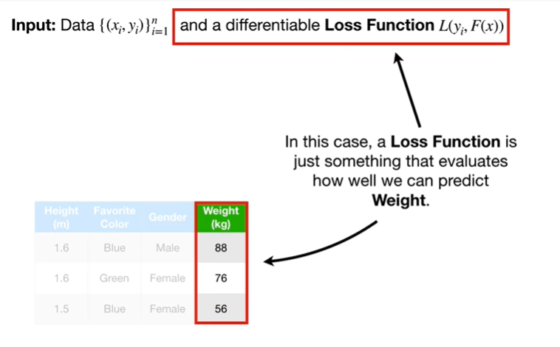

In this case a loss function is just something that evaluates how well we can predict weight.

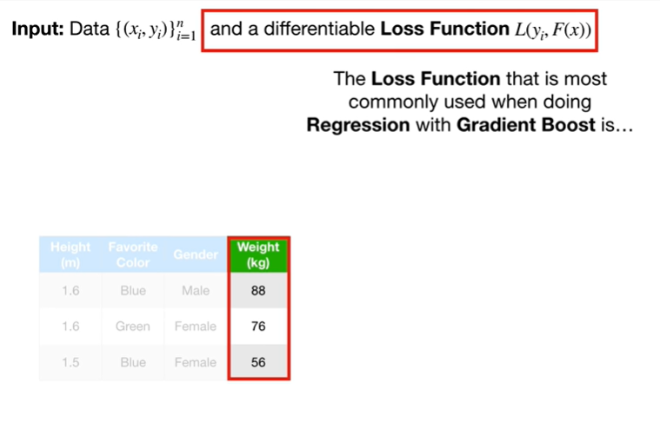

The loss function that is most commonly used doing regression with gradient boost is

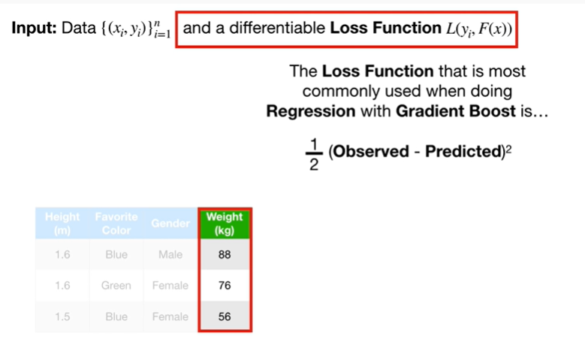

1/2 times the observed value minus the predicted value squared.

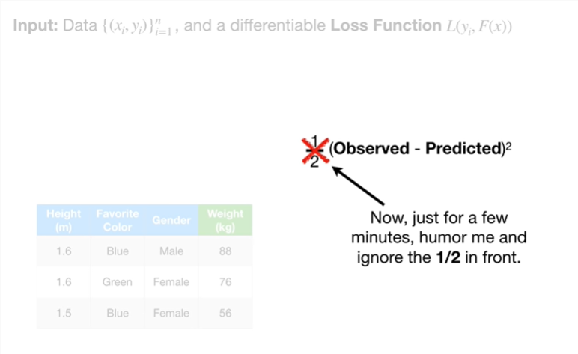

Now, just for a few minutes, humor me and ignore the one half in front.

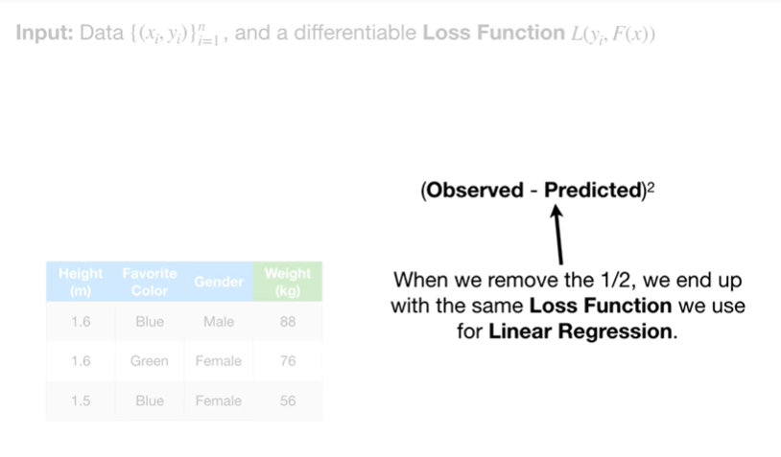

When we remove the ½, we end up with the same loss function we use for linear regression.

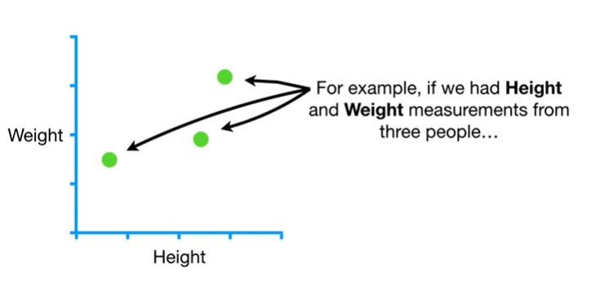

For example, if we had height and weight measurements from three people

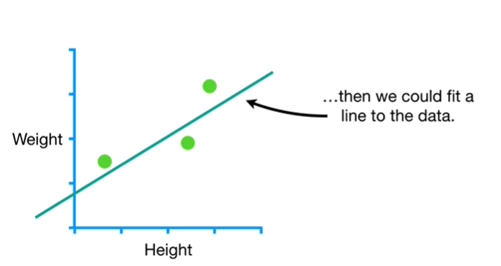

then we could fit a line to the data.

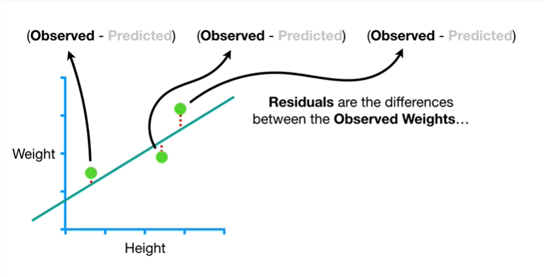

Residuals are the differences between the observed weights

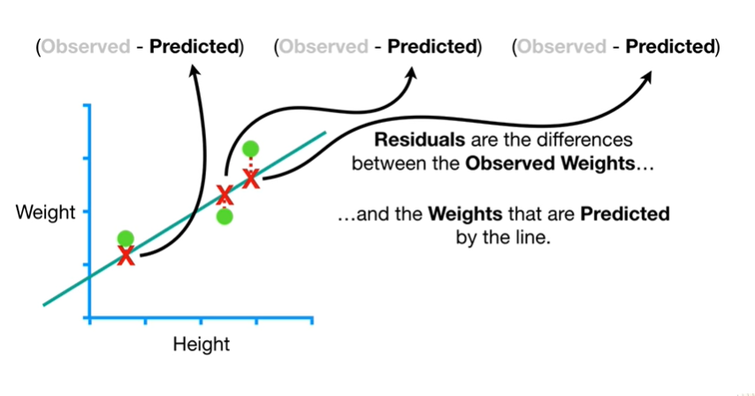

and the weights that are predicted by the line.

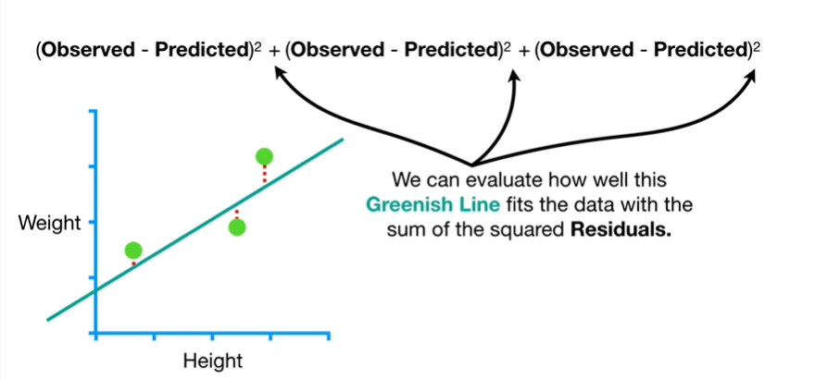

We can evaluate how well this greenish line fits the data with the sum of the squared residuals.

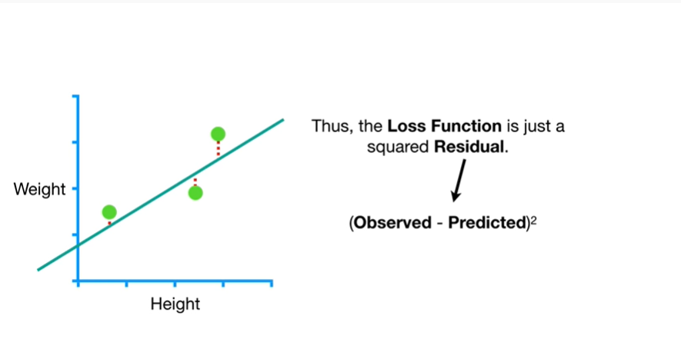

Thus, the loss function is just a squared residual.

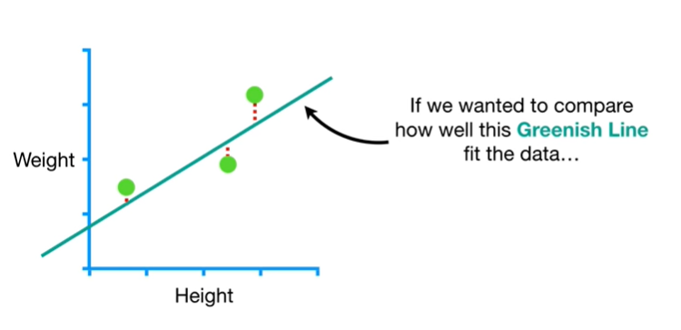

If we wanted to compare how well this greenish line fit the data

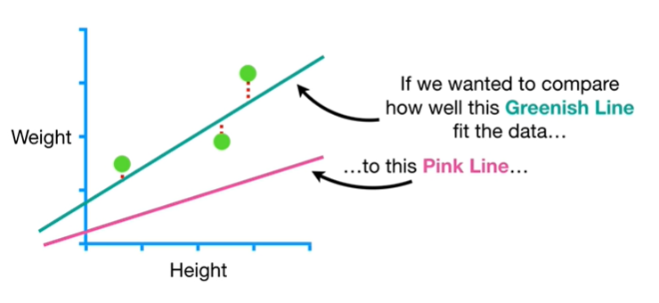

to this pink line

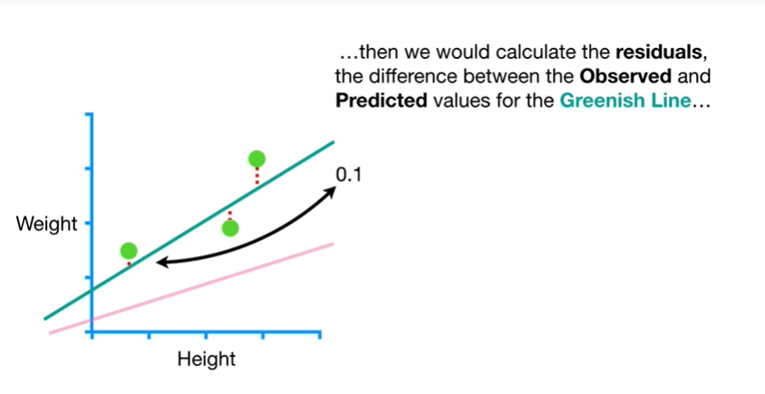

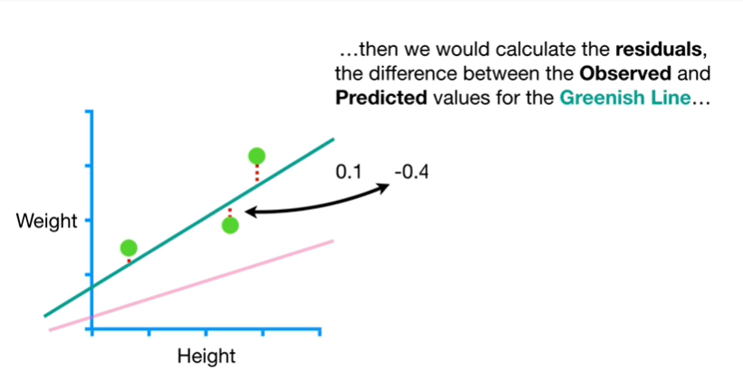

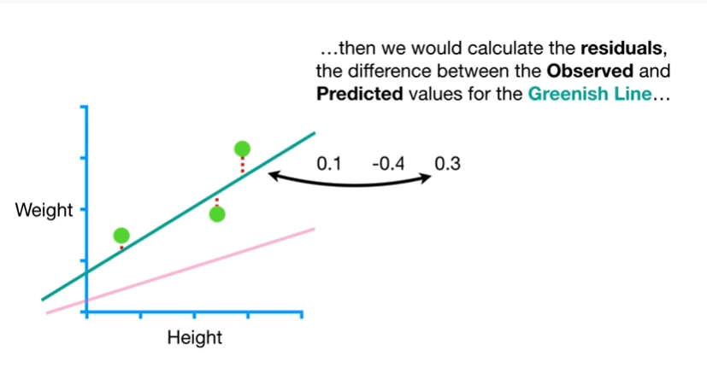

then we would calculate the residuals the difference between the observed and the predicted values for the greenish line

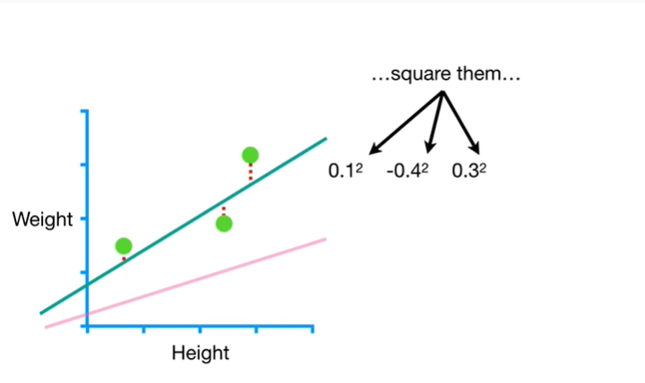

square them

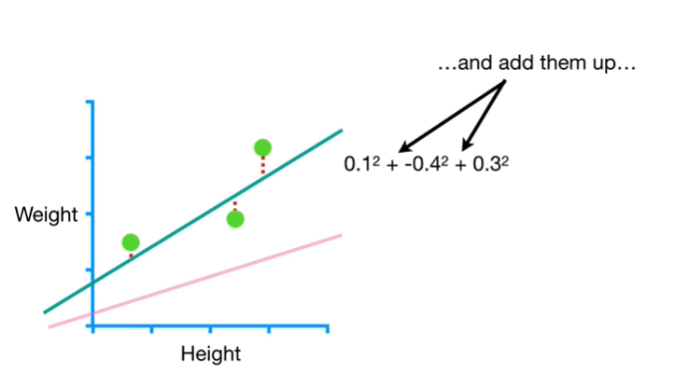

and add them up

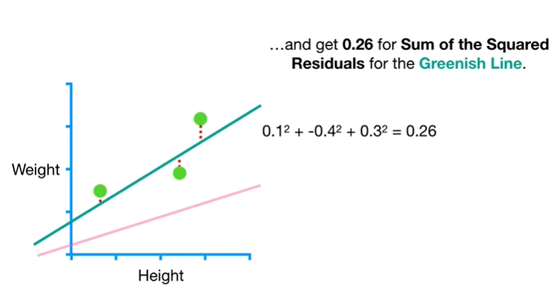

and get 0.26 for the sum of the squared residuals for the greenish line.

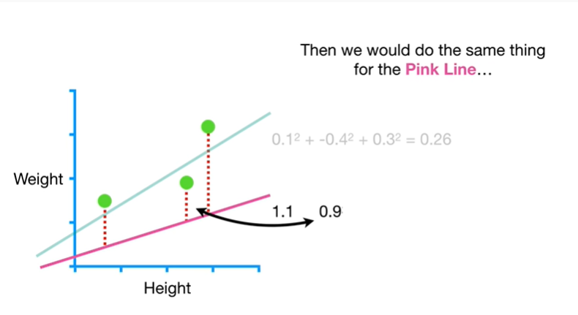

Then we would do the same thing for the pink line

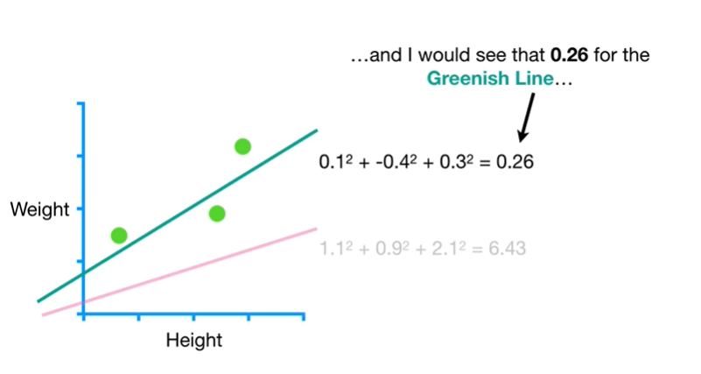

and I would see that 0.26 for the greenish line

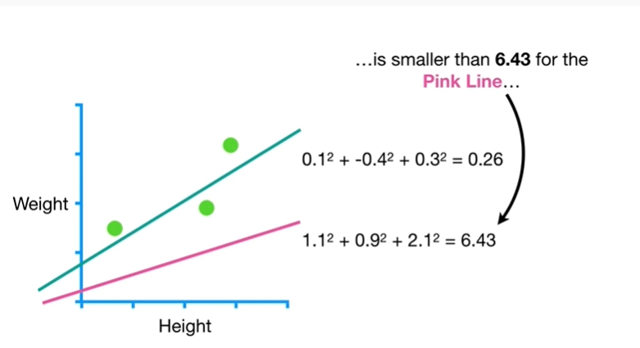

is smaller than 6.4 3 for the pink line

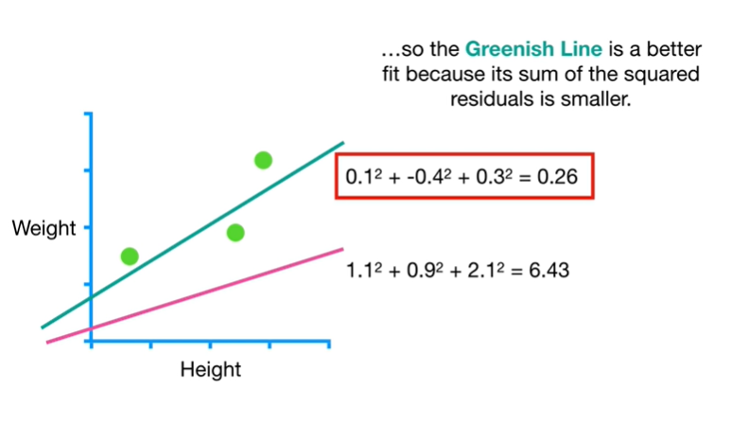

so the greenish line is a better fit because it's sum of the squared residuals is smaller.

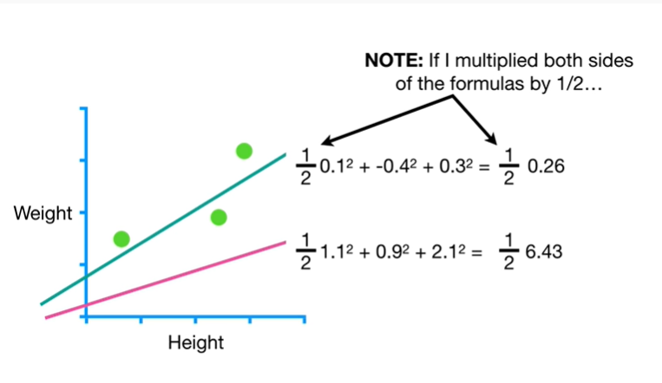

Note : if I multiplied both sides of the formulas by 1/2

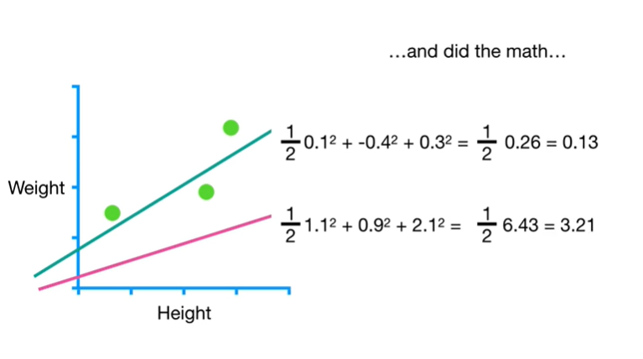

and did the math

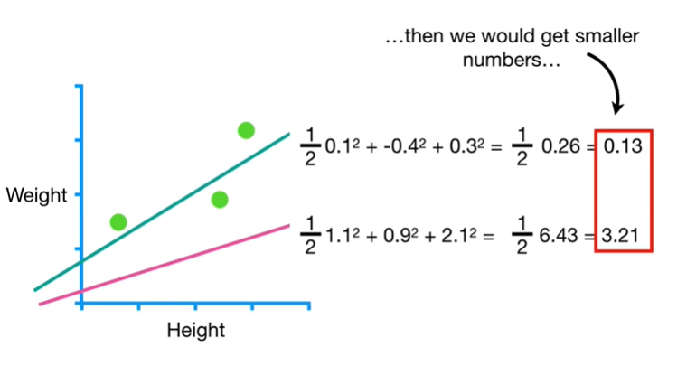

then we would get smaller numbers

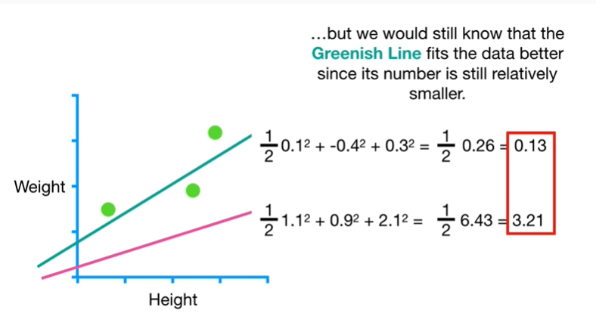

but we would still know that the greenish line fits the date of better since its number is still relatively smaller.

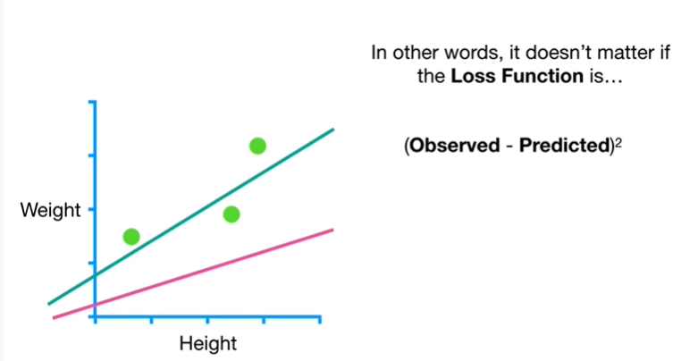

In other words, it doesn't matter if the loss function is the observed value minus the predicted value squared

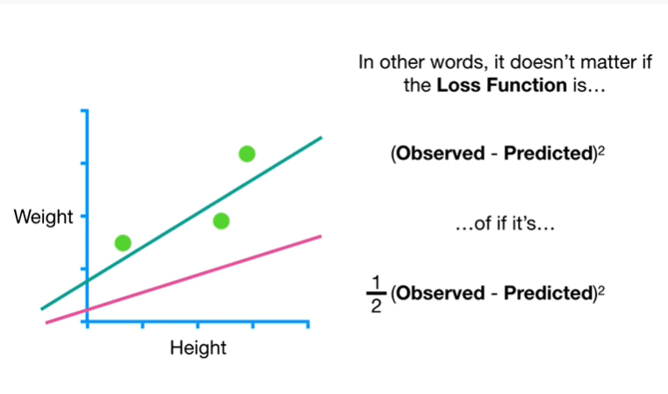

or if it's 1/2 times the observed value minus the predicted value squared.

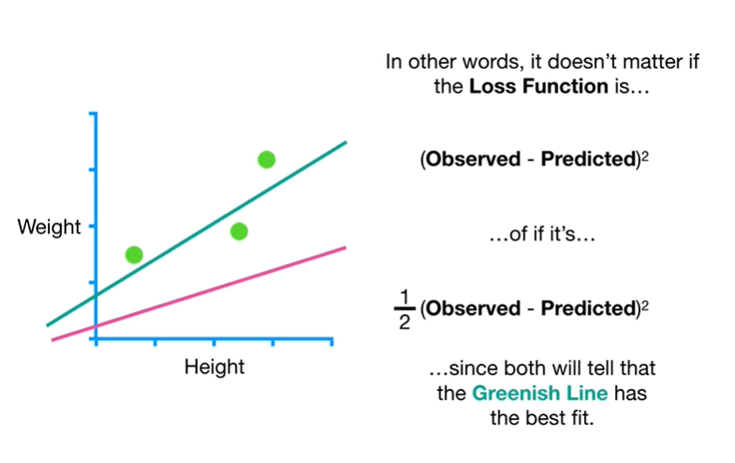

since both will tell us that the greenish line has the best fit.

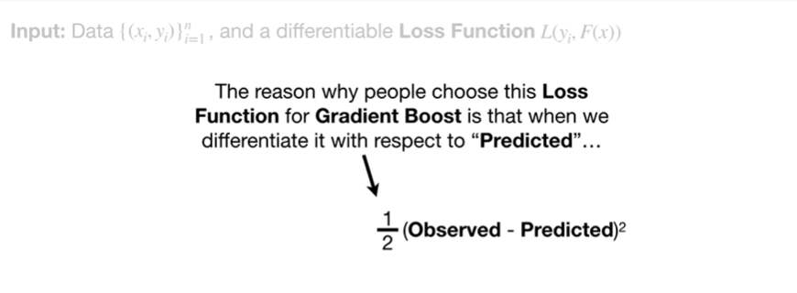

The reason why people choose this loss function for gradient boost is that when we differentiate it with respect to predicted

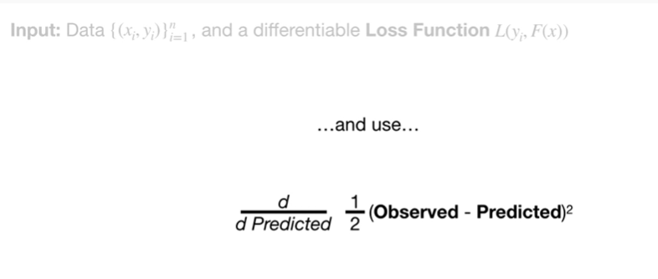

and use



the chain rule

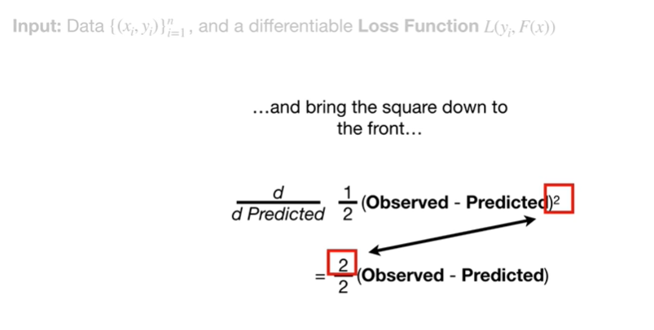

and bring the square down to the front

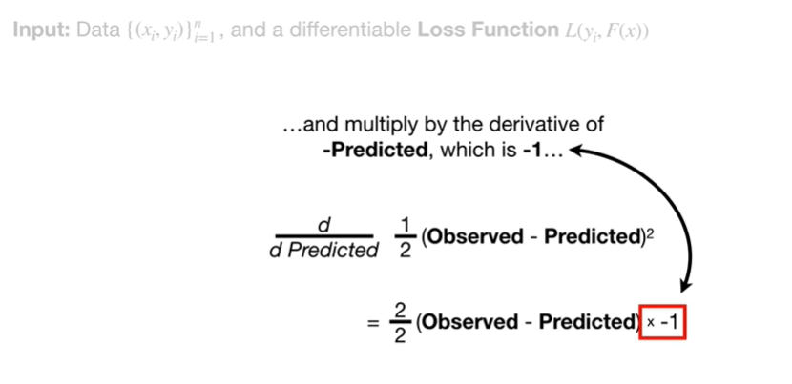

and multiply it by the derivative of minus predicted, which is negative one

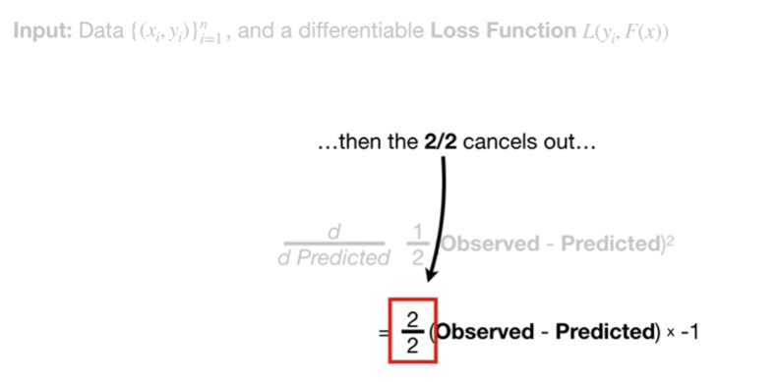

then the two divided by two cancels out

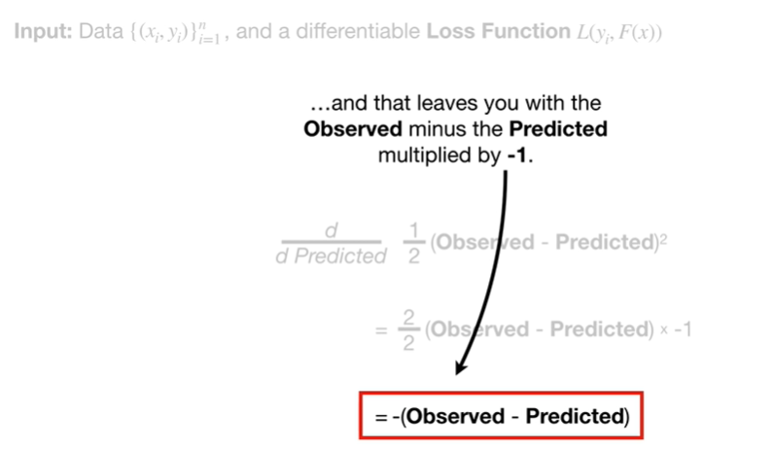

and that leaves you with the observed minus the predicted multiplied by negative one.

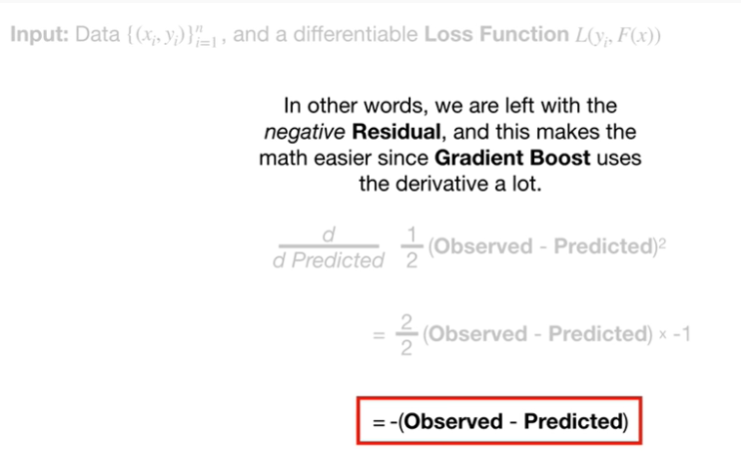

In other words, we are left with the negative residual and that makes the math easier since gradient boost uses the derivative a lot.

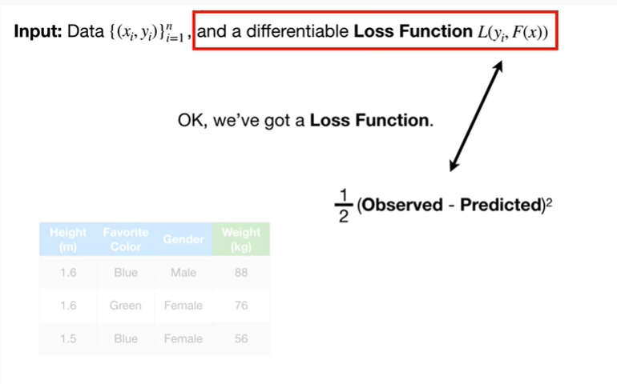

Okay, we've got a loss function.

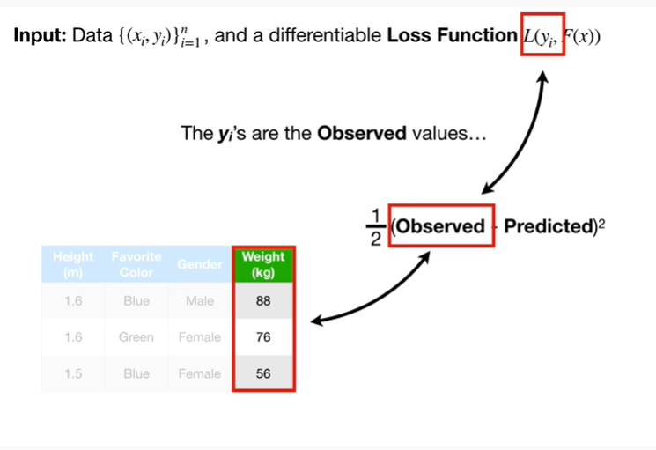

The y sub i's are the observed values

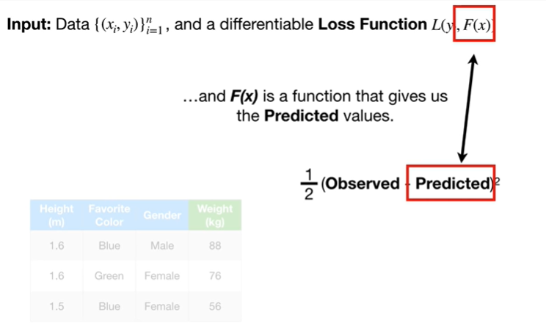

And F(X) is a function that gives us the predicted values.

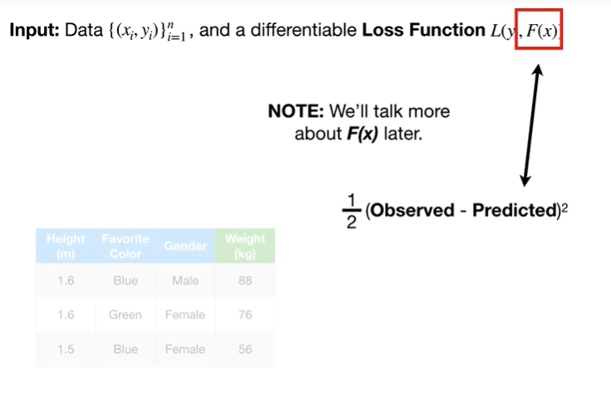

Note : we'll talk more about f of X later.

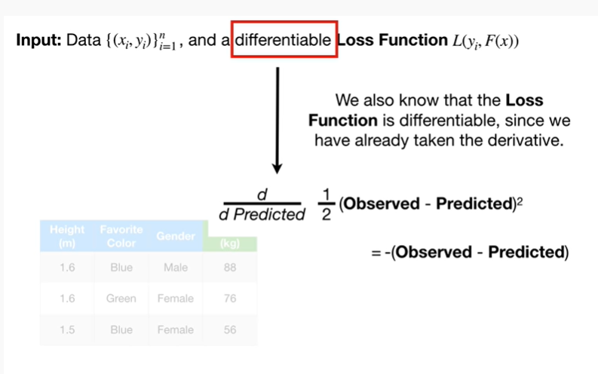

We also know that the loss function is differentiable, since we have already taken the derivative.

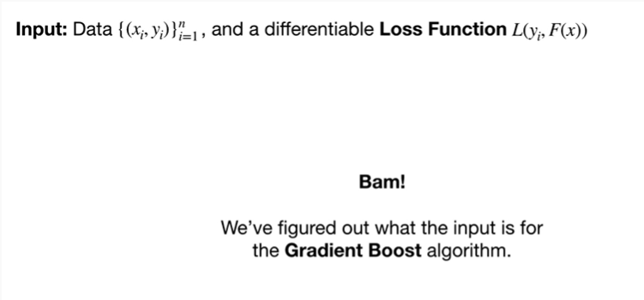

BAM !

We figured out what the input is for the gradient boost algorithm.

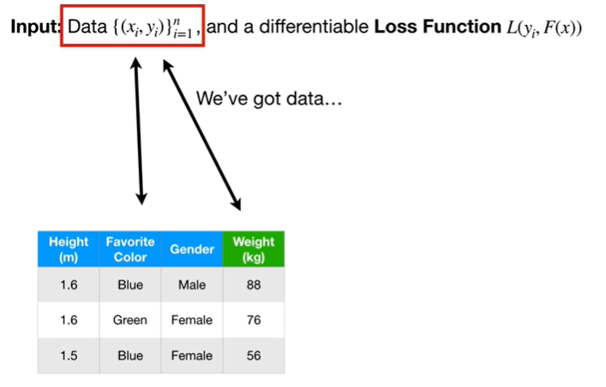

We've got data

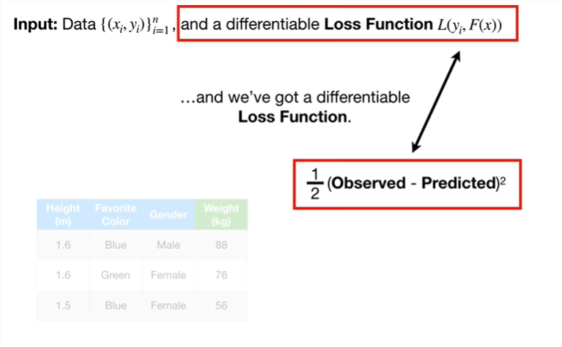

and we've got a differentiable loss function.

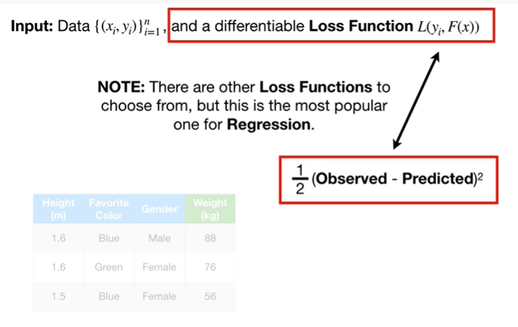

Note : there are other loss functions to choose from but this is the most popular one for regression.

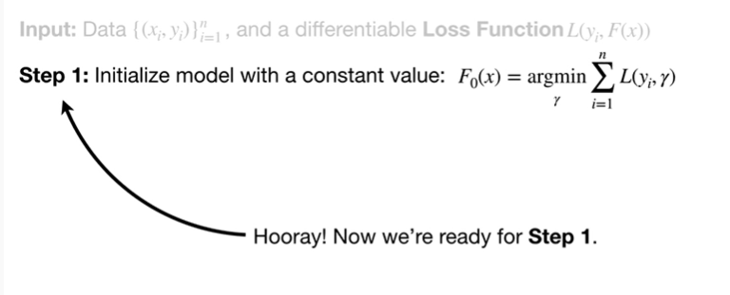

Hooray !

Now we're ready for step one.

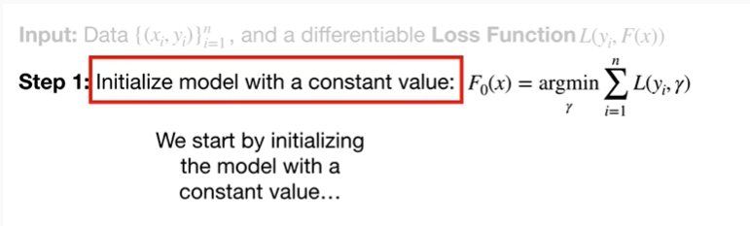

We start by initializing the model with a constant value

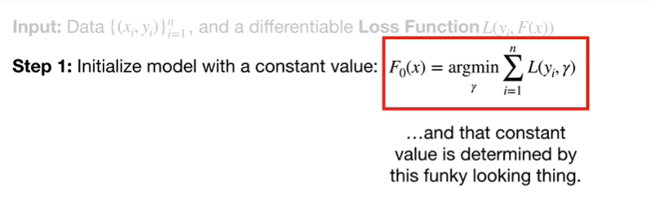

and that constant value is determined by this funky-looking thing.

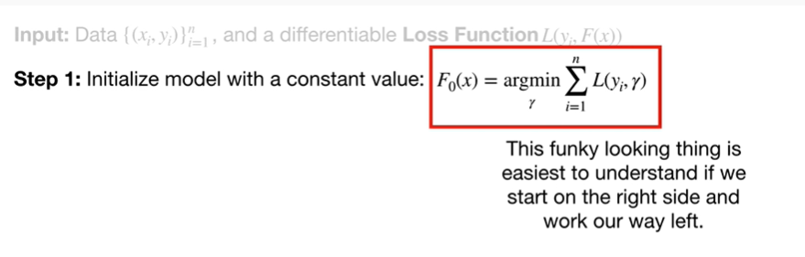

This funky-looking thing is easiest to understand if we start on the right side and work our way left.

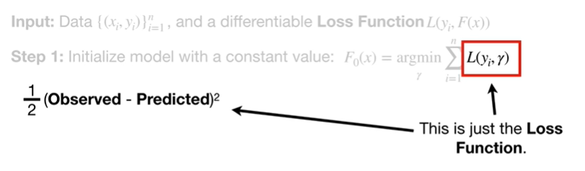

This is just the loss function.

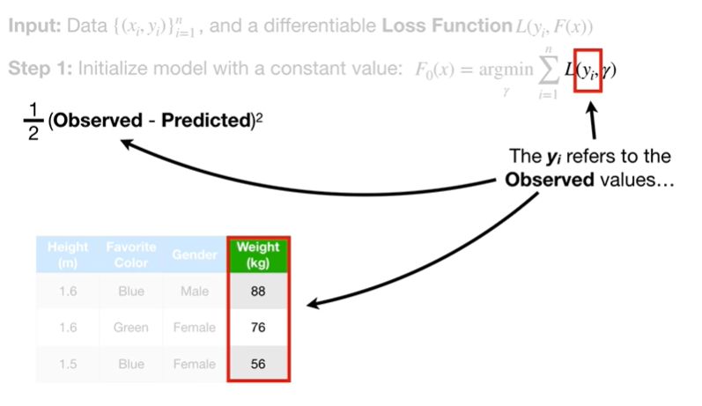

The y sub i refers to the observed values

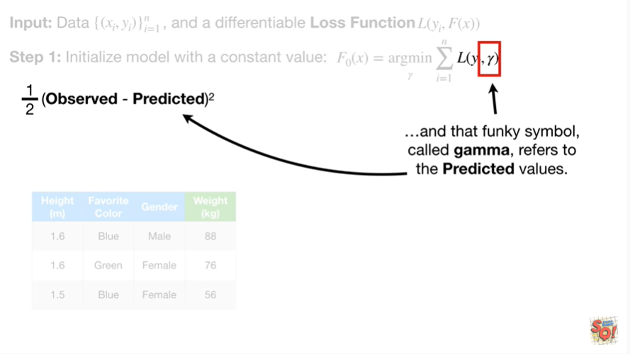

and that funky-looking symbol called gamma, refers to the predicted values.

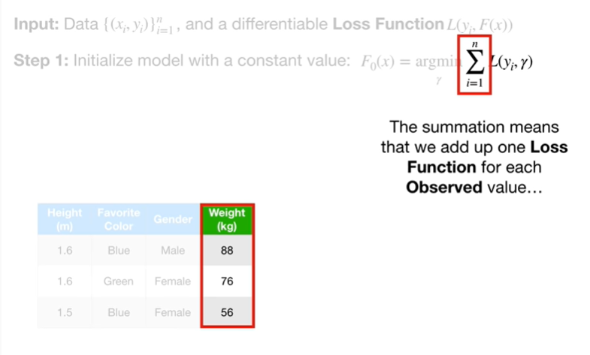

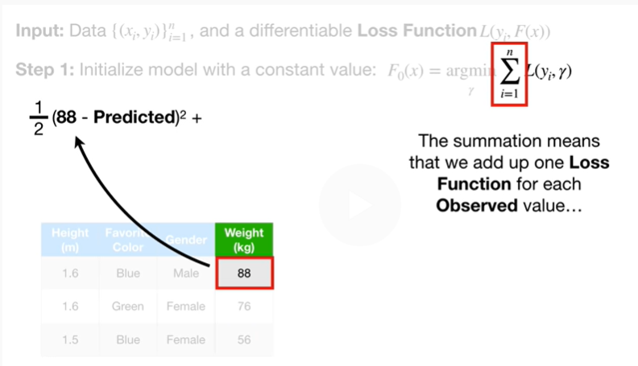

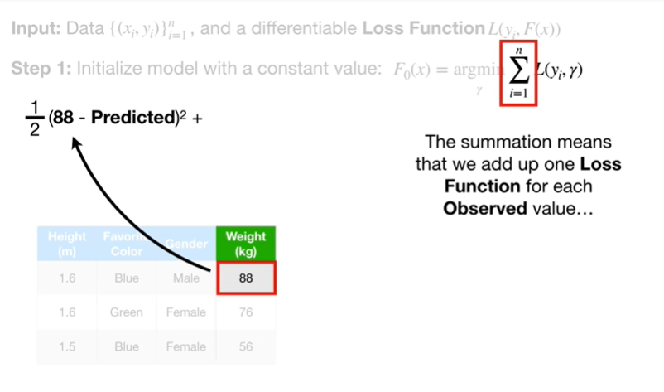

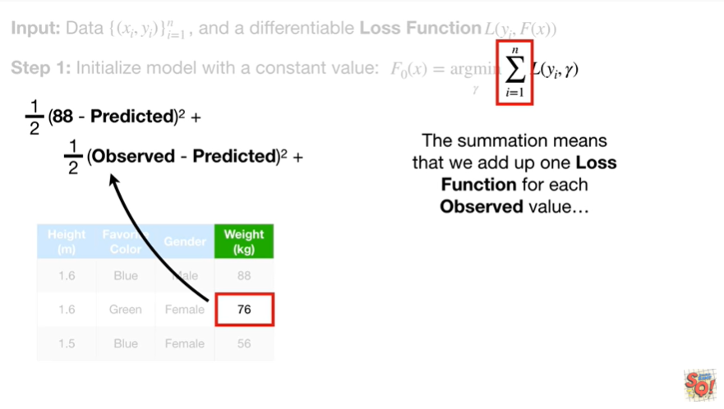

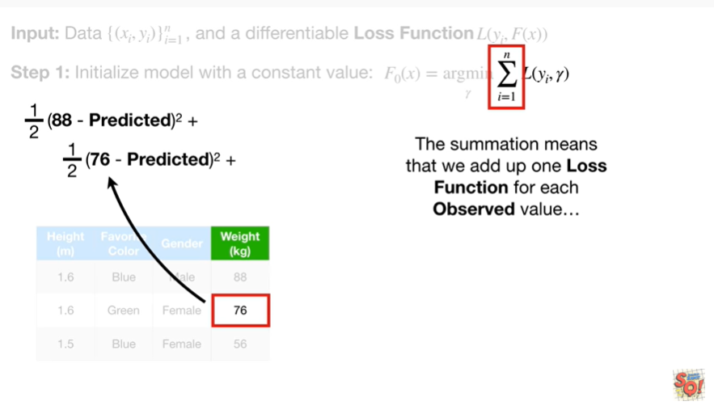

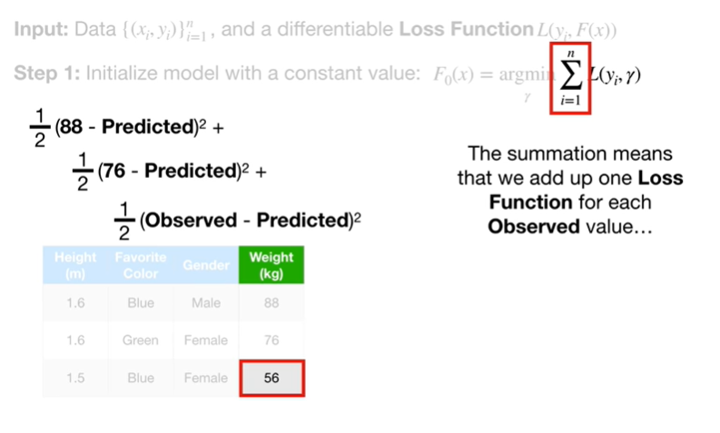

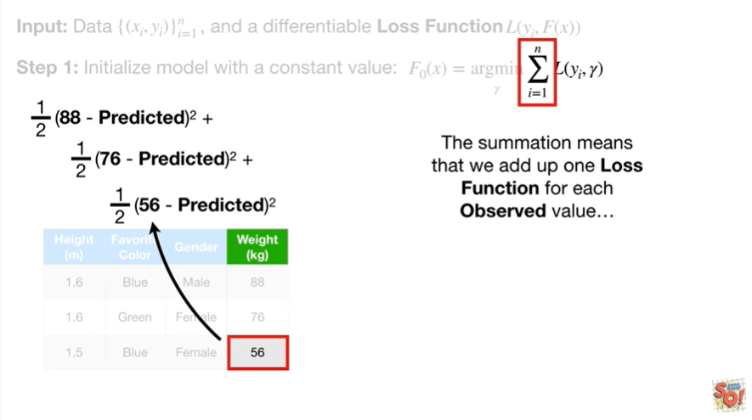

The summation means that we add up 1 loss function for each observed value

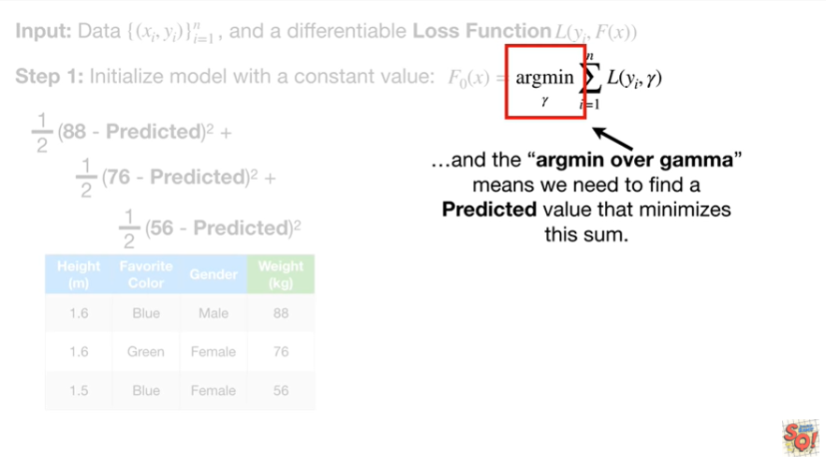

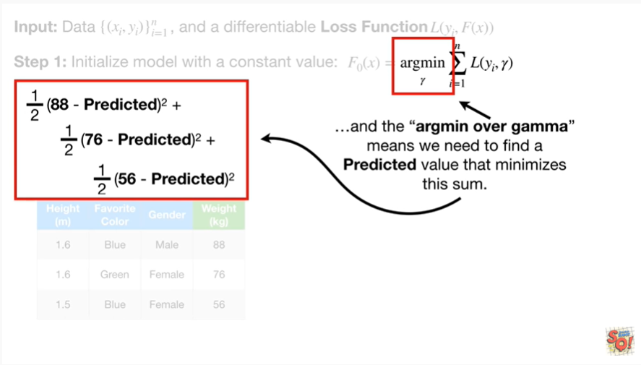

and the argmin over gamma means we need to find a predicted value that minimizes this sum.

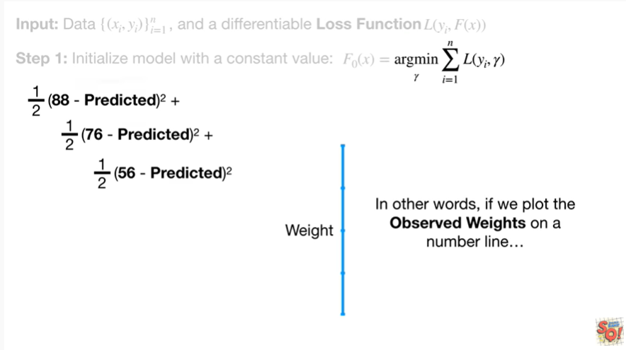

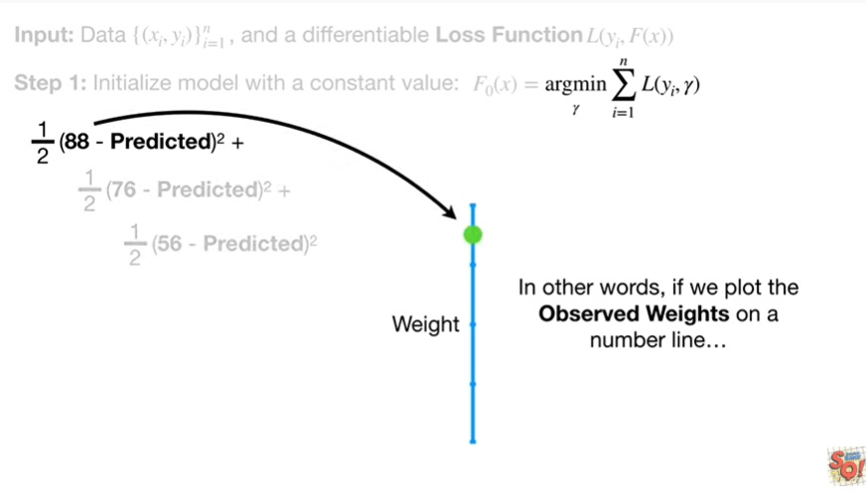

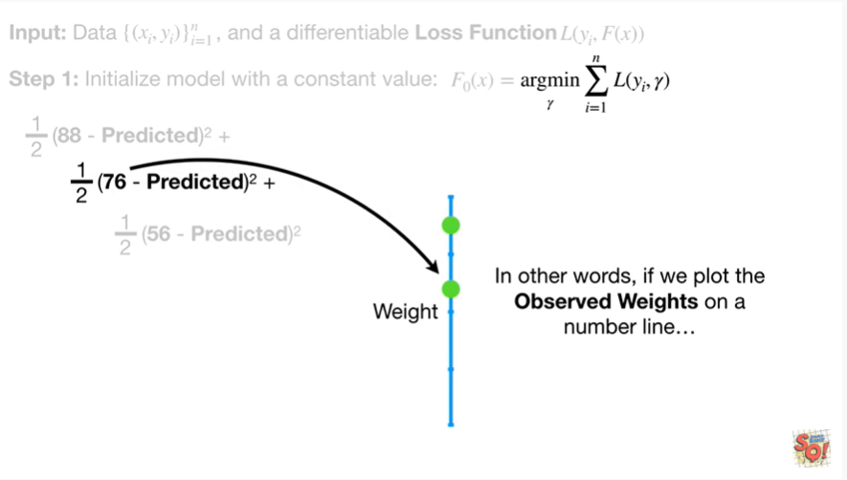

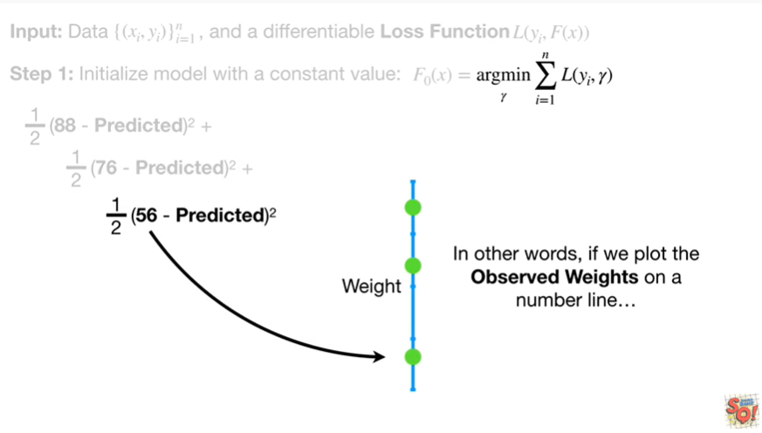

In other words, if we plot the observed weights on a number line

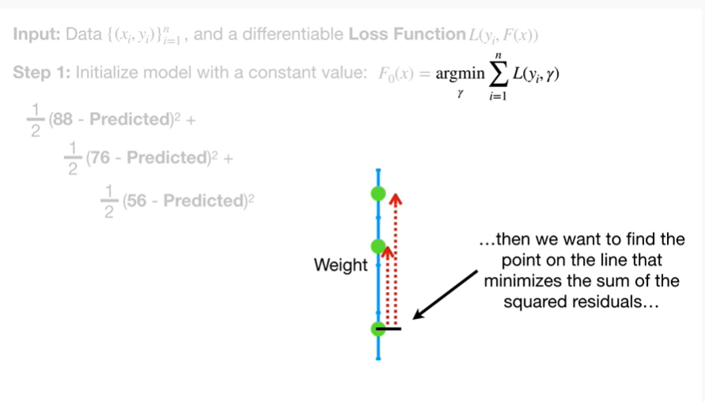



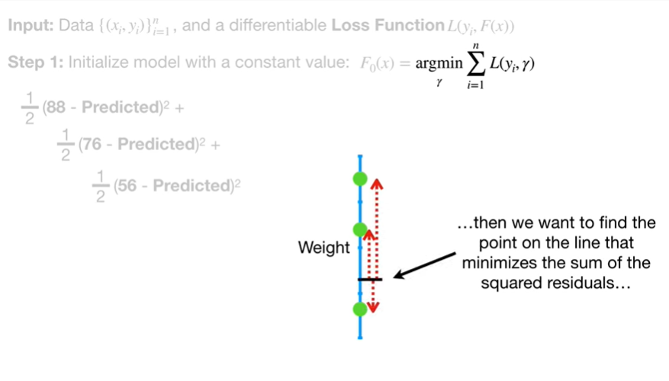

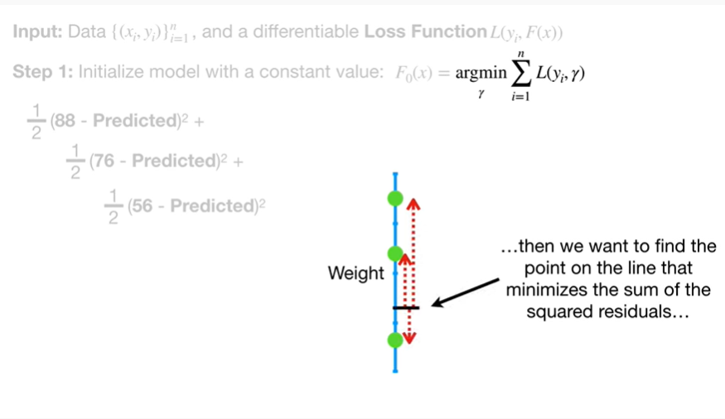

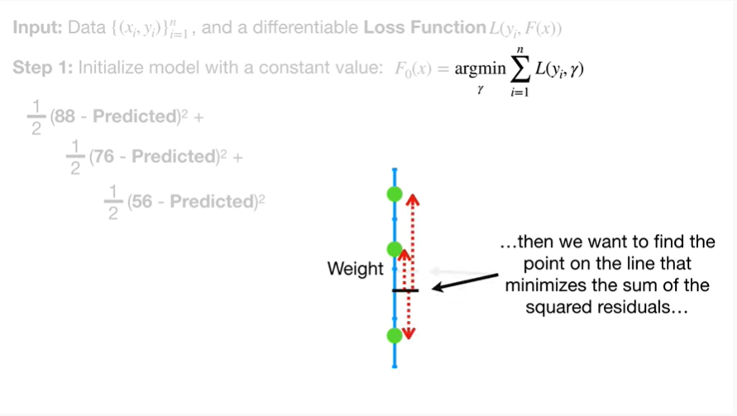

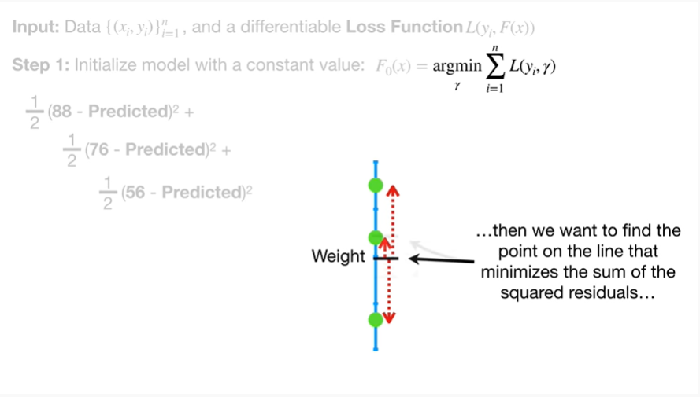

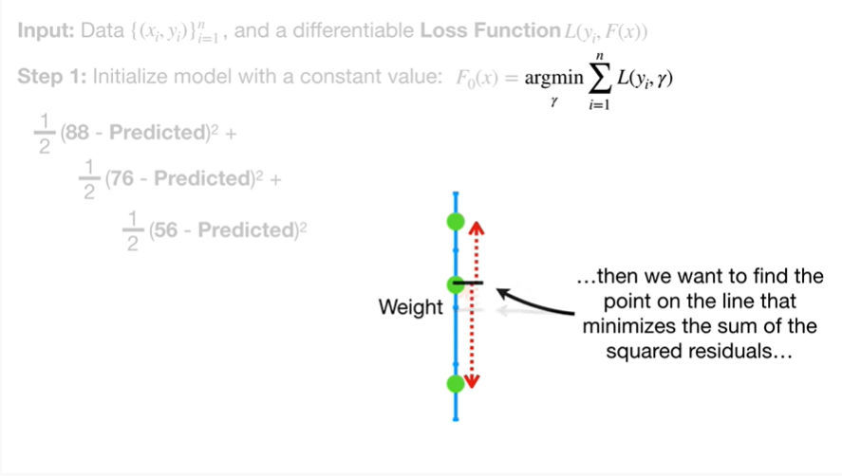

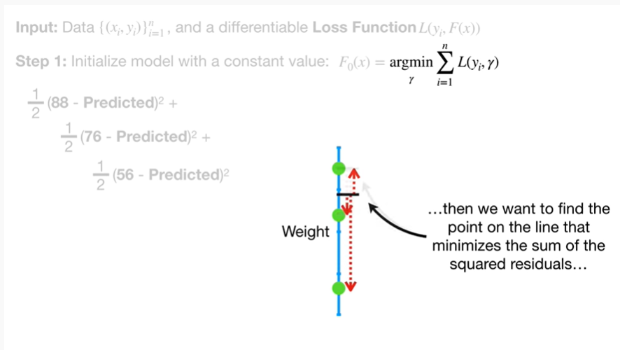

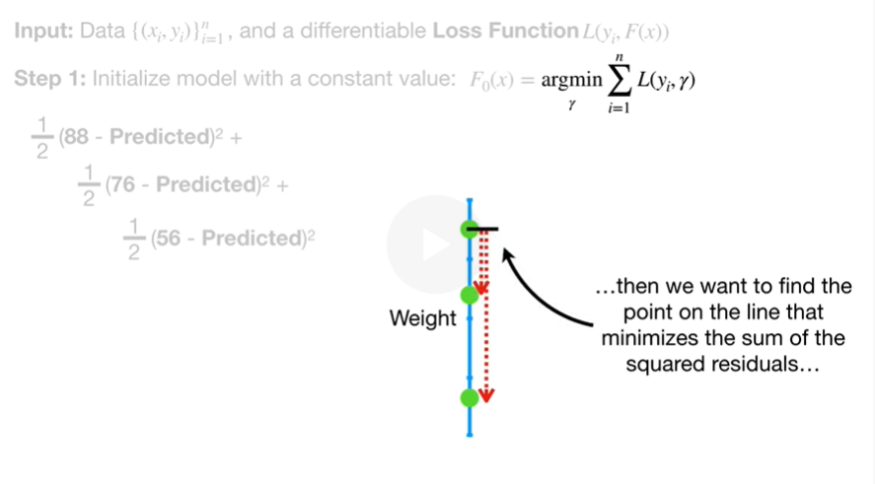

then we want to find the point on the line that minimizes the sum of the squared residuals

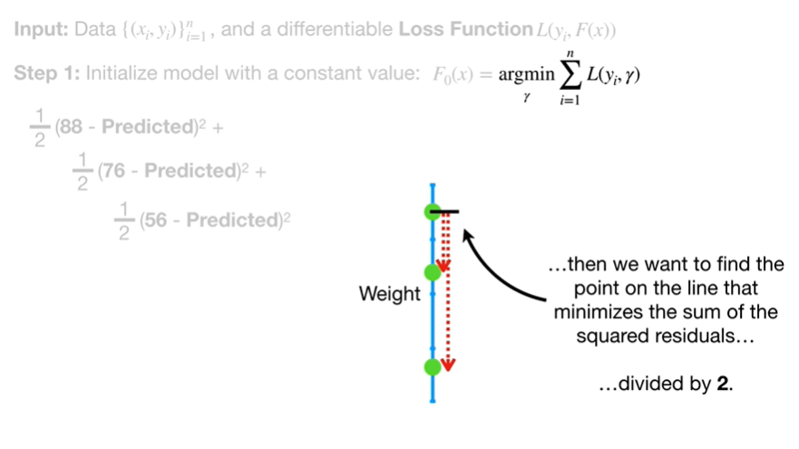

divided by two.

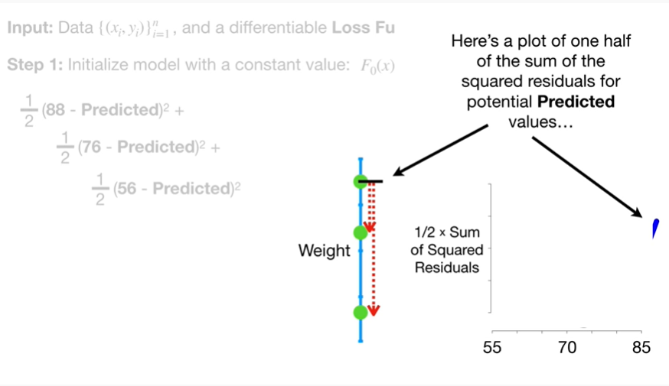

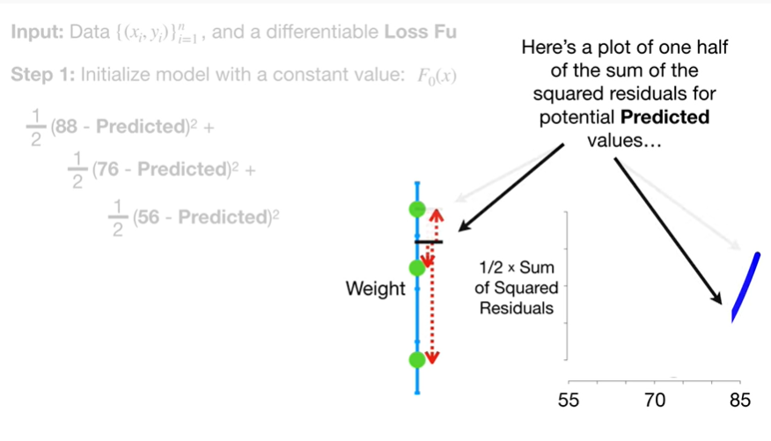

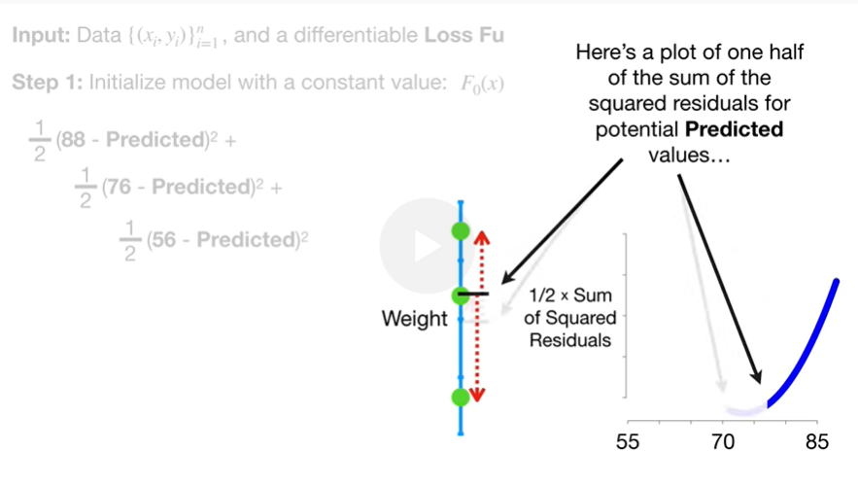

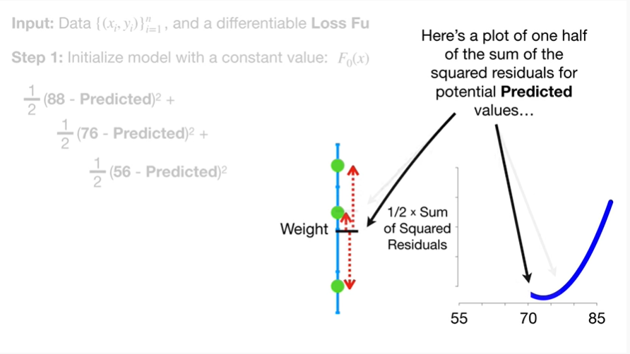

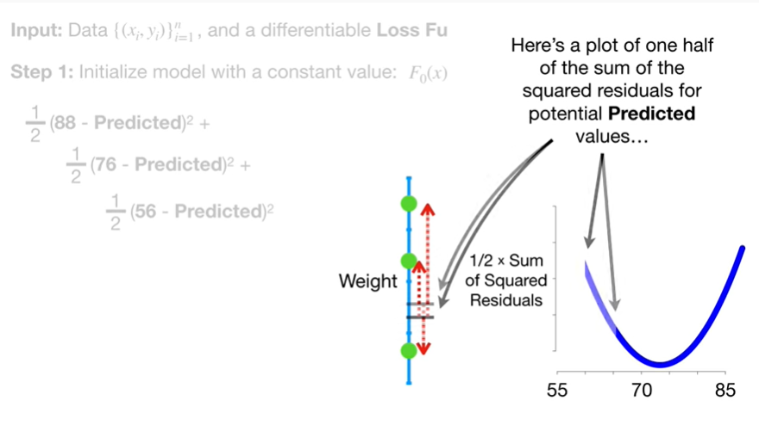

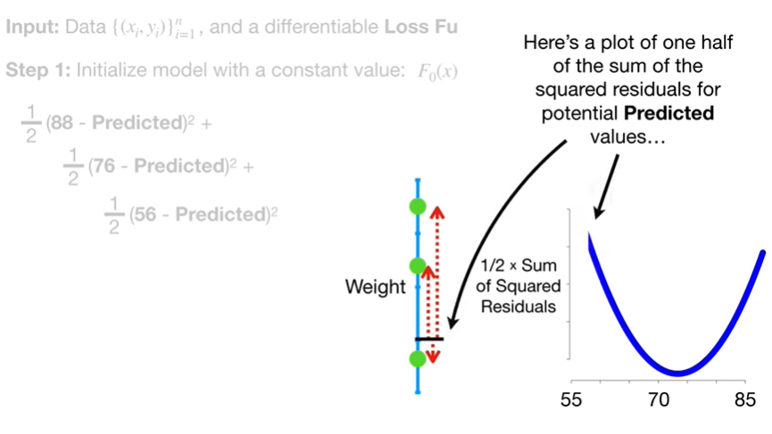

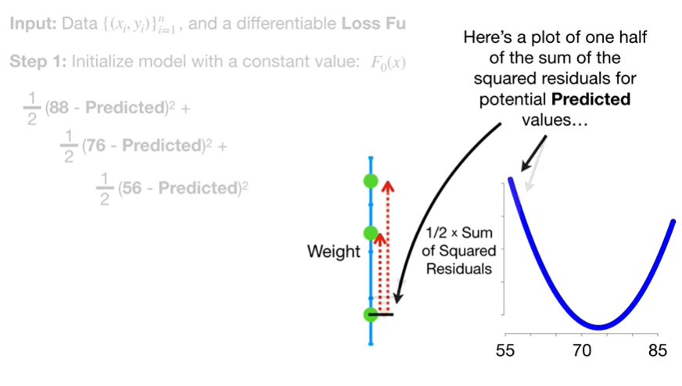

Here's a plot of one-half of the sum of the squared residuals for potential predicted values.

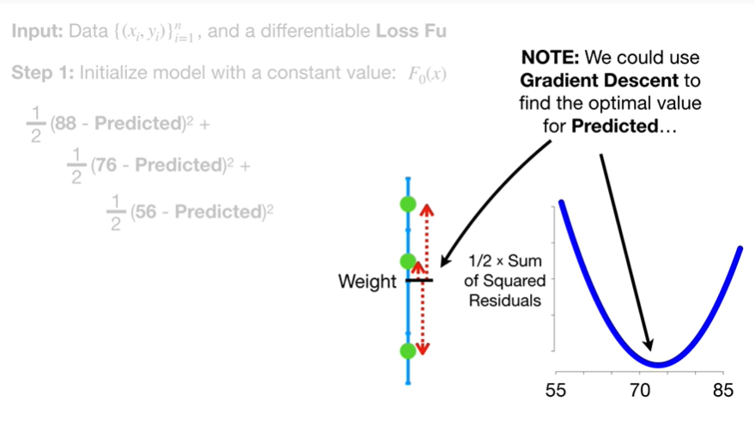

Note : we could use gradient descent to find the optimal value for predicted

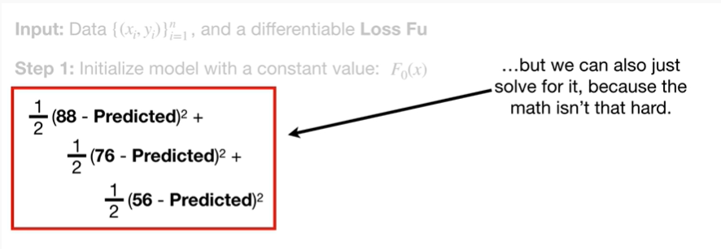

but we can also just solve for it because the math isn't that hard.

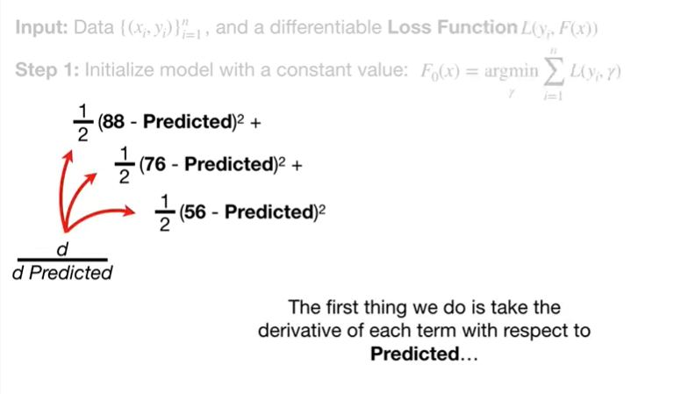

The first thing we do is take the derivative of each term with respect to predicted

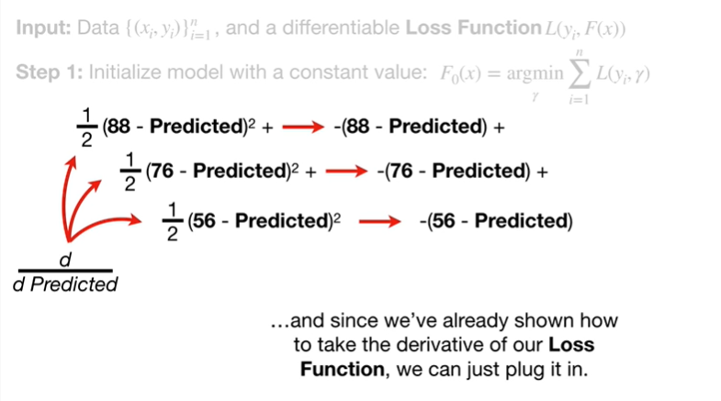

and since we've already shown how to take the derivative of our loss function we can just plug it in.

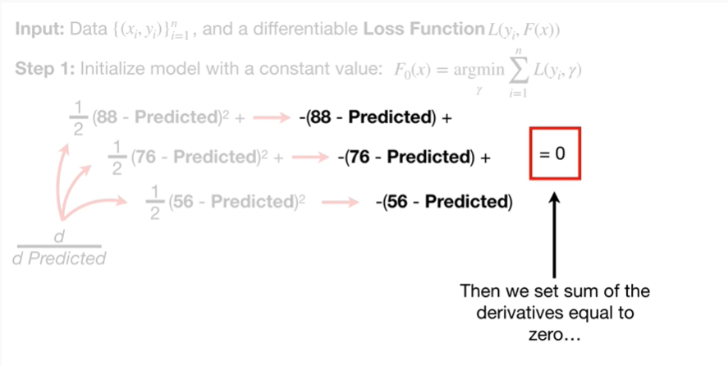

Then we set the sum of the derivatives equal to zero

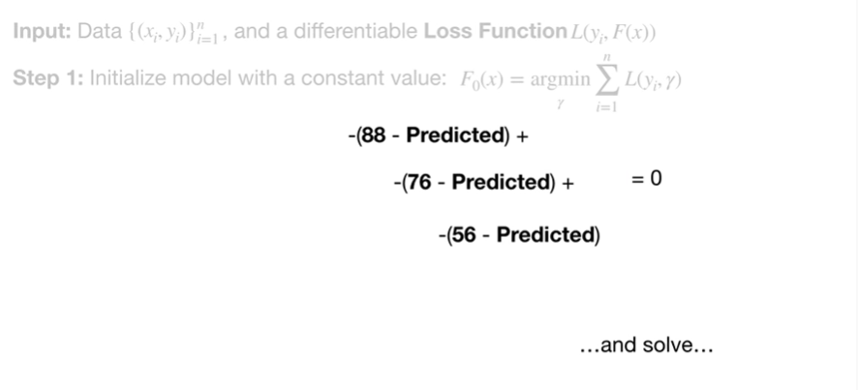

and solve

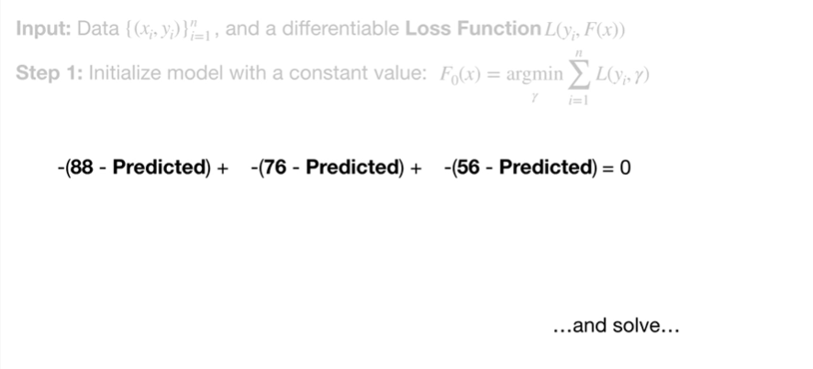

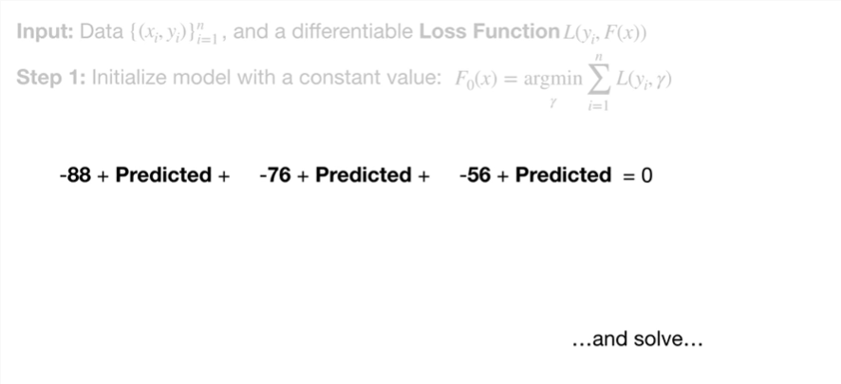

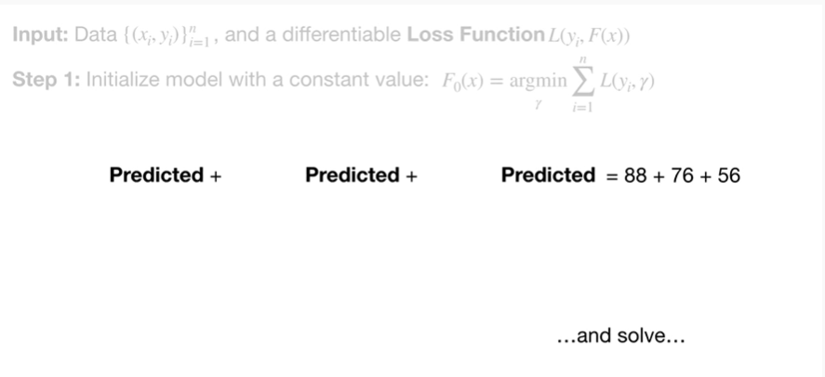

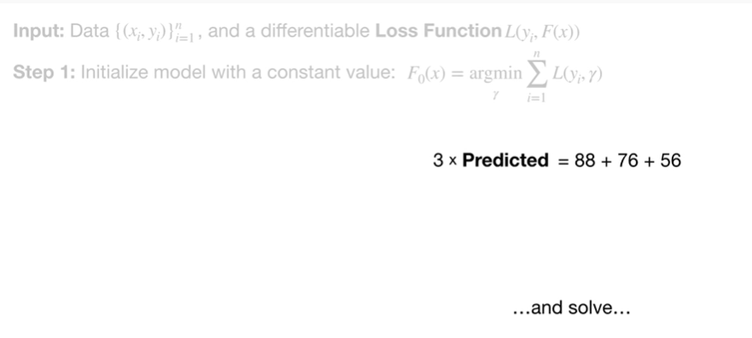

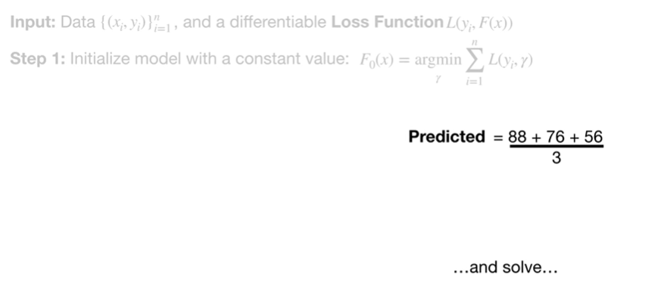

boo - boo boo boo - boo boo boo boo boo boo boo

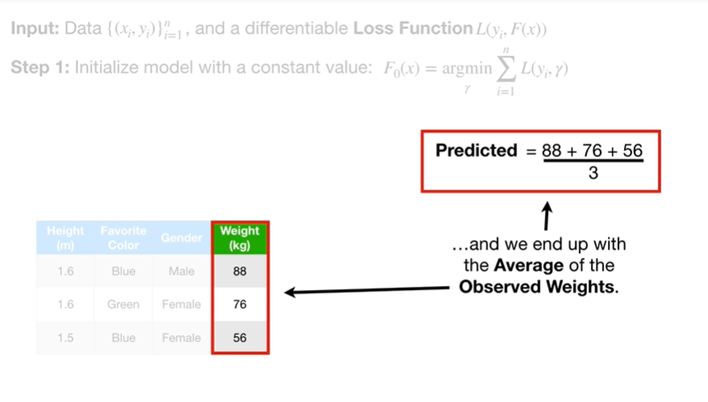

and we end up with the average of the observed weights.

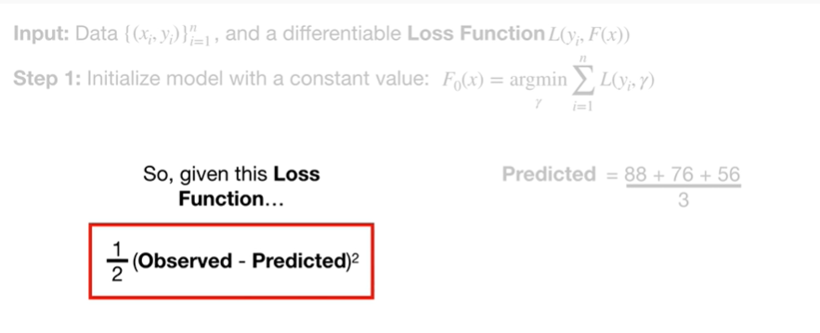

So given this loss function

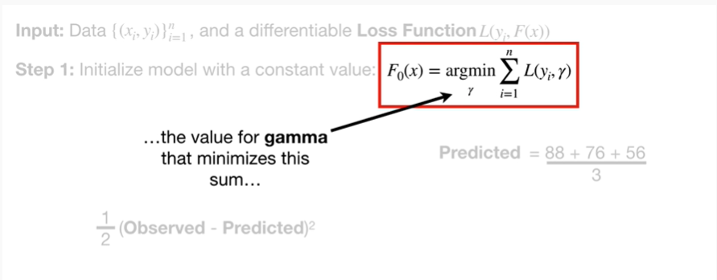

the value for gamma that minimizes this sum

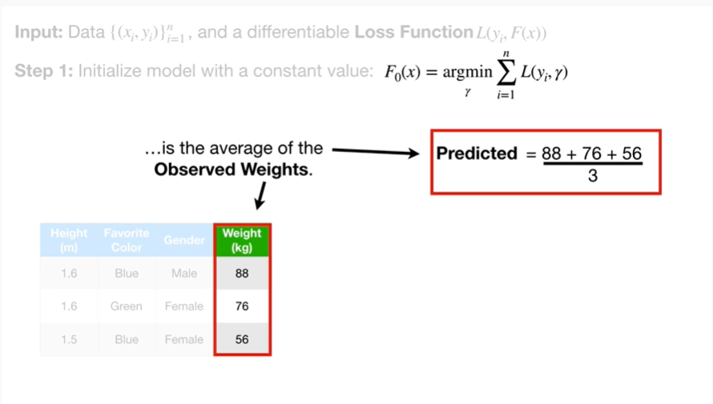

is the average of the observed weights.

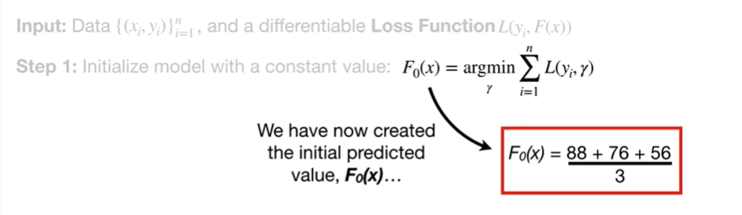

We have now created the initial predicted value F sub 0 of X

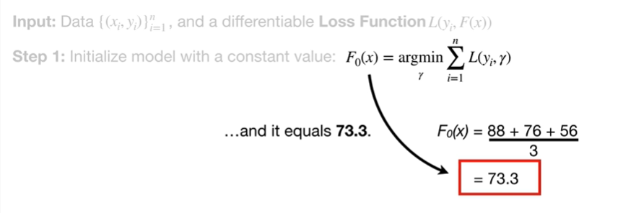

and it equals 73.3.

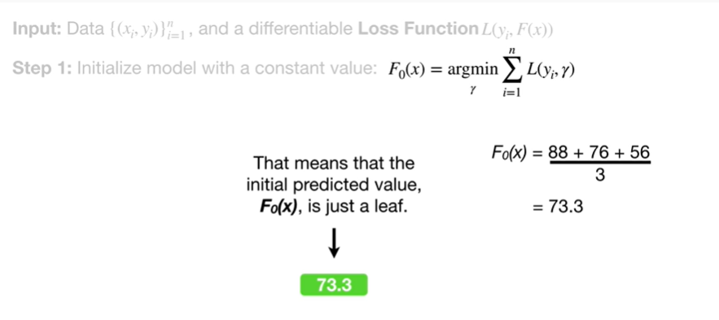

That means that the initial predicted value F sub 0 of X is just a leaf.

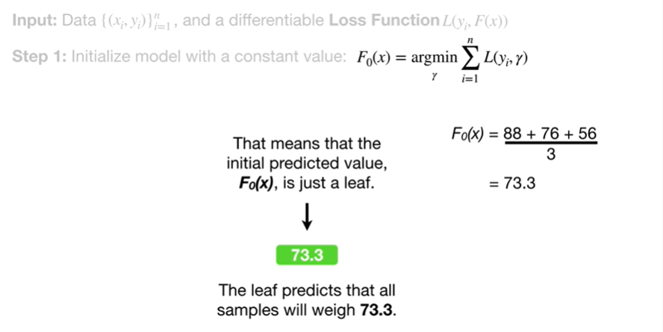

The leaf predicts that all samples will weigh 73.3.

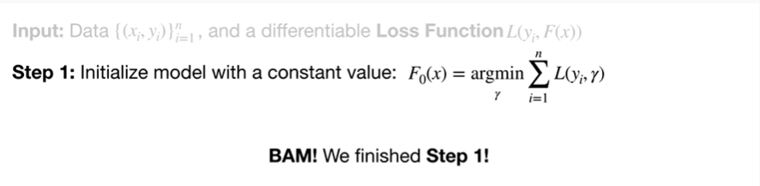

BAM !!!

We finished step 1.

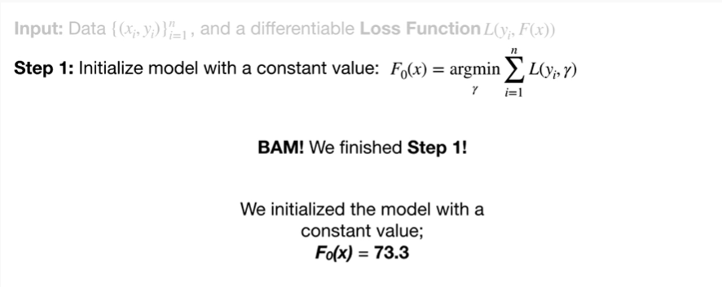

We initialize the model with a constant value F sub 0 of x equals 73.3.

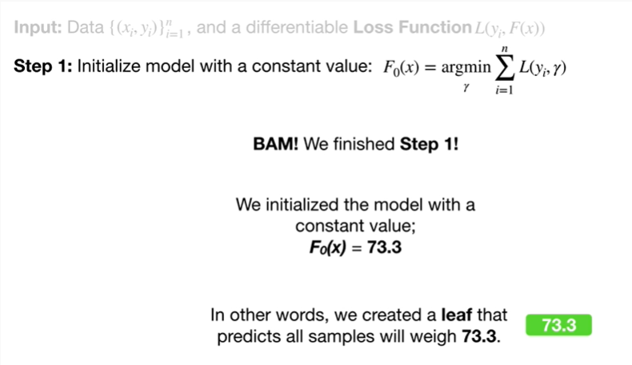

In other words, we created a leaf that predicts all samples will weigh 73.3.

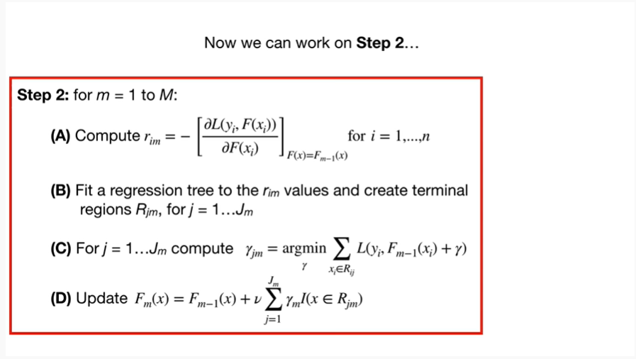

Now we can work on step 2.

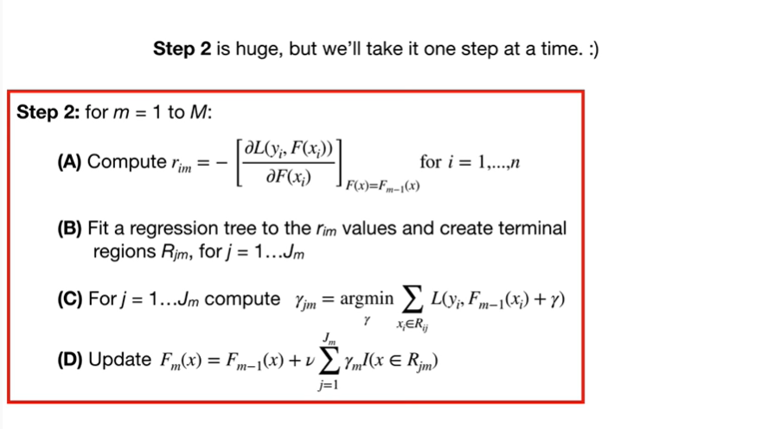

Step 2 is huge, but we'll take it one step at a time.

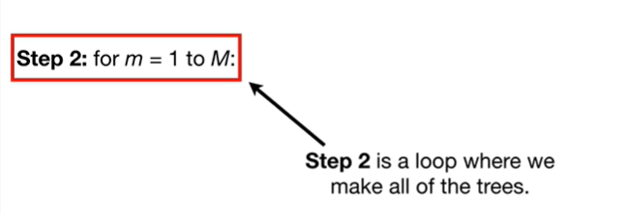

Step 2 is a loop where we make all of the trees.

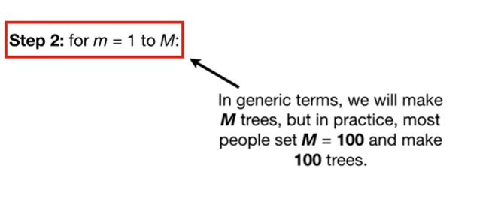

In generic terms, we will make em trees, but in practice, most people set them to be 100 and make 100 trees.

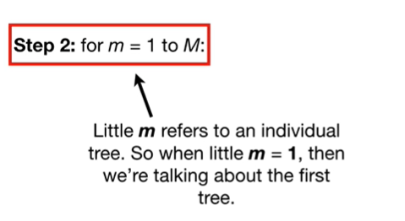

Little m refers to an individual tree.

So when little m equals 1, then we're talking about the first tree.

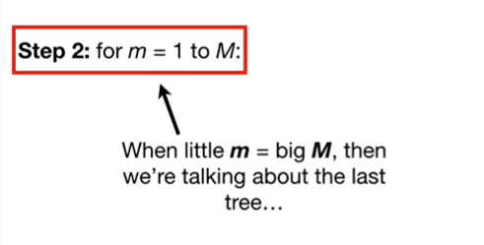

When little m equals Big M, then we're talking about the last tree.

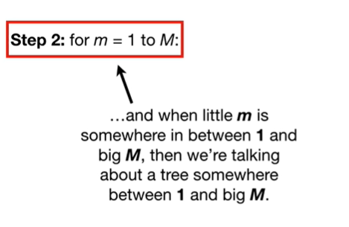

And when little m is somewhere between 1 and Big M ; then we're talking about a tree somewhere between 1 and Big M.

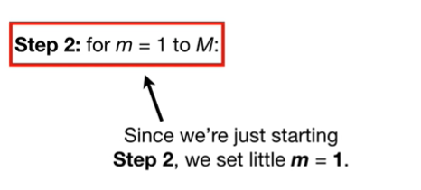

Since we are just starting step 2, we will set little m equal to 1.

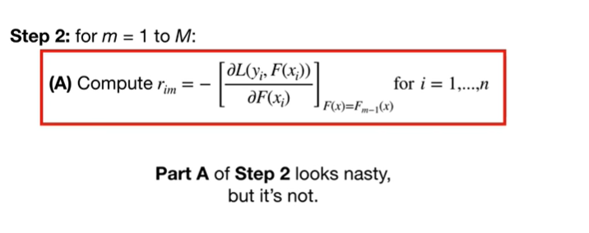

Part A of Step two looks nasty, but it's not.

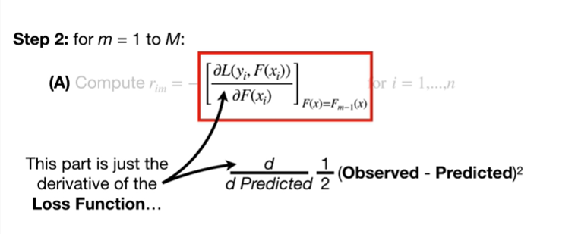

This part is just the derivative of the loss function

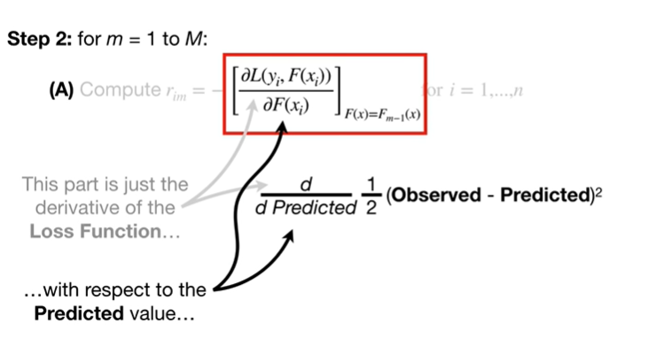

with respect to the predicted value

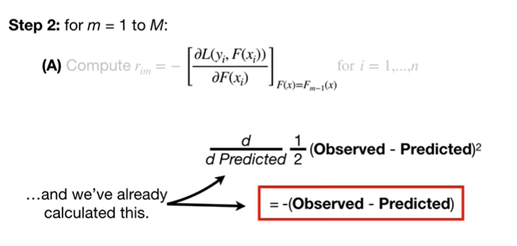

and we've already calculated this.

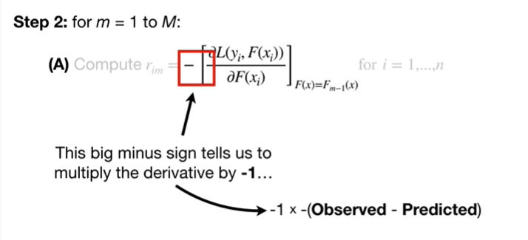

This big minus sign tells us to multiply the derivative by negative one

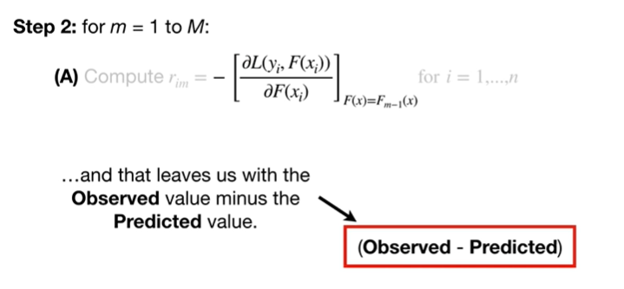

and that leaves us with the observed value minus the predicted value.

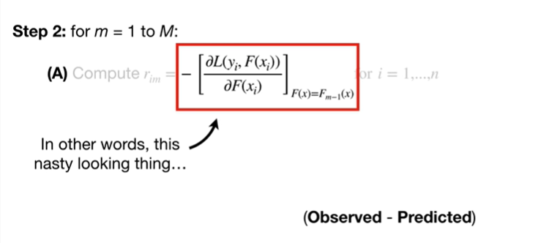

In other words, this nasty looking thing

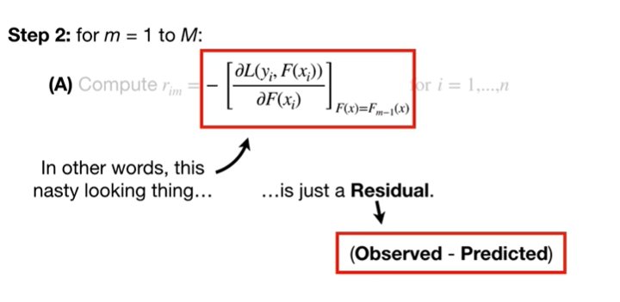

is just a residual.

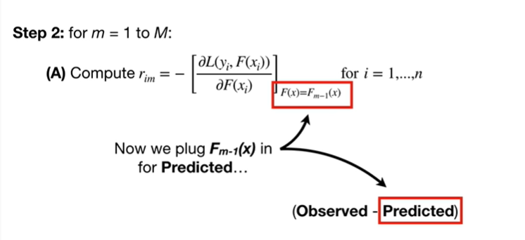

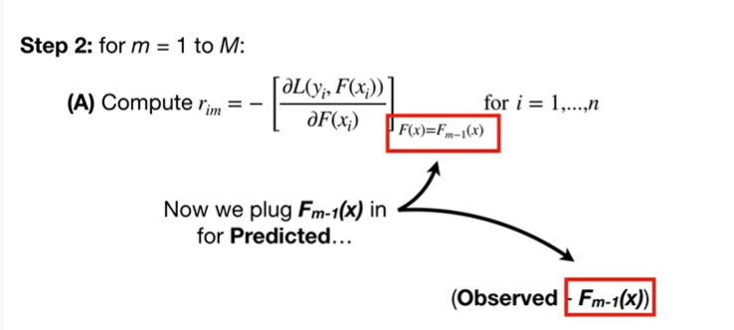

Now we plug F sub (m minus 1) of X in for predicted

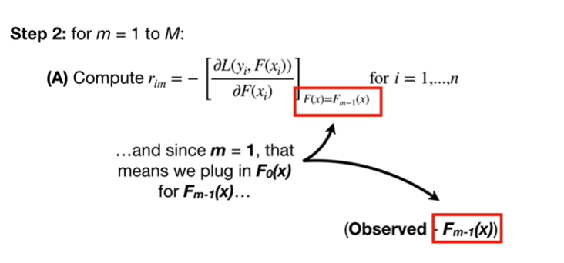

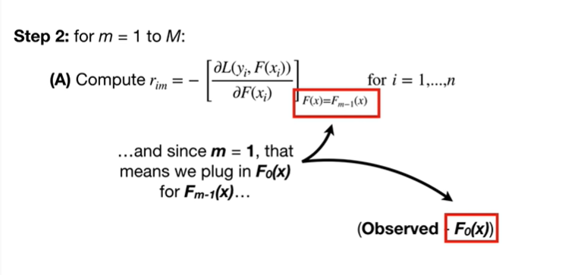

and since m equals 1, that means we plug in F sub 0 of X for f sub (m minus 1) of X

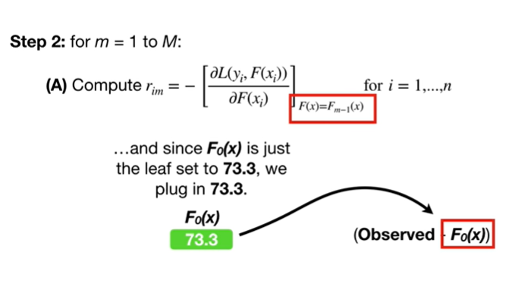

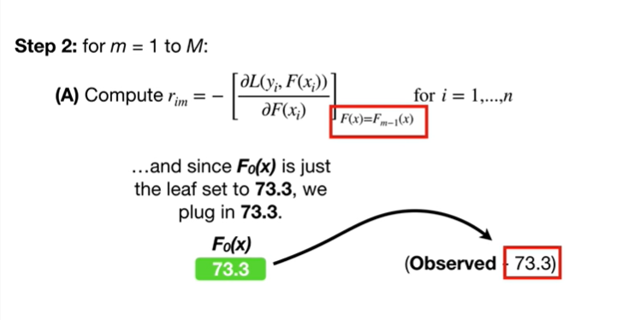

and since F sub 0 of X is just the leaf set to 73.3, we plug in 73.3.

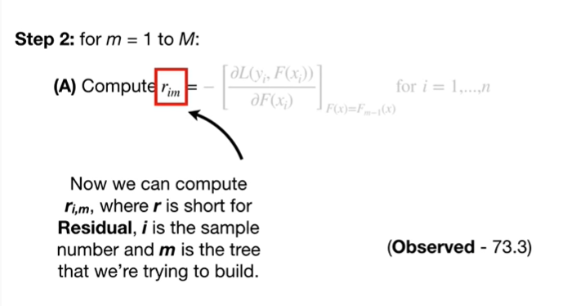

Now we can compute r sub i comma m, where r is short for residual, i is the sample number and m is the tree that we're trying to build.

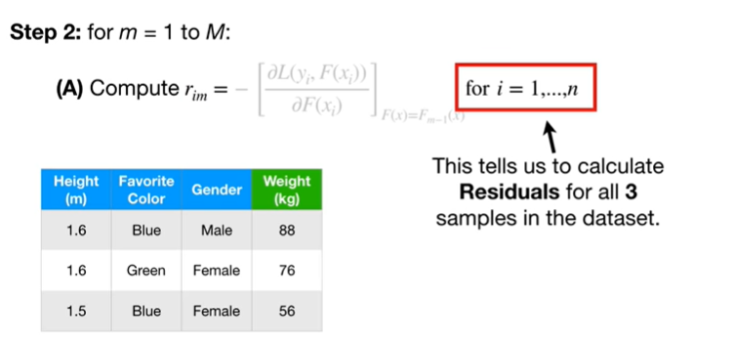

This tells us to calculate residuals for all three samples in the data set.

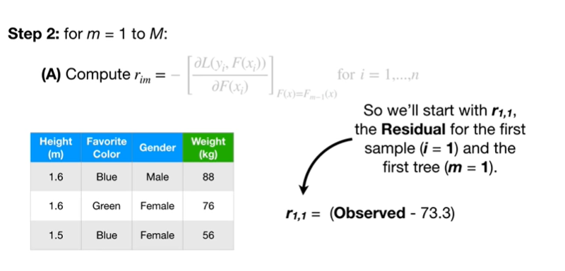

So we'll start with r sub 1 comma 1, the residual for the first sample and the first tree.

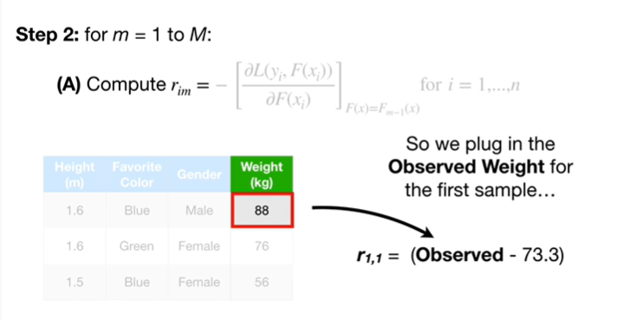

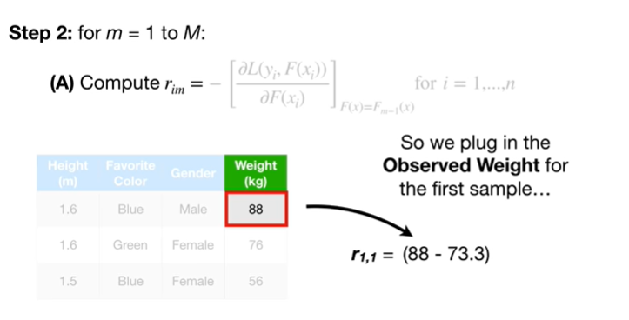

So we plug in the observed weight for the first sample

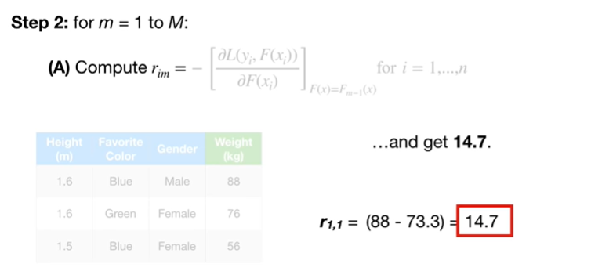

and get 14.7.

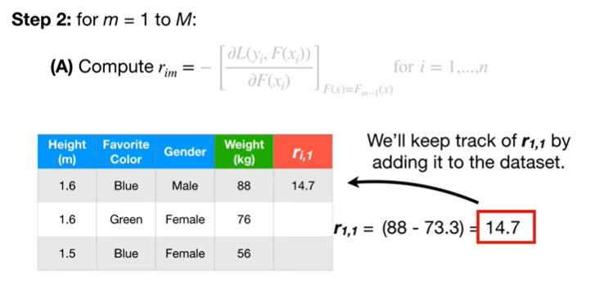

We'll keep track of r sub 1 comma 1, by adding it to the data set.

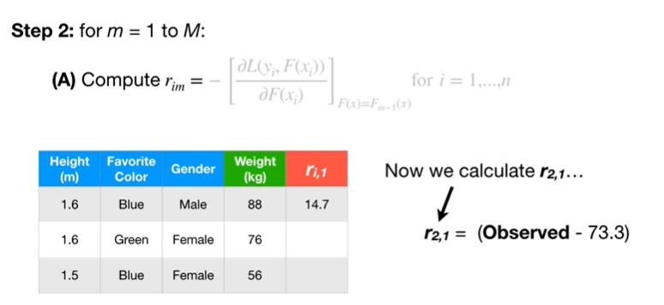

Now we calculate R sub 2 comma 1

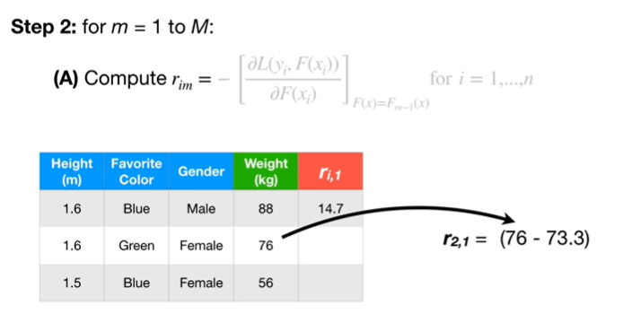

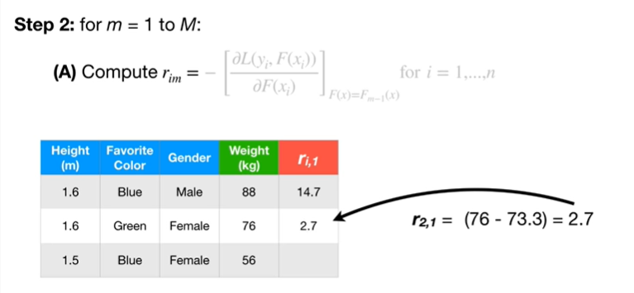

lip up up up but up up up up up up up but up up

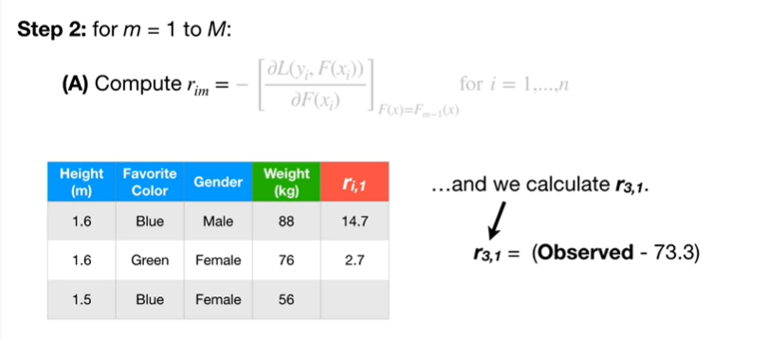

and we calculate R sub 3 comma 1

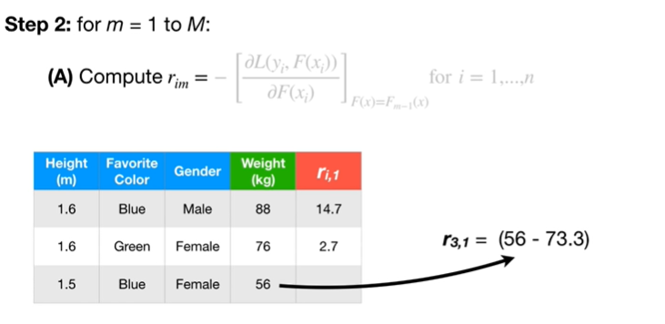

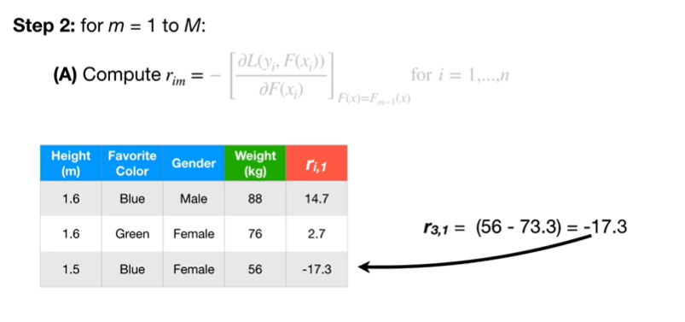

the pepopepa Allah buppa buppa buppa buppa buppa up up.

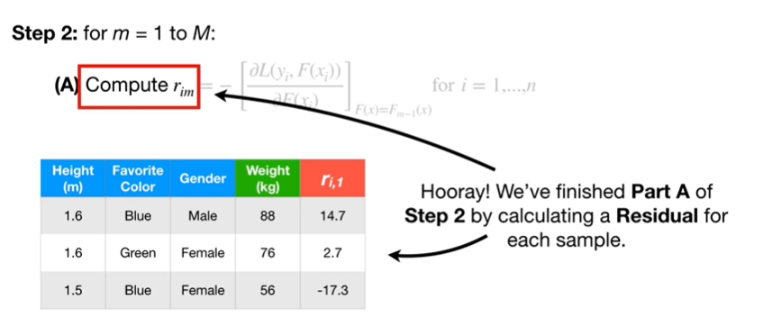

Hooray !

We finished Part A of step 2 by calculating a residual for each sample.

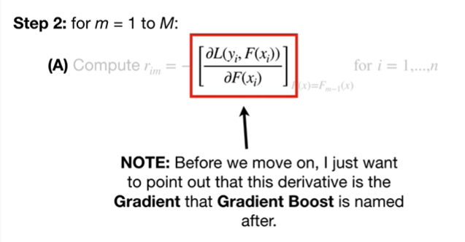

Note : before we move on I just want to point out that this derivative is the gradient that gradient boost is named after.

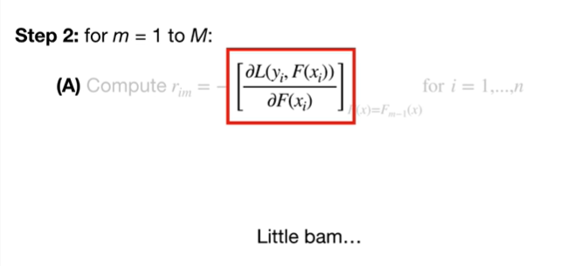

Little Bam…

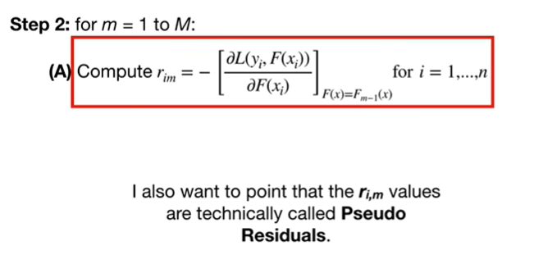

I also want to point out that the r sub I comma m values are technically called pseudo residuals.

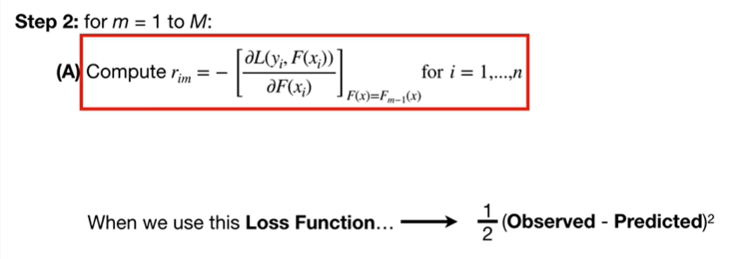

When we use this loss function

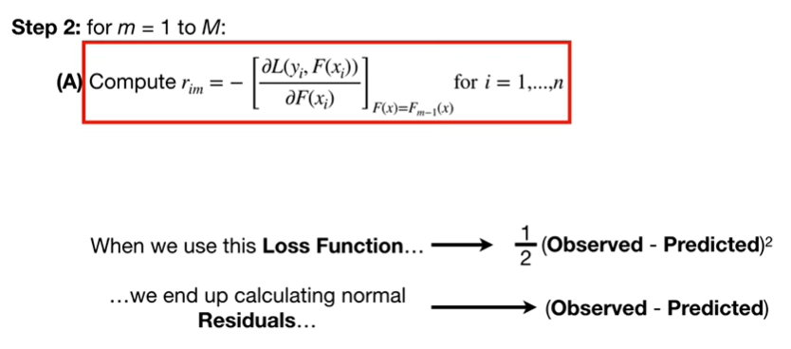

we end up calculating normal residuals.

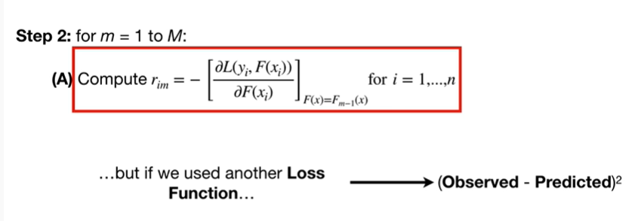

But if we used another loss function this time were not multiplying by 1/2

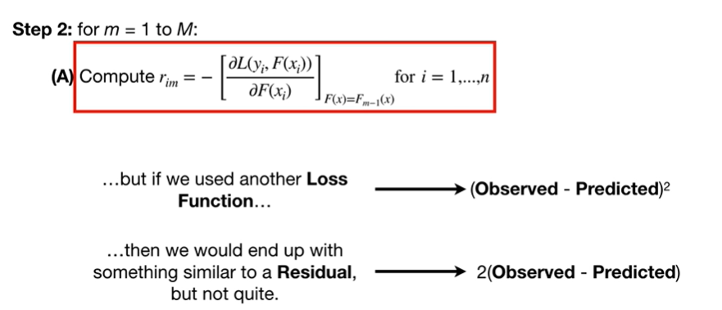

then we would end up with something similar to a residual but not quite.

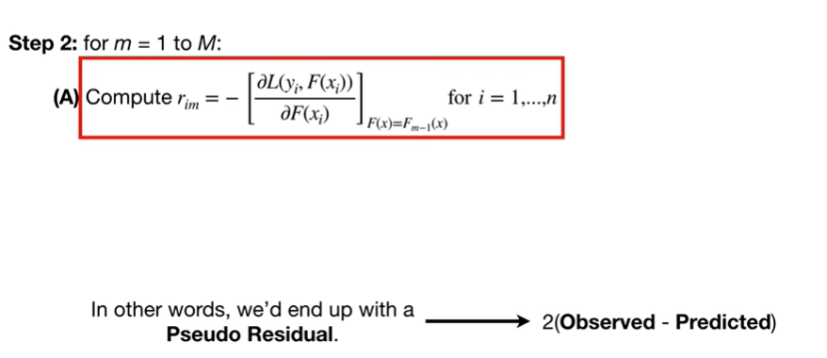

In other words we'd end up with a pseudo residual

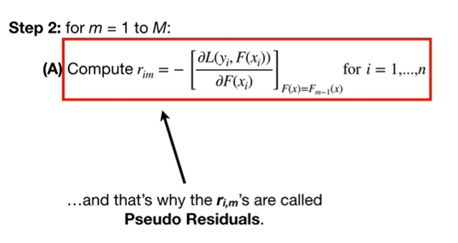

and that's why the r of i comma m's are called pseudo residuals.

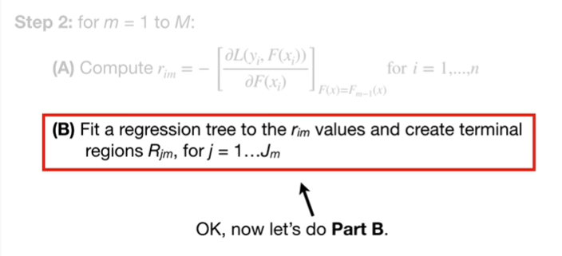

Okay, now let's do Part B.

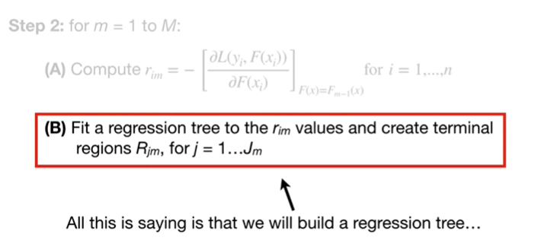

All this is saying is that we will build a regression tree

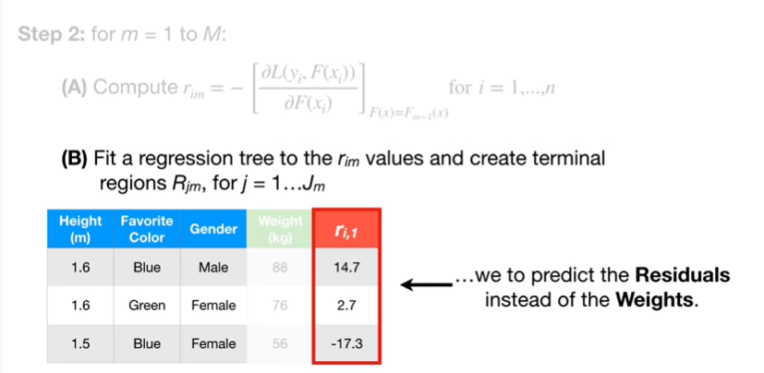

to predict the residuals instead of the weights.

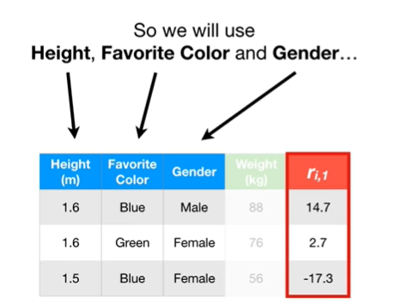

So we will use height favorite color and gender

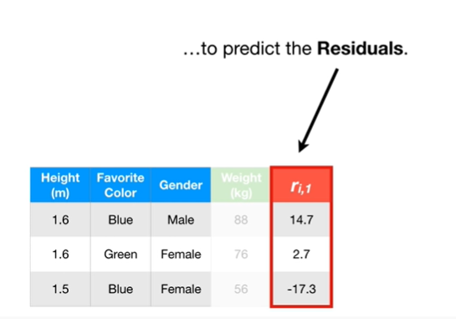

to predict the residuals.

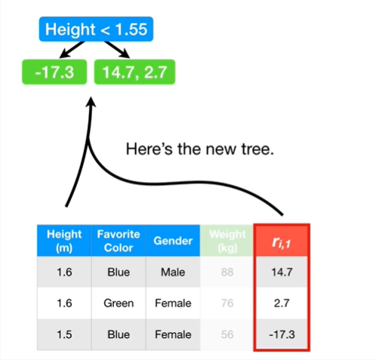

Here's the new tree.

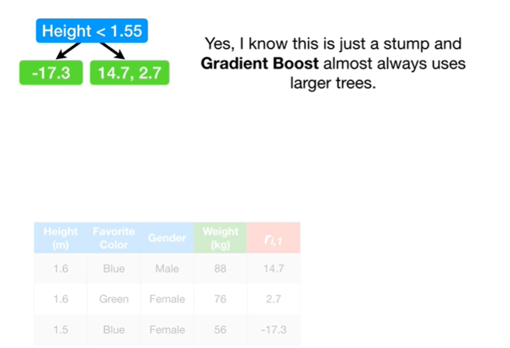

Yes, I know this is just a stump ingredient boost almost always uses larger trees.

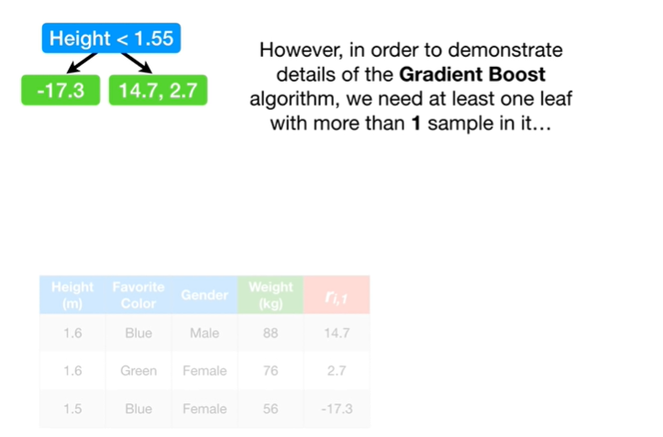

However, in order to demonstrate the details of the gradient boost algorithm, we need at least one leaf with more than one sample in it

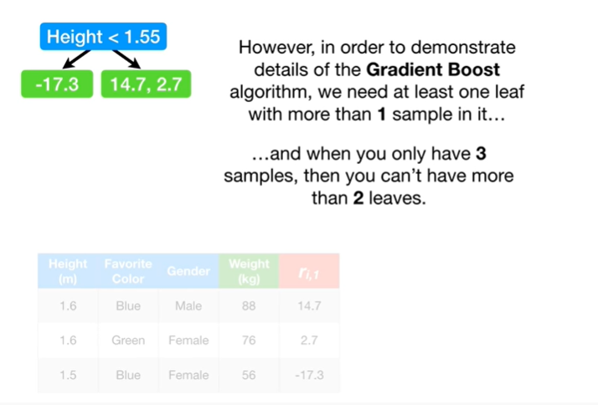

and when you only have three samples, then you can't have more than two leaves.

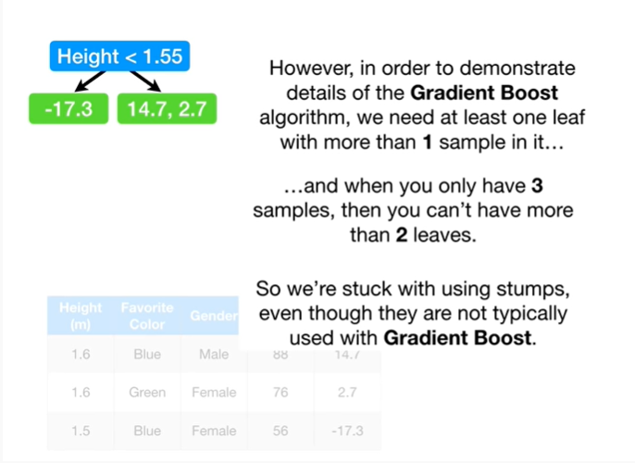

So we're stuck using stumps, even though they are not typically used with gradient boost.

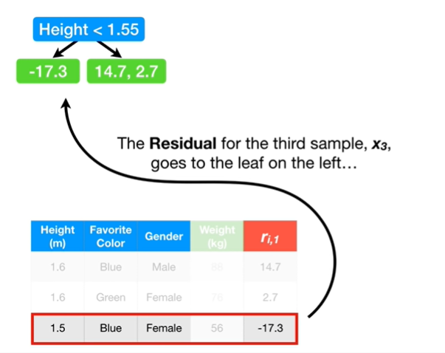

The residual for the third sample, x sub, 3 goes to the leaf on the left

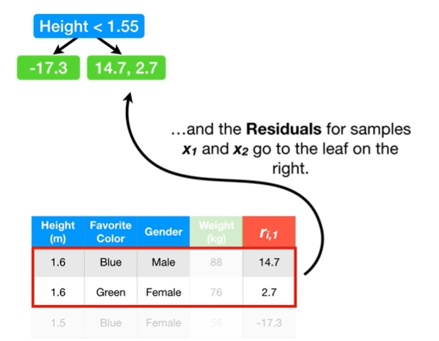

and the residual for samples x sub 1 and x sub 2 go to the leaf on the right.

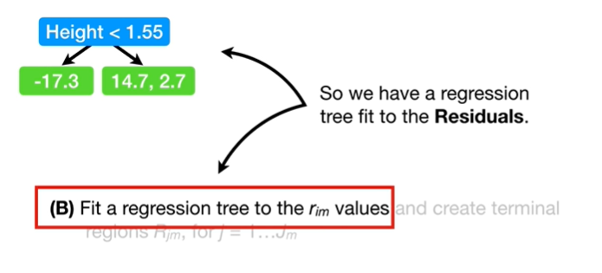

So we have a regression tree fit to the residuals.

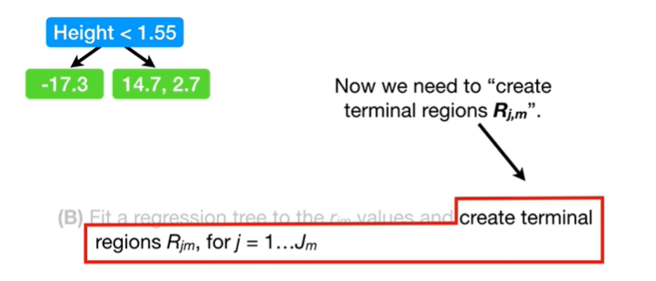

Now we need to create terminal regions r sub j comma m.

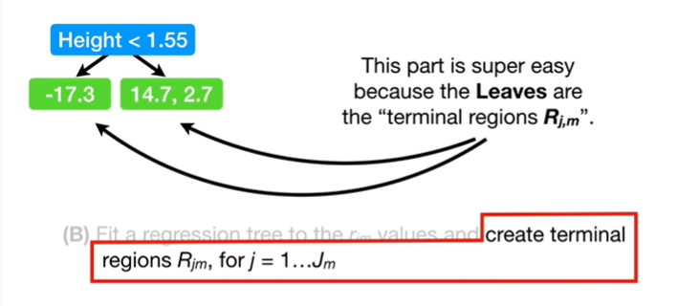

This part is super easy because the leaves are the terminal regions r sub j comma m.

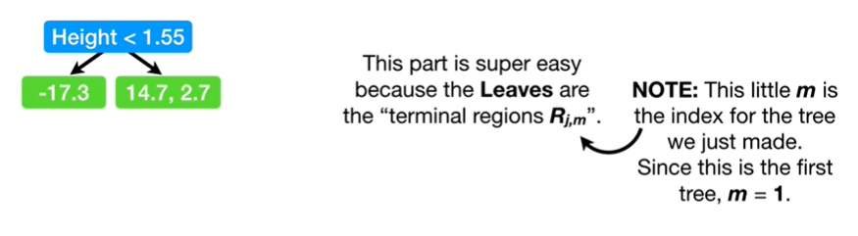

Note : this little m is the index for the tree we just made.

Since this is the first tree, m equals 1.

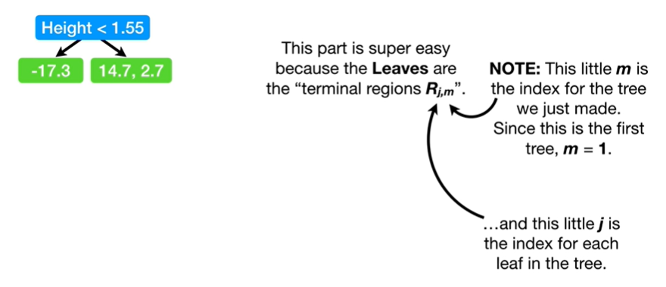

And this little J is the index for each leaf in the tree.

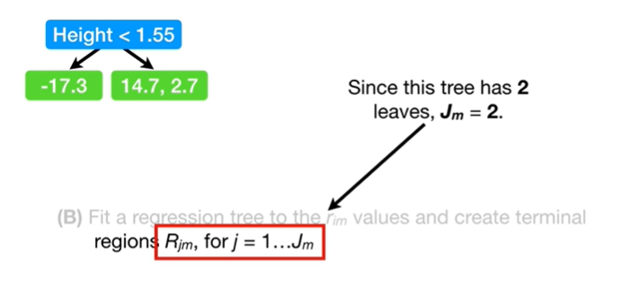

Since this tree has two leaves, j sub equals 2.

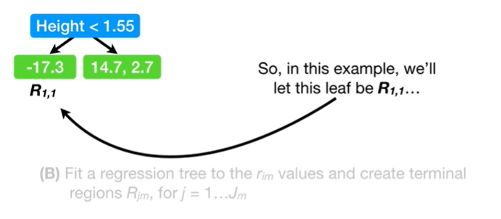

So, in this example, we'll let this leaf be R sub 1 comma 1

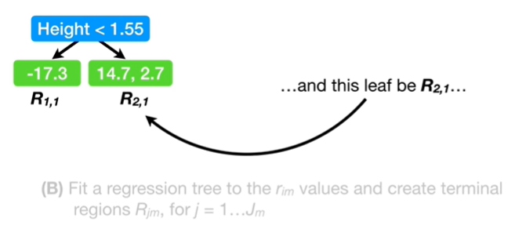

and this leaf be R sub 2 comma 1.

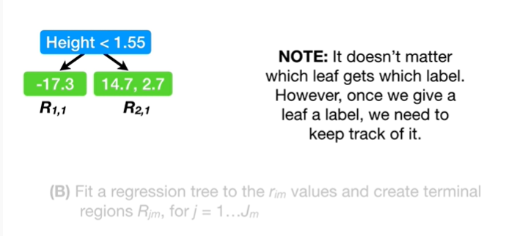

Note : it doesn't matter which leaf gets which label.

However, once we give a leaf a label, we need to keep track of it.

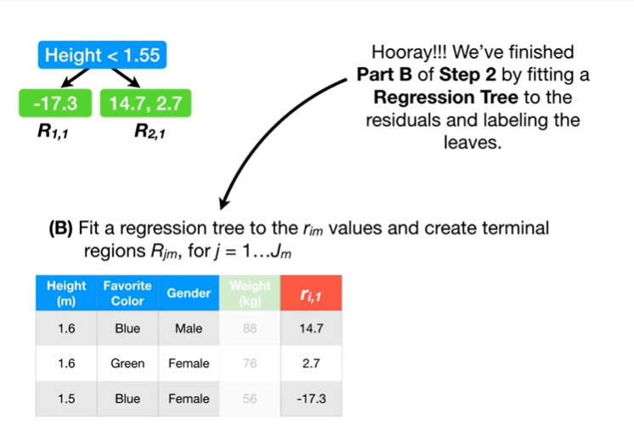

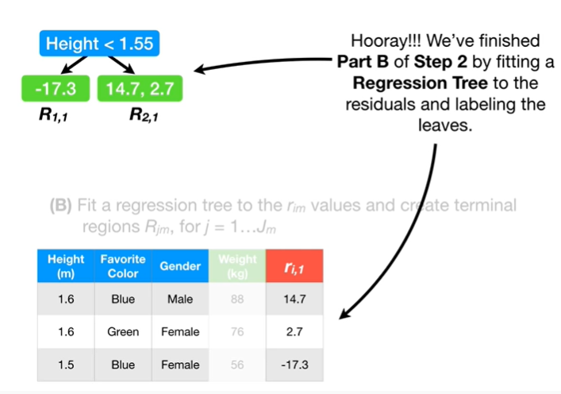

Hooray !

We finished Part B of step 2 by fitting a regression tree to the residuals and labeling the leaves.

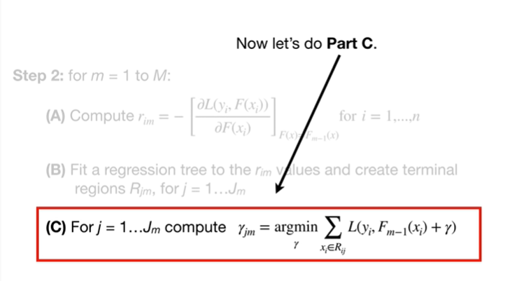

Now let's do Part C.

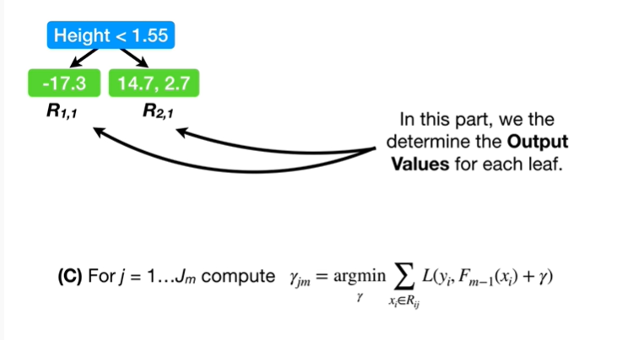

In this part we determine the output values for each leaf.

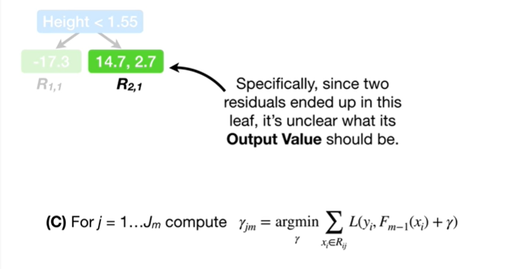

Specifically, since two residuals ended up in this leaf, it's unclear what its output value should be.

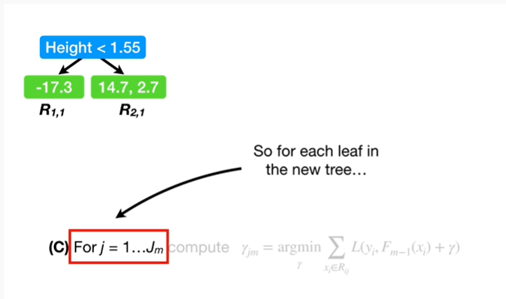

So for each leaf in the nex tree

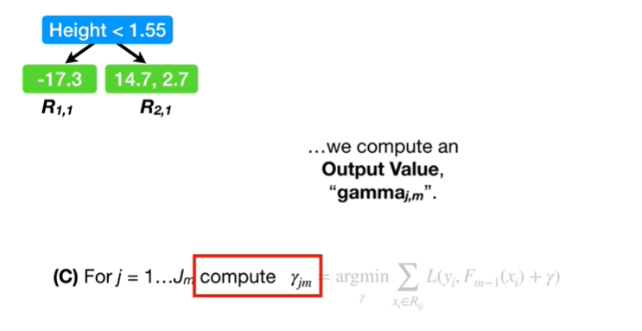

we compute an output value, gamma sub j comma m.

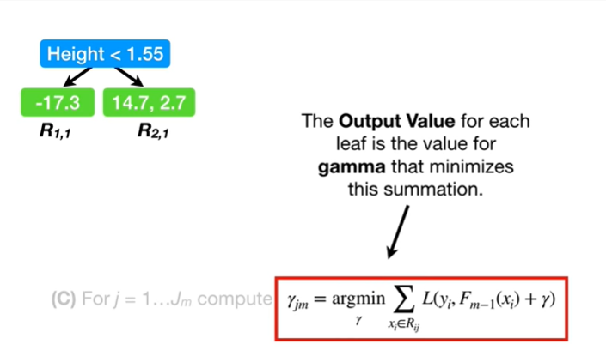

The output value for each leaf is the value for gamma that minimizes this summation.

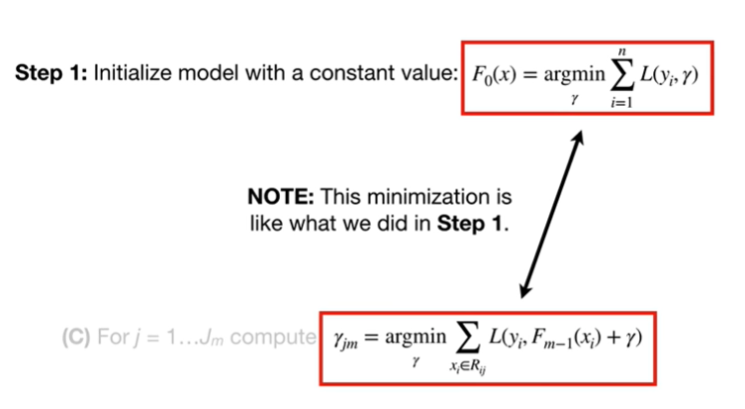

Note : this minimization is like what we did in step 1.

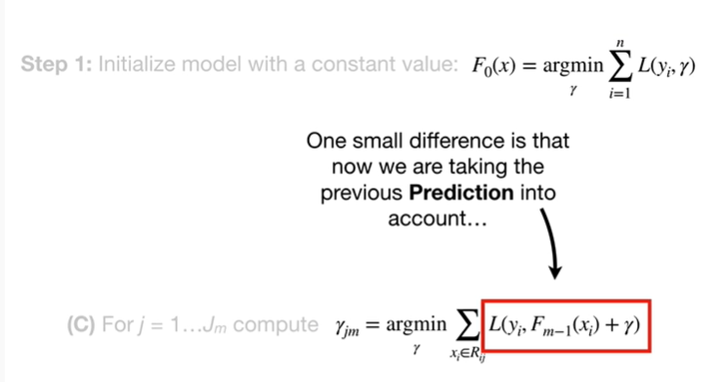

One small difference is that now we are taking the previous prediction into account

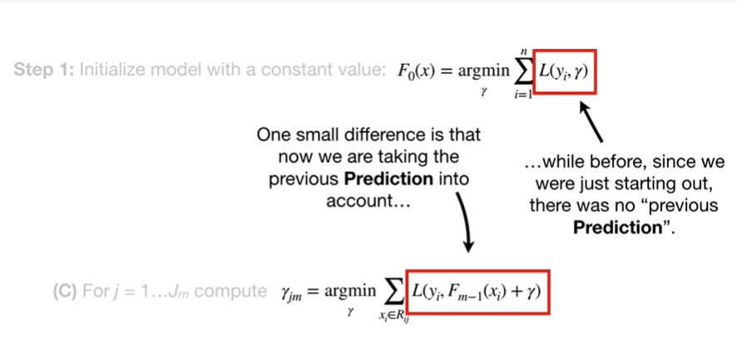

while before since we are just starting out there was no previous prediction.

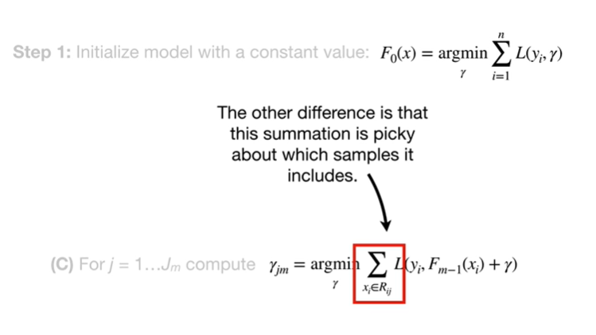

The other difference is that this summation is picky about which samples it includes.

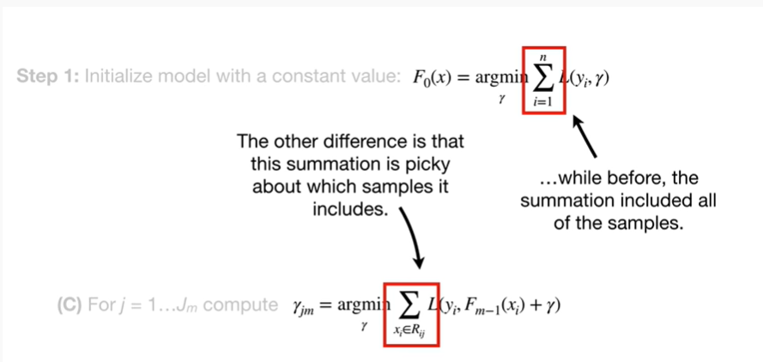

While before the summation included all of the samples.

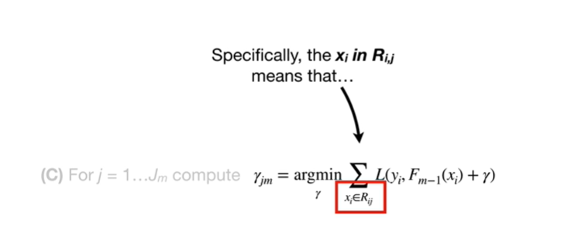

Specifically the x sub i in R sub i comma j means that

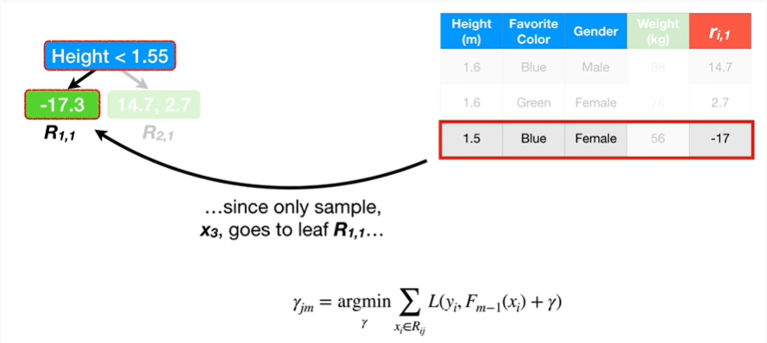

since only one sample x sub 3, goes to leaf R sub 1 comma 1

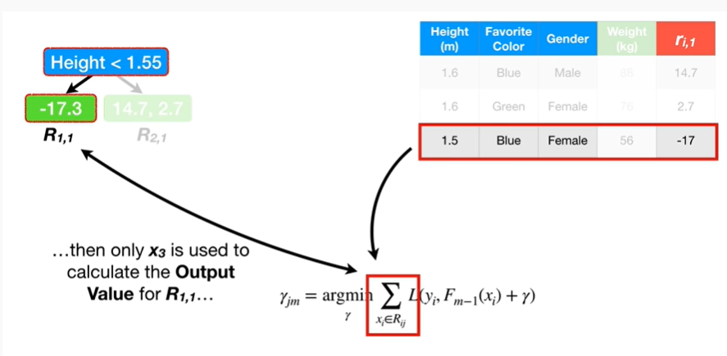

then only x sub 3 is used to calculate the output value for R sub 1 comma 1

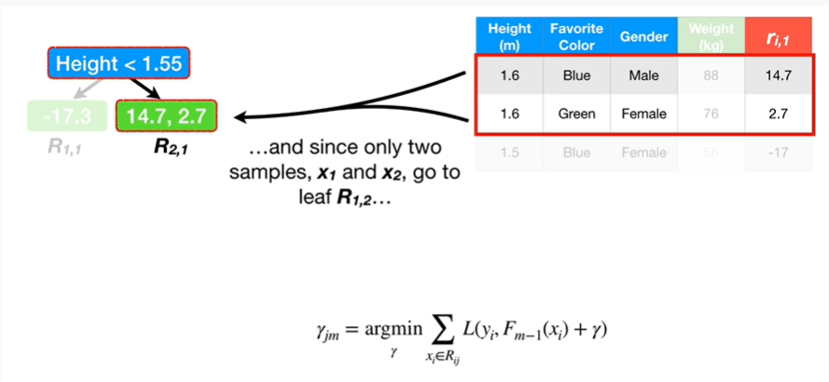

and since only two samples x sub 1 and x sub 2 go to leaf R sub 1 comma 2

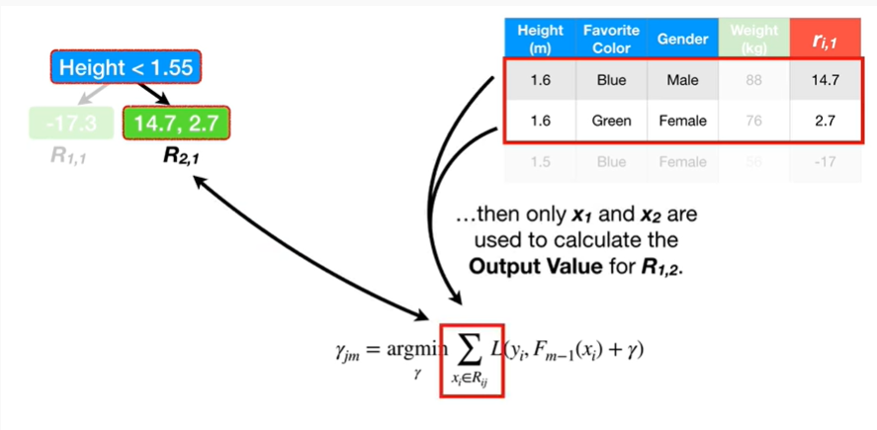

then only X sub 1 and X sub 2 are used to calculate the output value for R sub 1 comma 2.

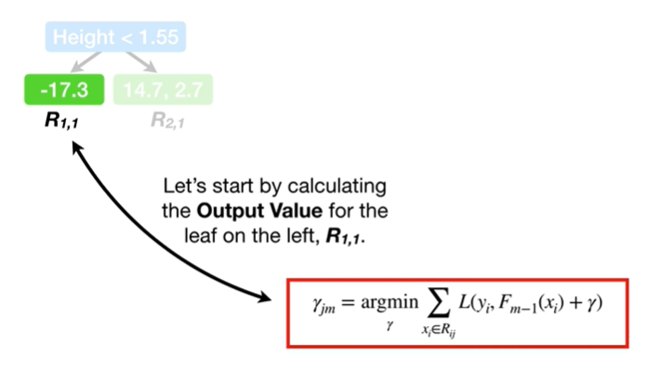

Let's start by calculating the output value for the leaf on the Left, R sub 1 comma 1.

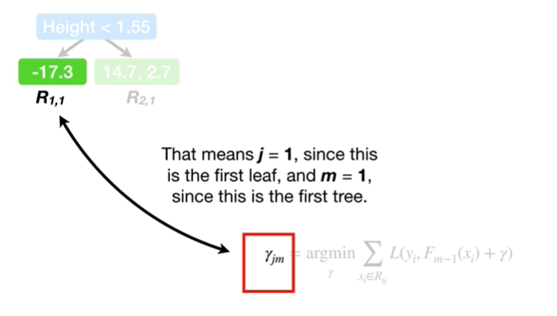

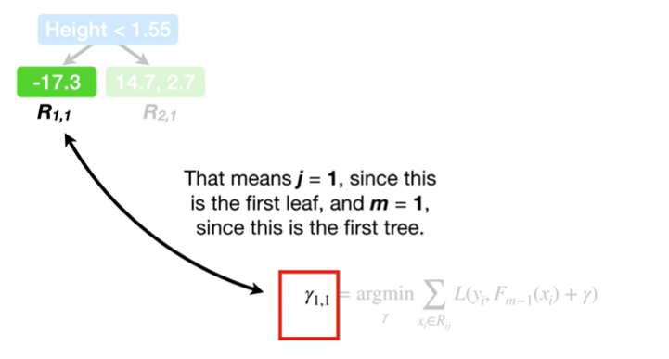

That means j equals 1 since this is the first leaf, and m equals 1 since this is the first tree.

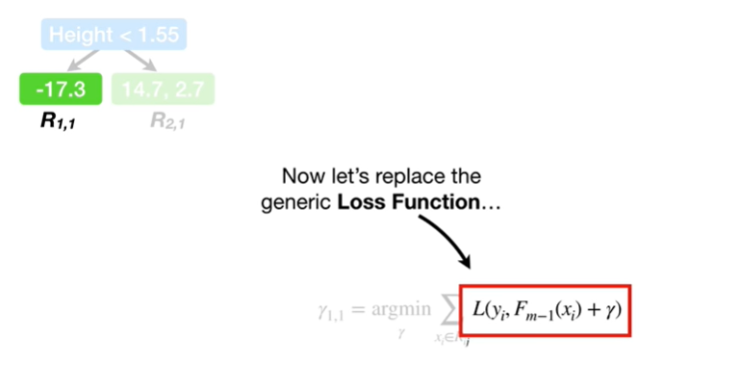

Now let's replace the generic loss function

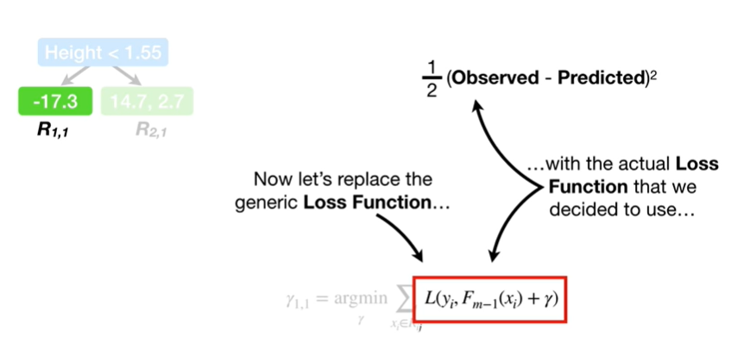

with the actual loss function that we decided to use

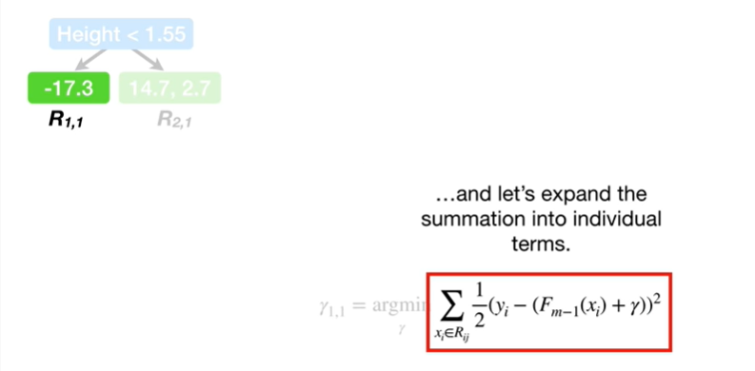

and let's expand the summation into individual terms.

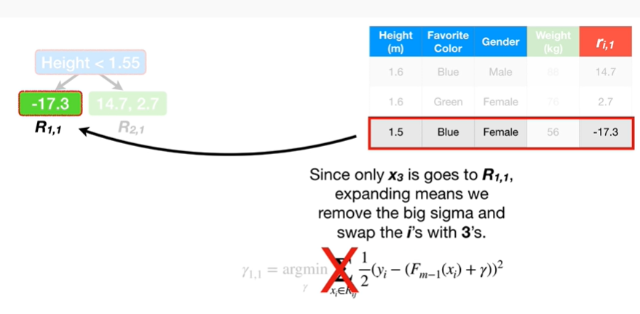

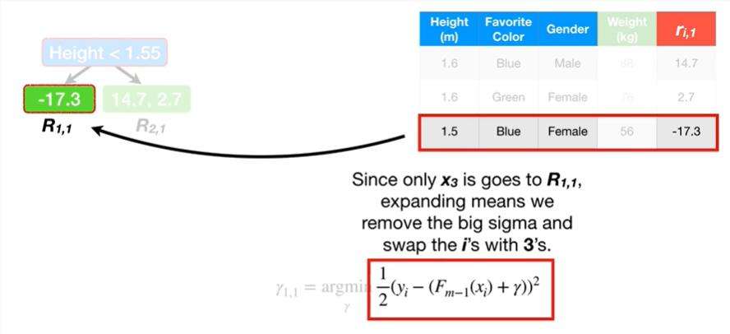

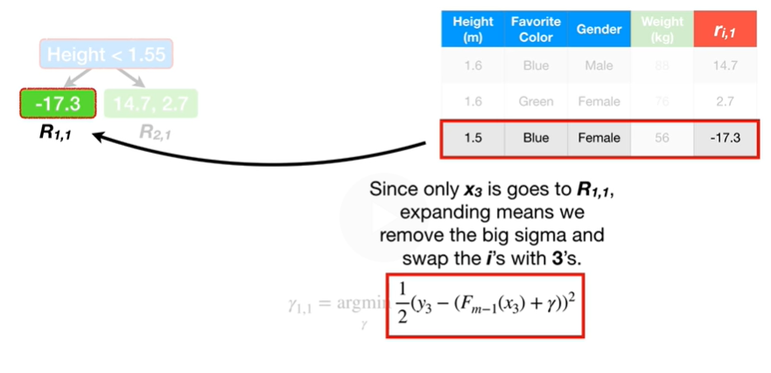

Since only x sub 3 goes to R sub 1 comma 1, expanding means we remove the big Sigma and swap the i’s with 3’s.

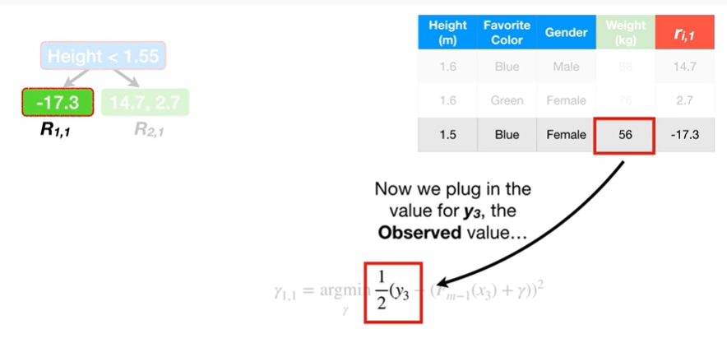

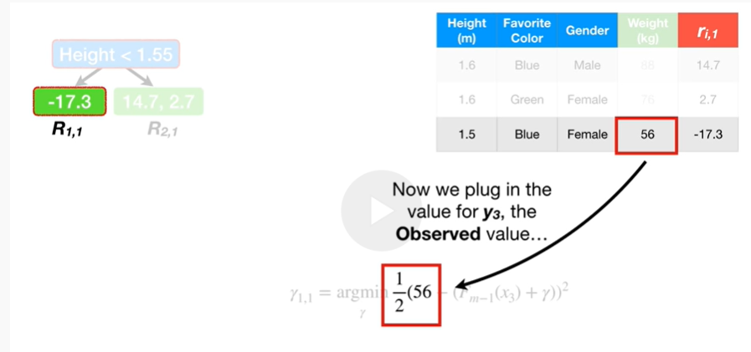

Now we plug in the value for y sub 3 the observed value

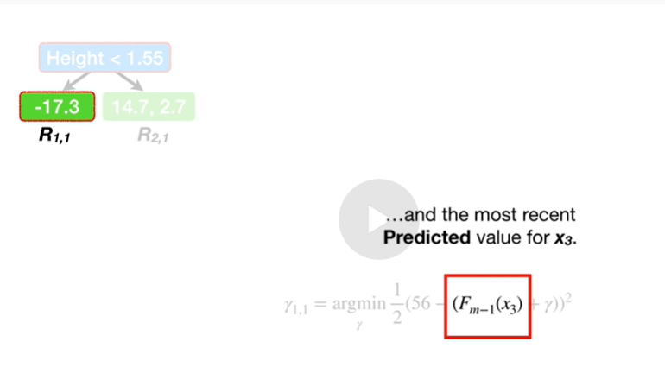

and the most recent predicted value for x sub 3.

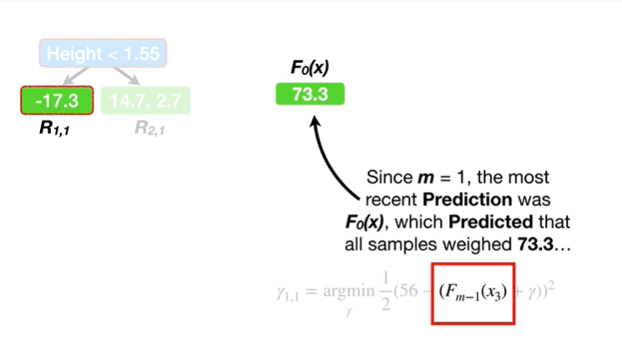

Since m equals 1, the most recent prediction was F sub 0 of x, which predicted that all samples weighed 73.3

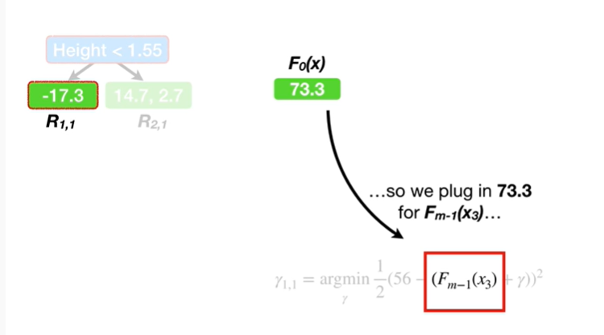

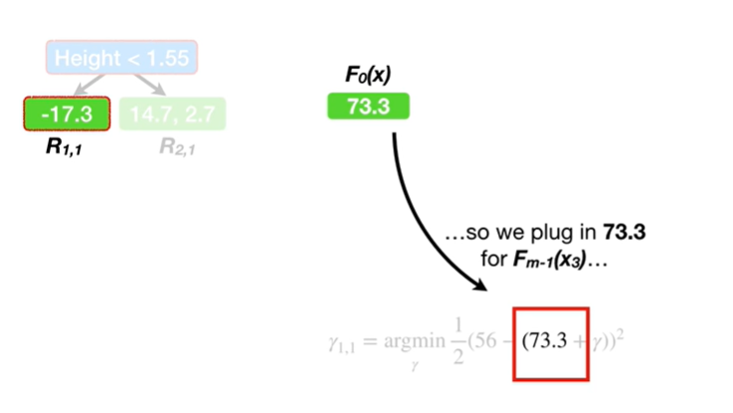

so we plug in 73.3 for F sub m minus 1 of x sub 3

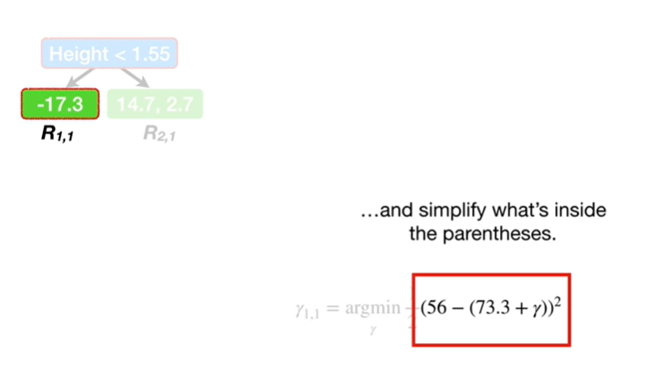

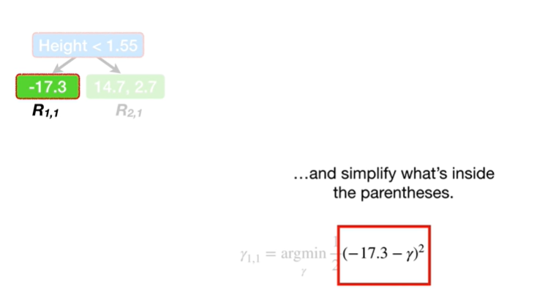

and simplify what's inside the parentheses.

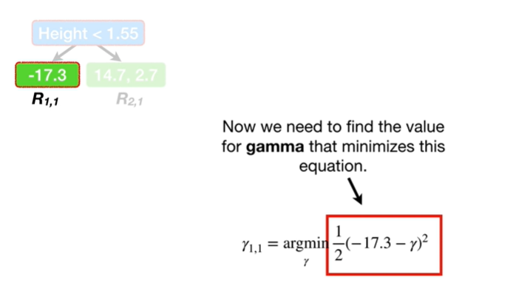

Now we need to find the value for gamma that minimizes this equation.

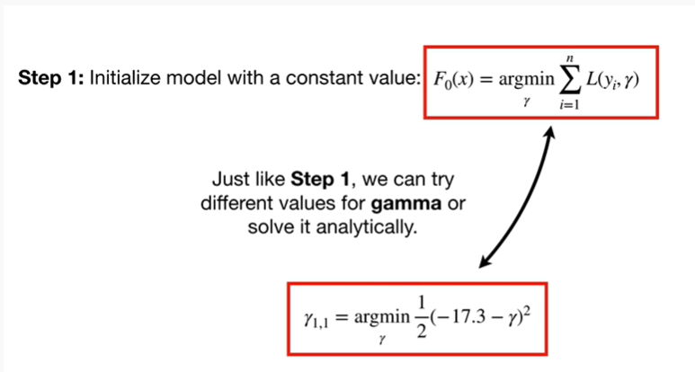

Just like step one, we can try different values for gamma or solve it analytically.

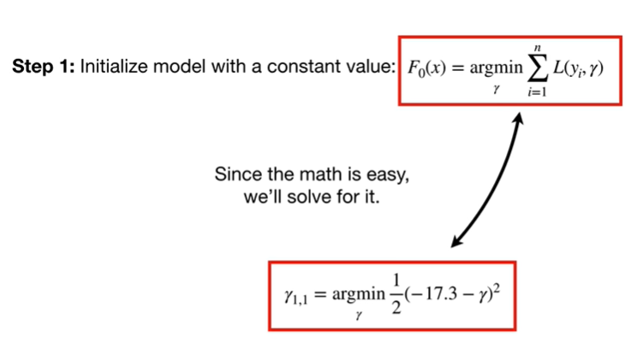

Since the math is easy we'll solve for it.

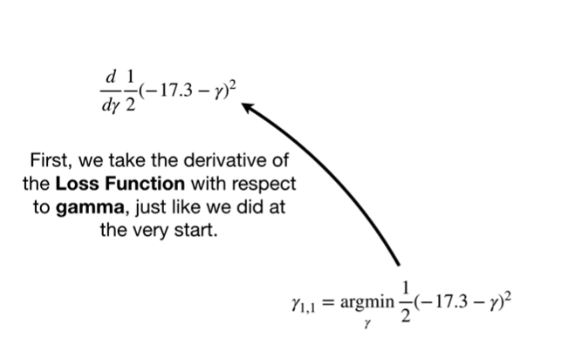

First we take the derivative of the loss function with respect to gamma just like we did at the very start.

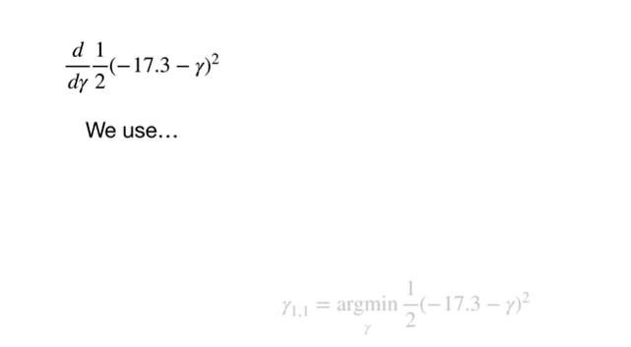

we use



the chain rule

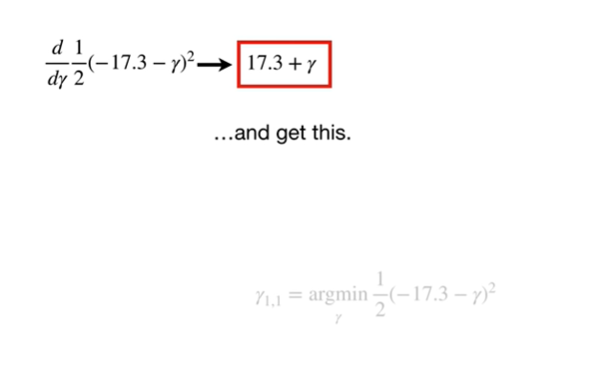

and get this.

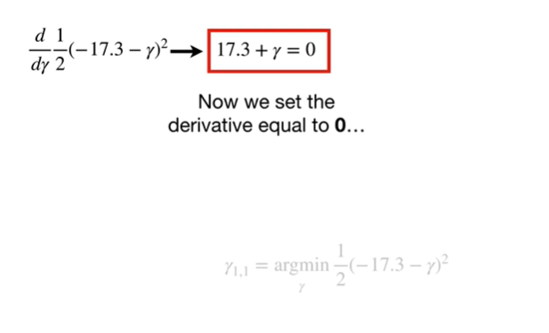

Now we set the derivative equal to zero

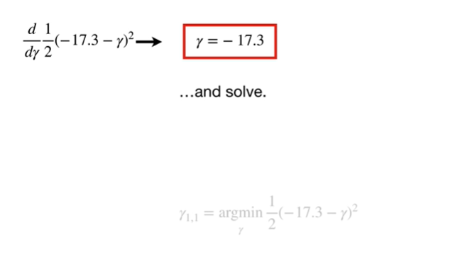

and solve.

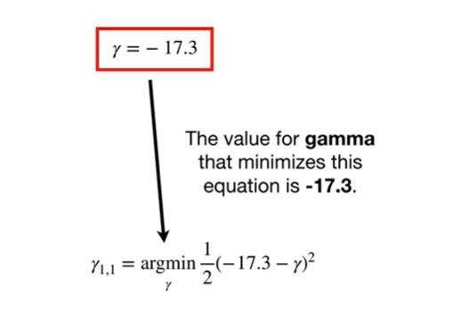

The value for gamma that minimizes this equation is negative 17.3.

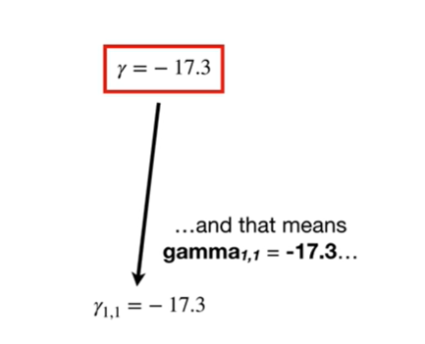

And that means gamma sub 1 comma 1 equals negative 17 point 3

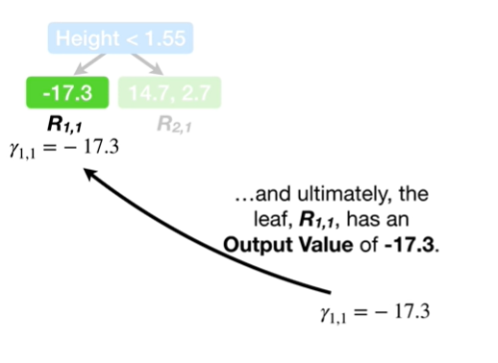

and ultimately the leaf R sub 1 comma 1, has an output value of negative seventeen point three.

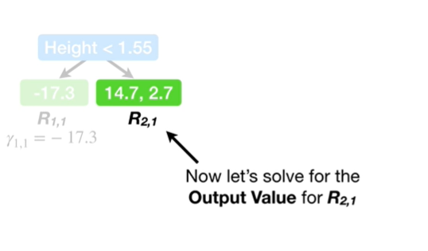

Now let's solve for the output value for R sub 2 comma 1.

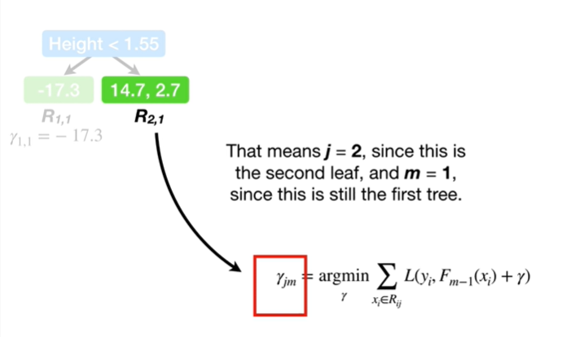

That means j equals 2, since this is the second leaf, and m equals 1, since this is still the first tree.

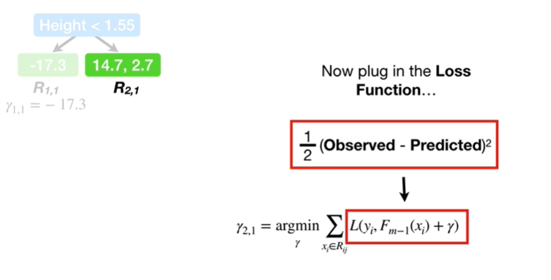

Now plug in the loss function

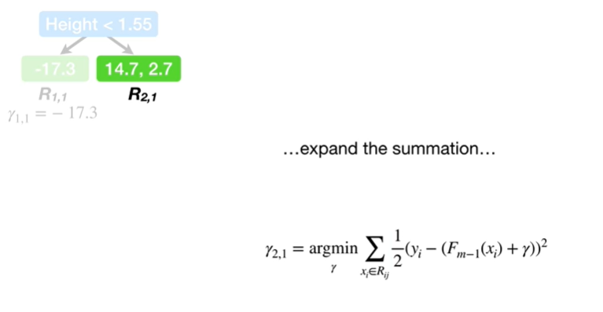

expand the summation

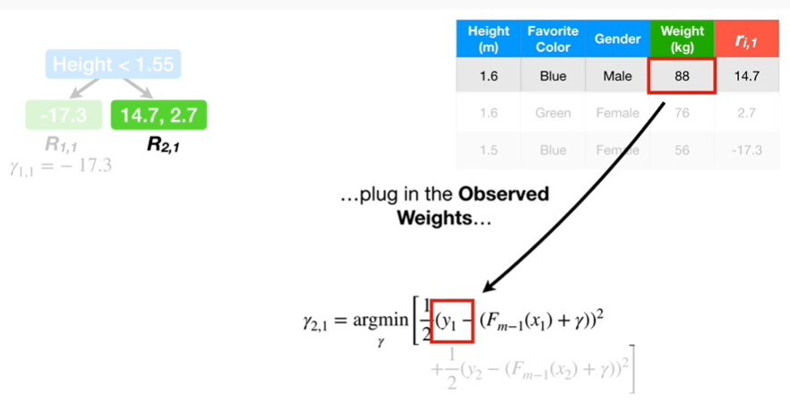

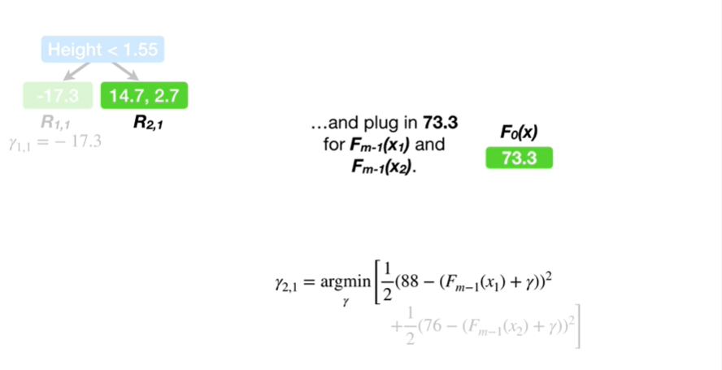

and plug in the observed weights

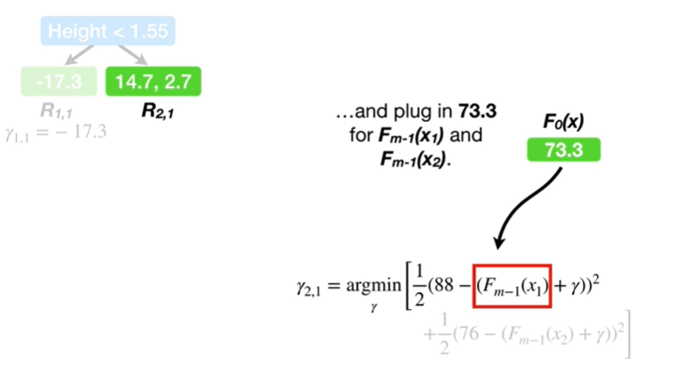

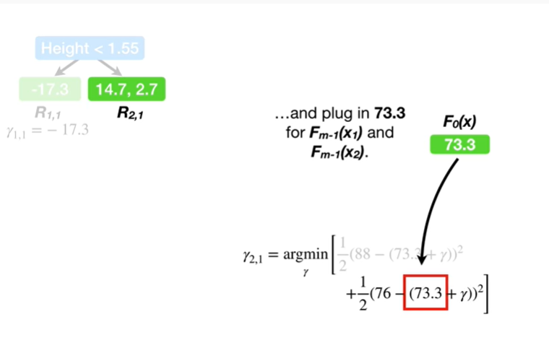

and plug in 73.3 for F sub m minus 1 of x sub 1 and F sub m minus 1 of x sub 2.

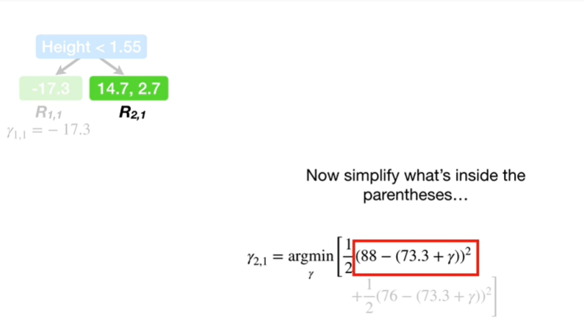

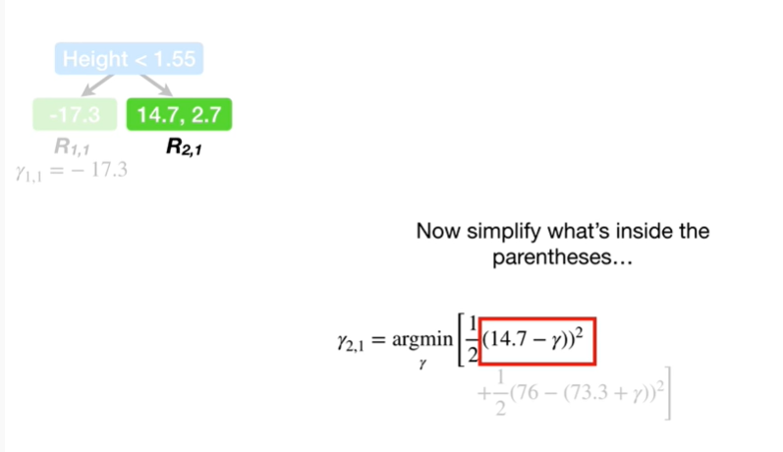

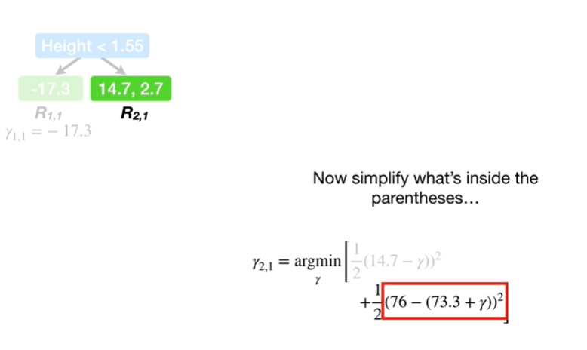

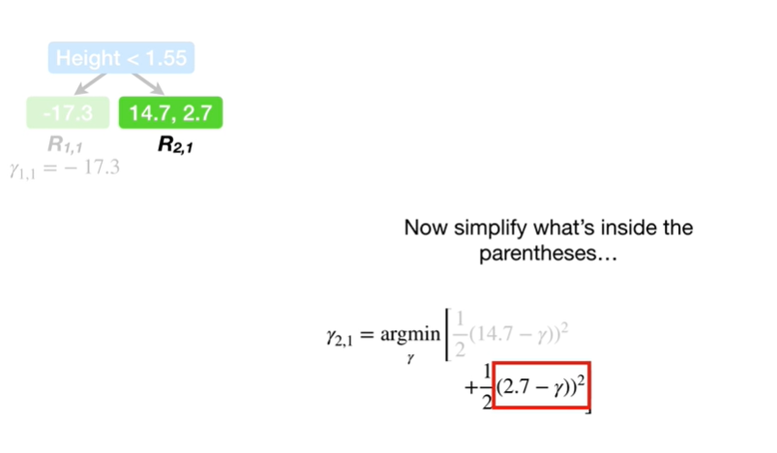

Now simplify what's inside the parentheses

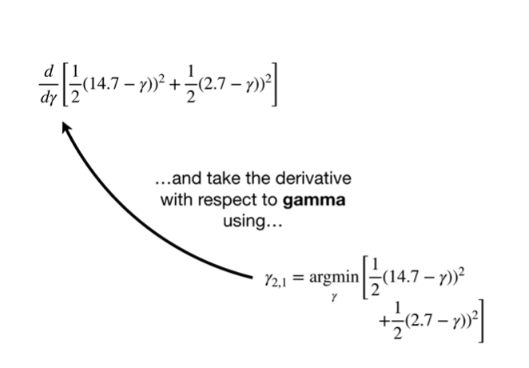

and take the derivative with respect to gamma using



the chain rule

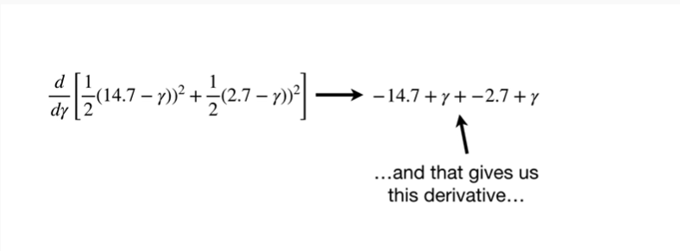

and that gives us this derivative

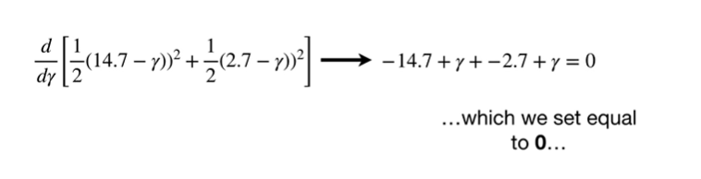

which we set equal to zero

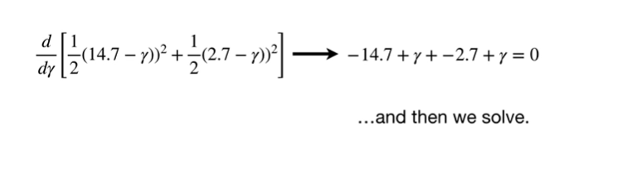

and then we solve.

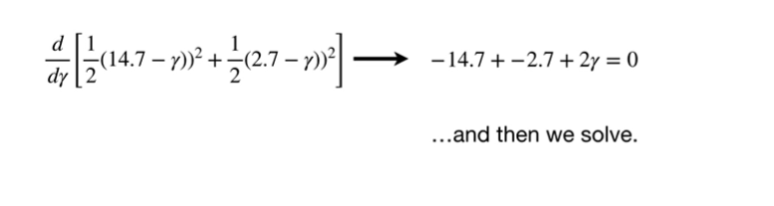

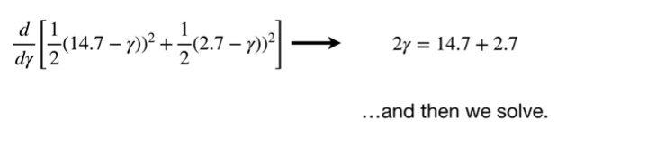

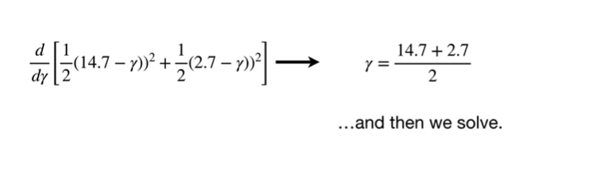

beep boop-boop boop-boop

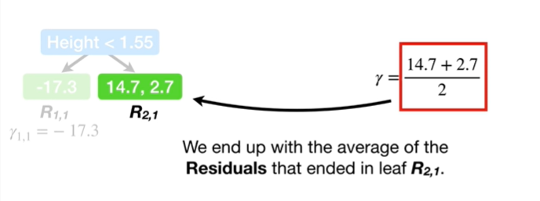

We end up with the average of the residuals that ended up in leaf R sub 2 comma 1.

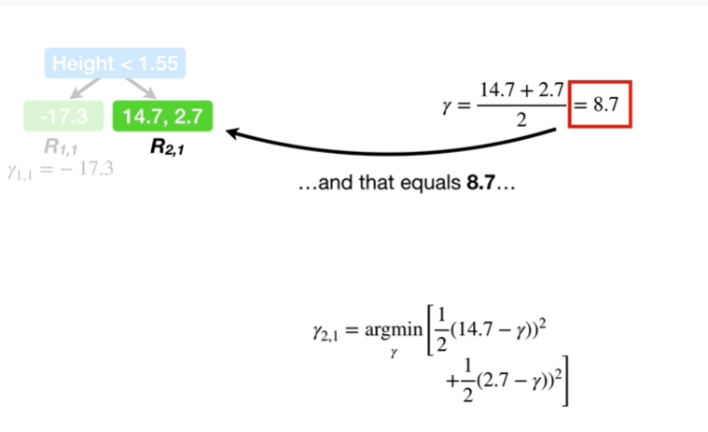

And that equals 8 point 7.

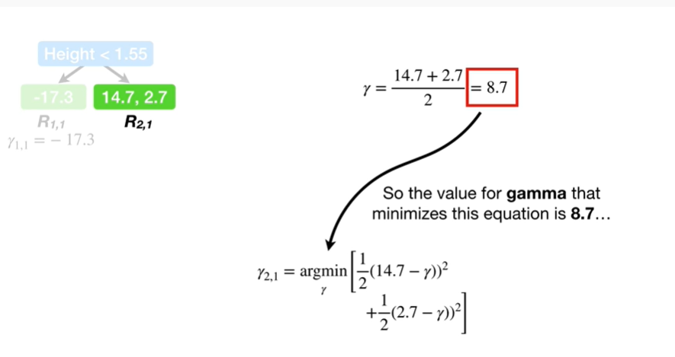

So the value for gamma that minimizes this equation is 8 point 7

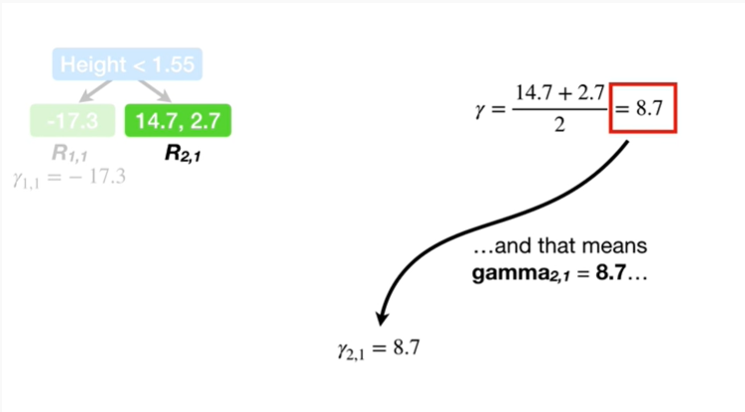

and that means gamma sub 2 comma 1 equals 8 point 7

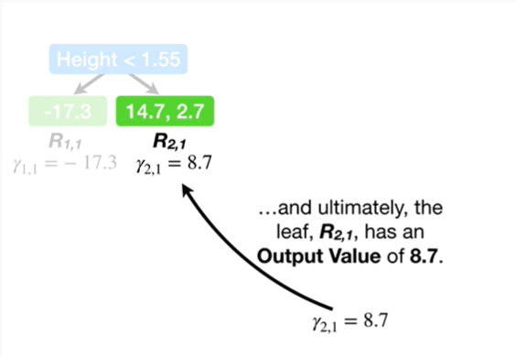

and ultimately the leaf R sub 2 comma 1 has an output value of 8 point 7.

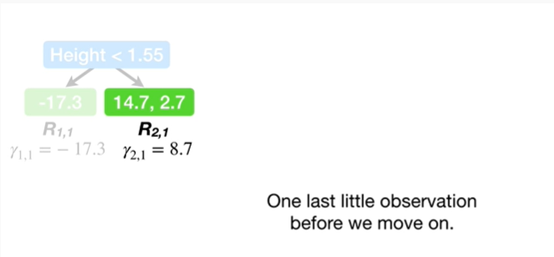

One last little observation before we move on.

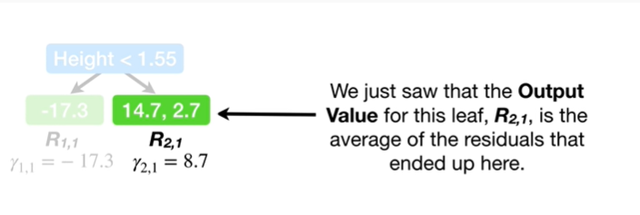

We just saw that the output value for this leaf, R sub 2 comma 1, is the average of the residuals that ended up here.

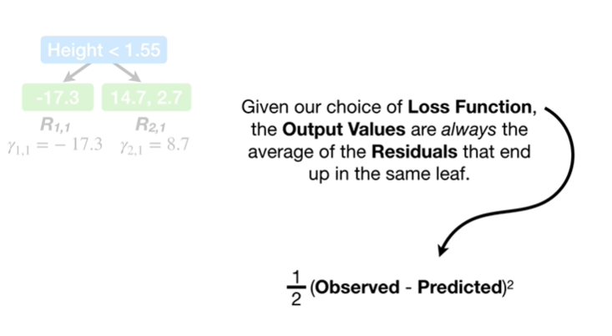

Given our choice of loss function the output values are always the average of the residuals that end up in the same leaf.

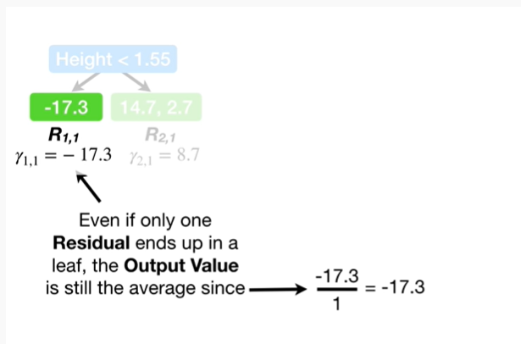

Even if only one residual ends up in a leaf the output value is still the average since negative 17.3 divided by 1 equals negative 17 point 3.

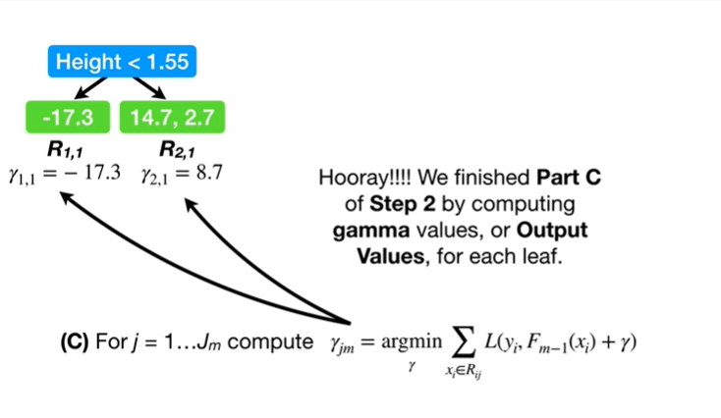

Hooray !

We finished Part C of step 2 by computing gamma values, or output values, for each leaf.

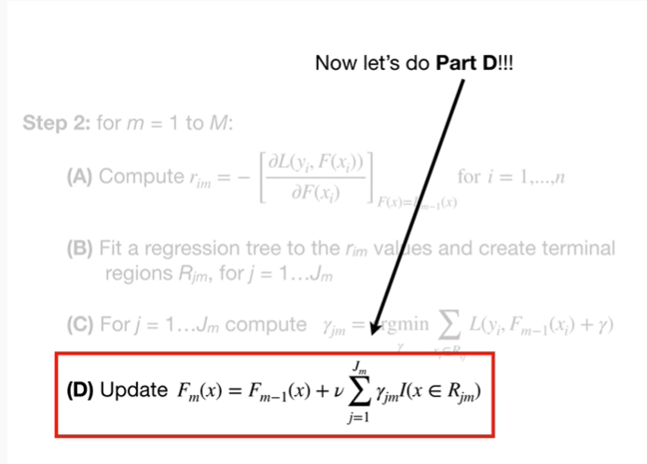

Now let's do Part.

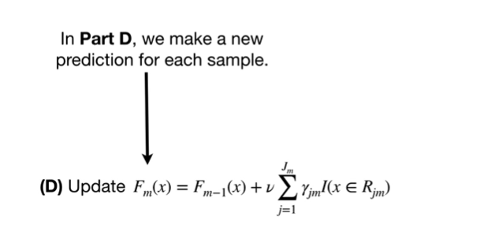

In Part D, we make a new prediction for each sample.

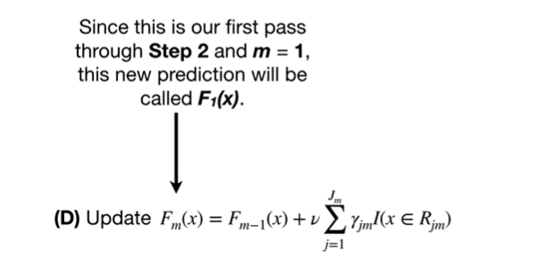

Since this is our first pass through step 2 and m equals ,1 this new prediction will be called F sub 1 of x.

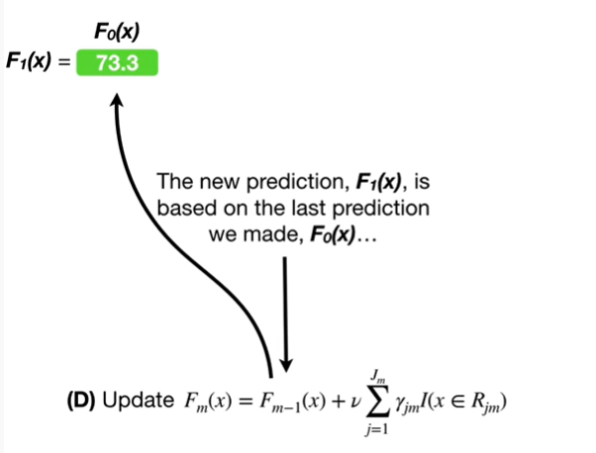

The new prediction F sub 1 of x, is based on the last prediction we made, F sub 0 of x

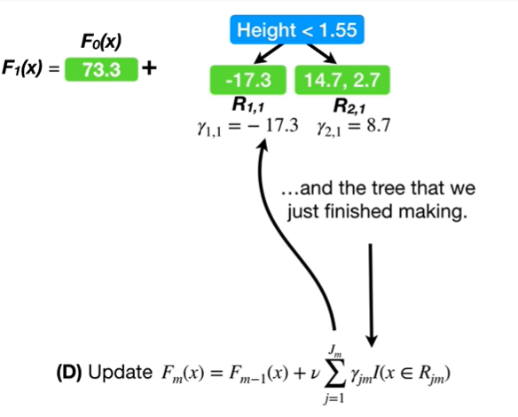

and the tree we just finished making.

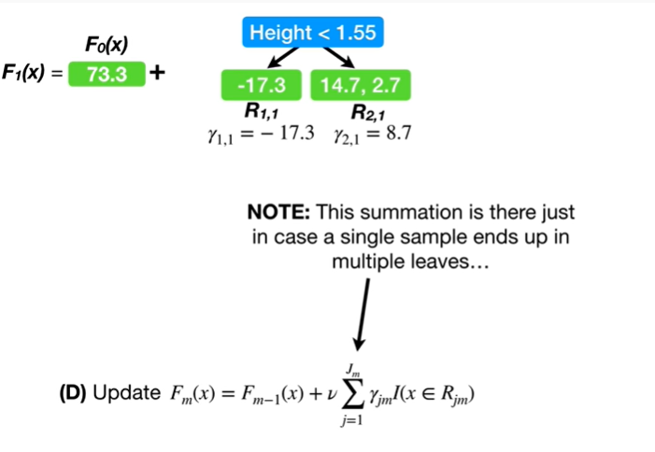

Note : this summation is there just in case a single sample ends up in multiple leaves.

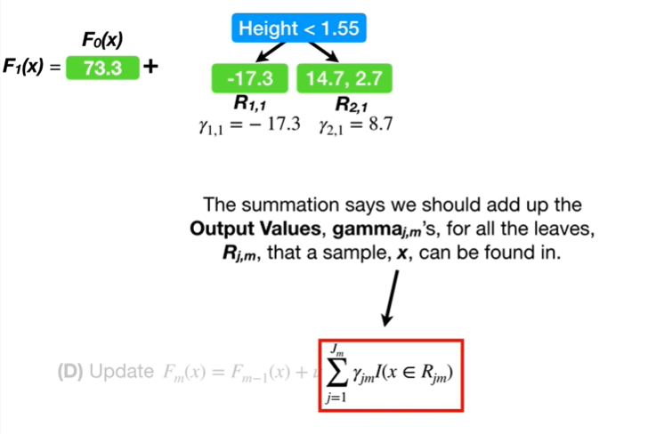

The summation says we should add up the output values, gamma sub j comma m's, for all the leaves, R sub j comma mn, that a sample, x, can be found in.

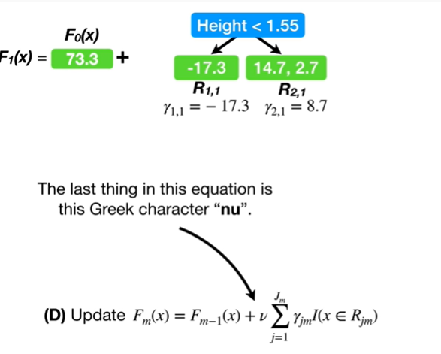

The last thing in this equation is this Greek character nu.

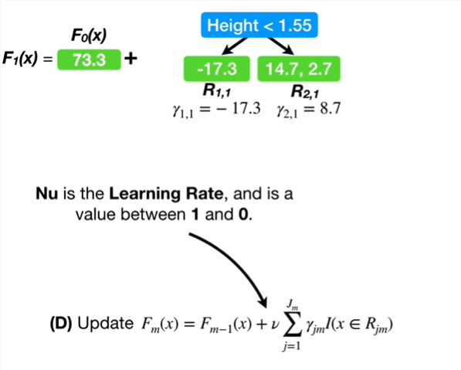

Nu is the learning rate and is a value between 1 and 0.

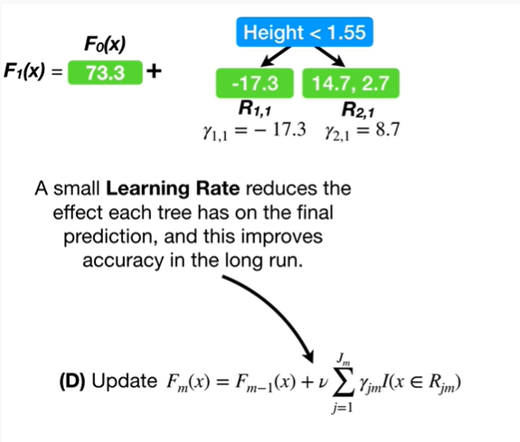

A small learning rate reduces the effect each tree has on the final prediction, and this improves accuracy in the long run.

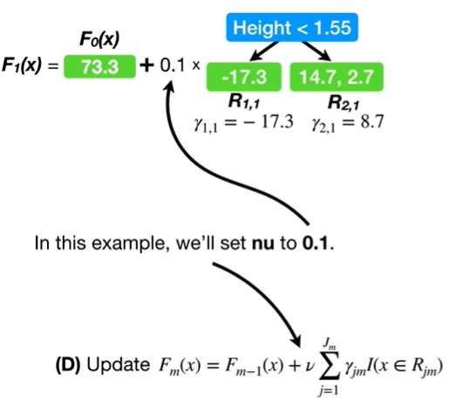

In this example, we'll set new to 0.1.

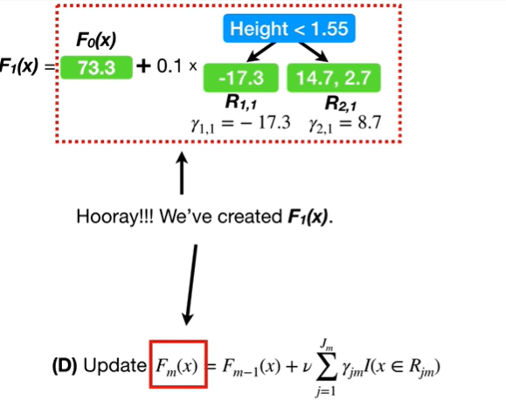

Hooray !

We've created F sub 1 of x.

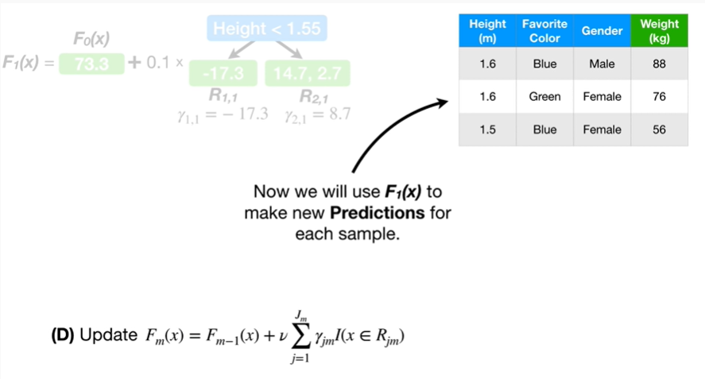

Now we will use F sub 1 of x to make new predictions for each sample.

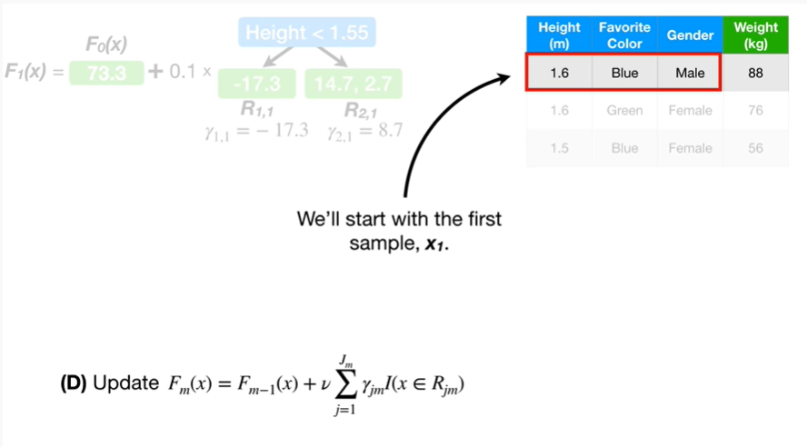

We'll start with the first sample, x sub 1.

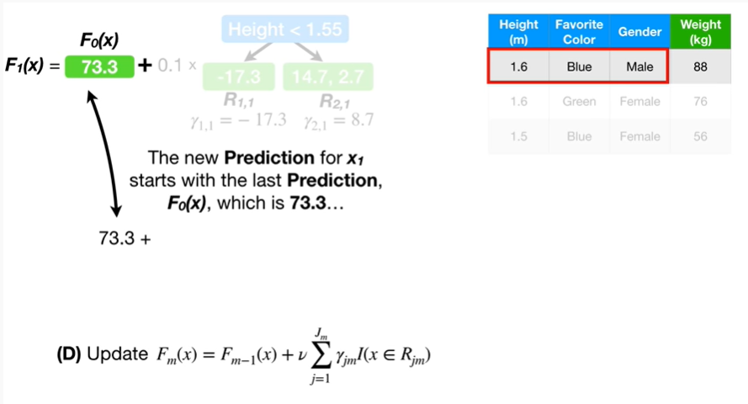

The new prediction for x sub 1 starts with the last prediction, F sub 0 of x, which is 73.3

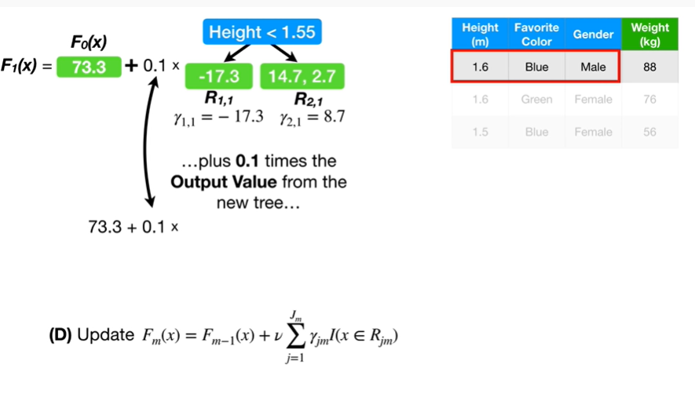

plus 0.1 times the output value from the new tree

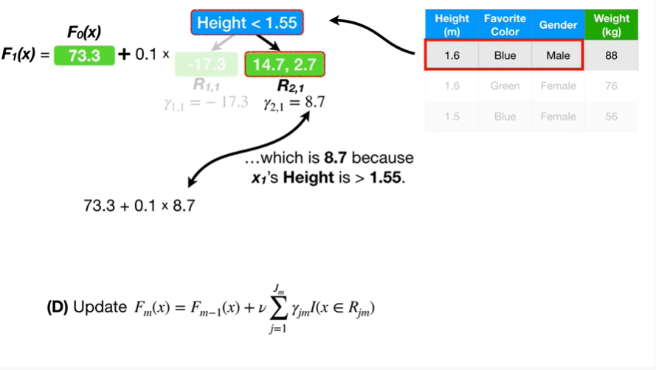

which is 8 point 7 because x sub one's height is greater than 1 point 5 5.

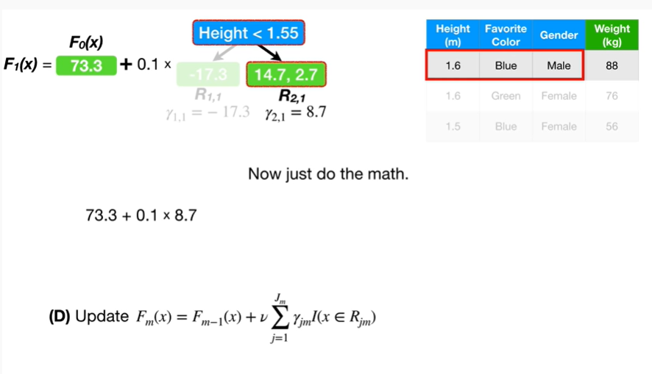

Now just do the math.

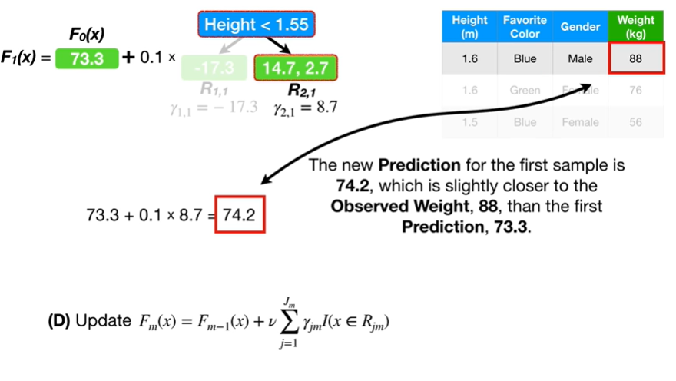

The new prediction for the first sample is 74 point 2, which is slightly closer to the observed weight, 88, then the first prediction, 73.3.

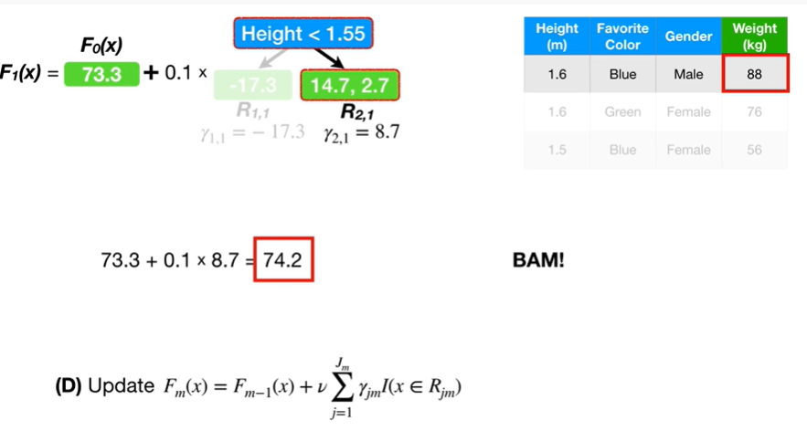

BAM !

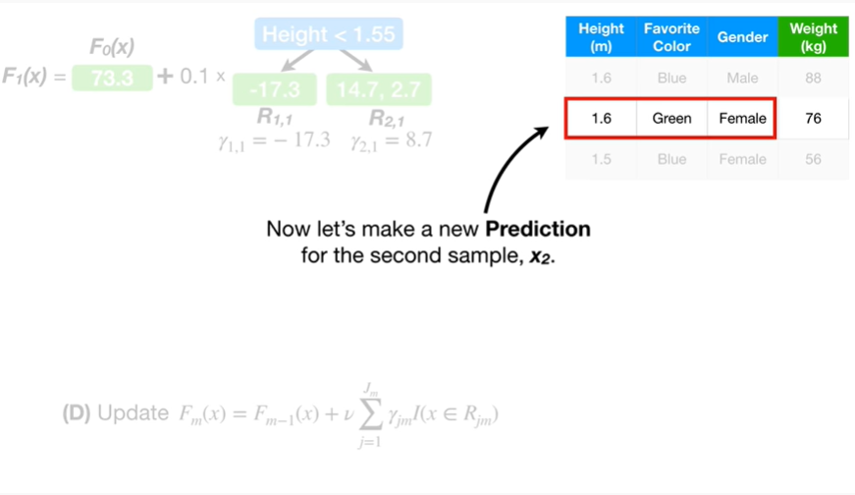

Now let's make a new prediction for the second sample X sub 2

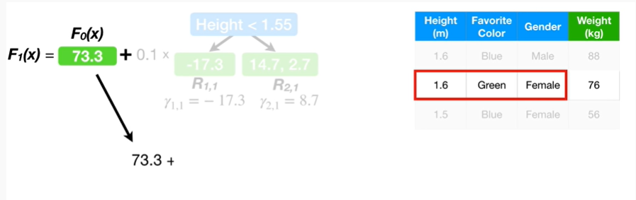

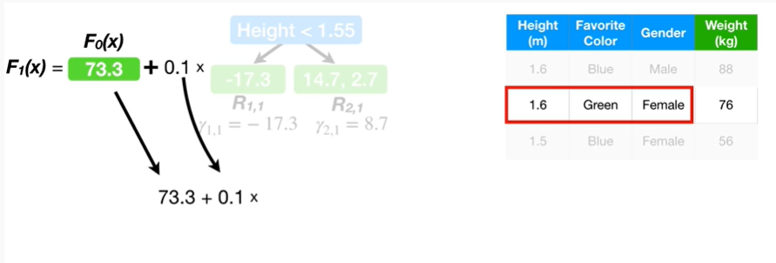

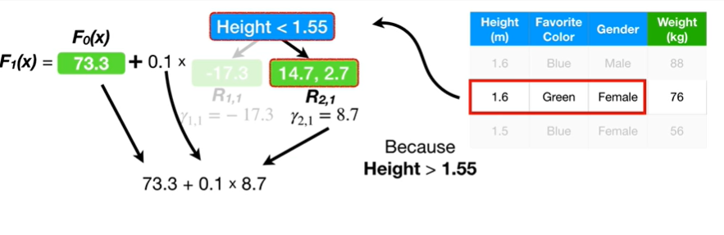

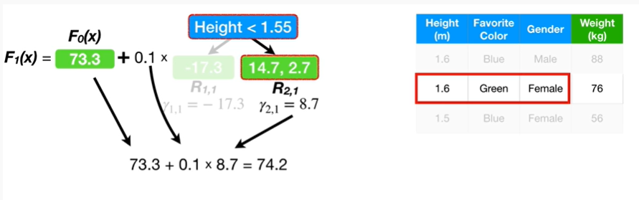

boop-boop boop-boop boop-boop boop-boop boop-boop.

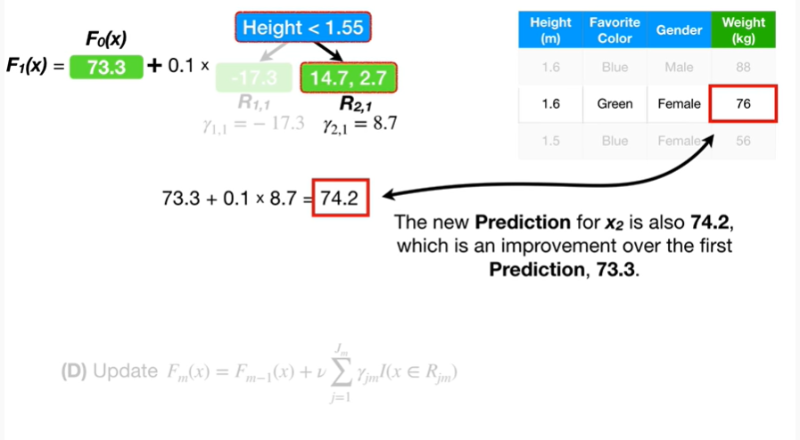

The new prediction for x sub 2 is also 74 point 2, which is an improvement over the first prediction, 73.3.

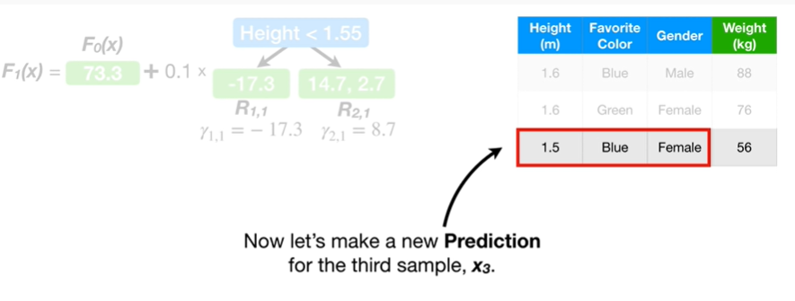

Now let's make a new prediction for the third sample X sub 3

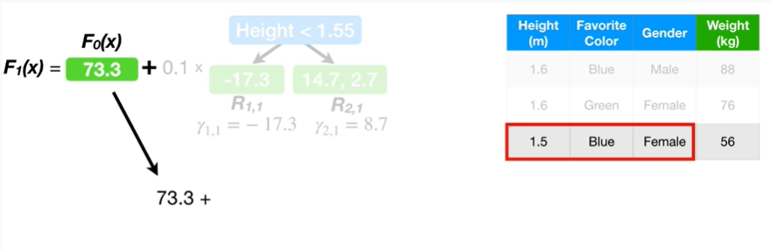

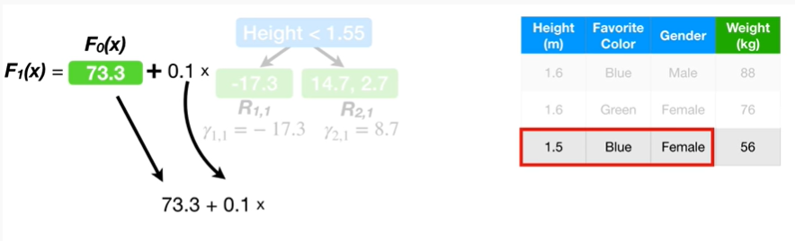

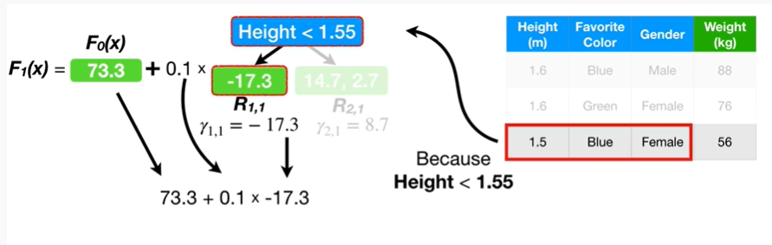

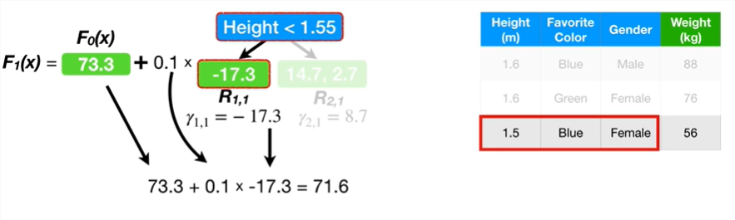

boo-boo-boo-boo.

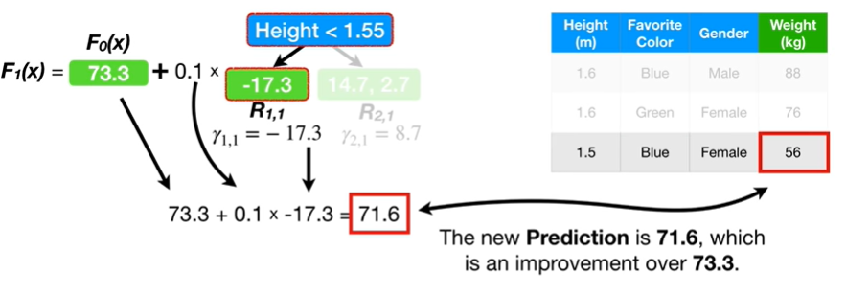

The new prediction is 71 point six which is an improvement over seventy three point three.

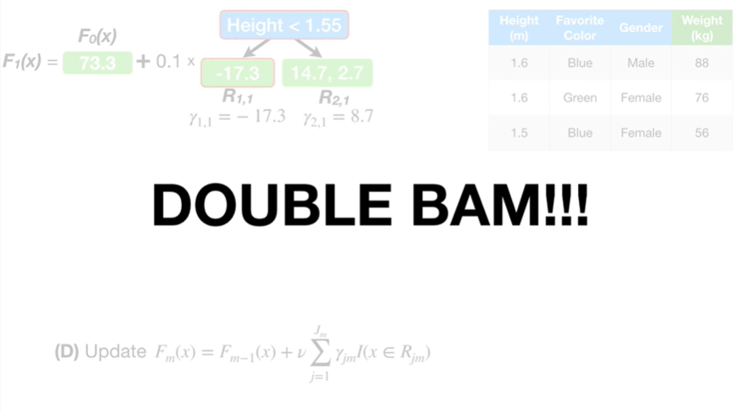

Double bam !!!

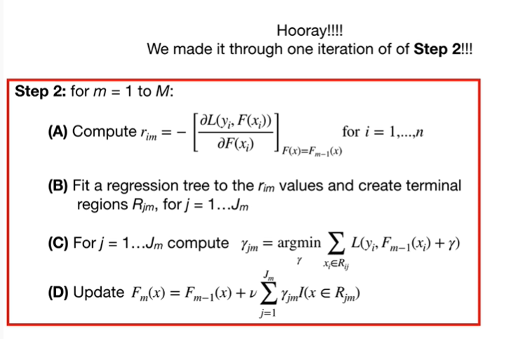

Hooray !!!

We made it through one iteration of step 2 !!!

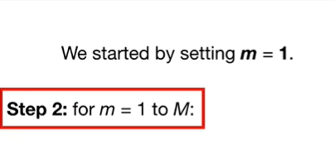

We started by setting m to 1

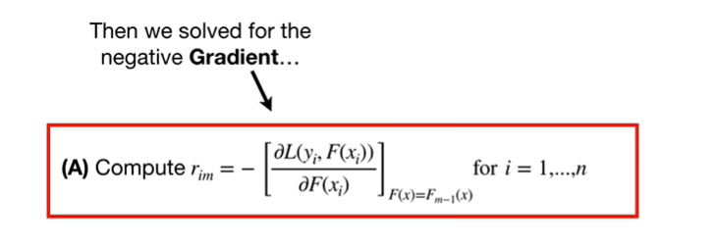

then we solved for the negative gradient

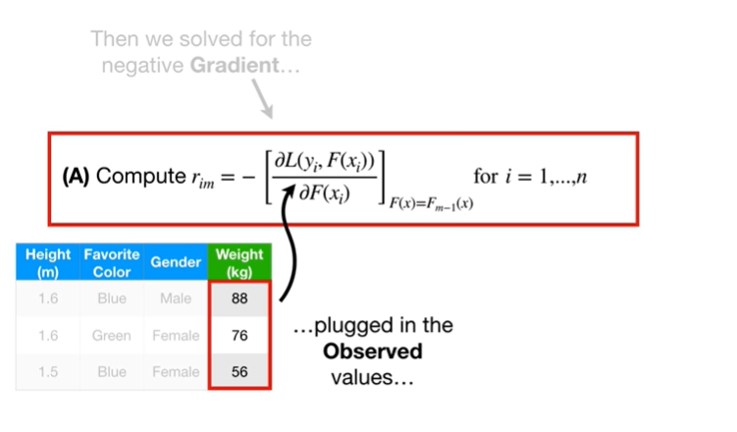

plugged in the observed values

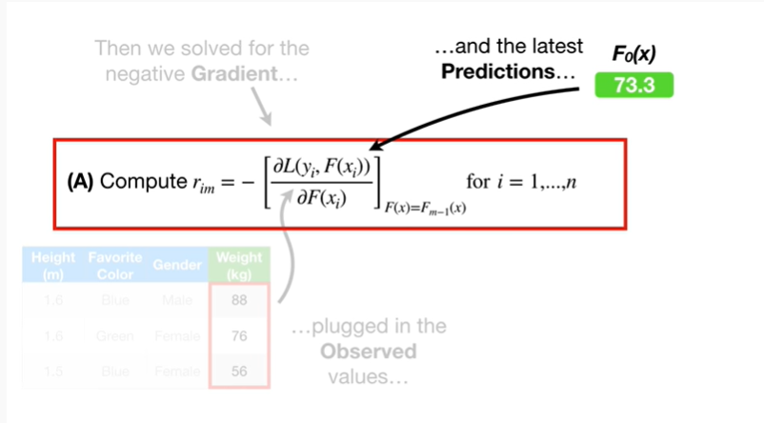

plugged in the latest predictions

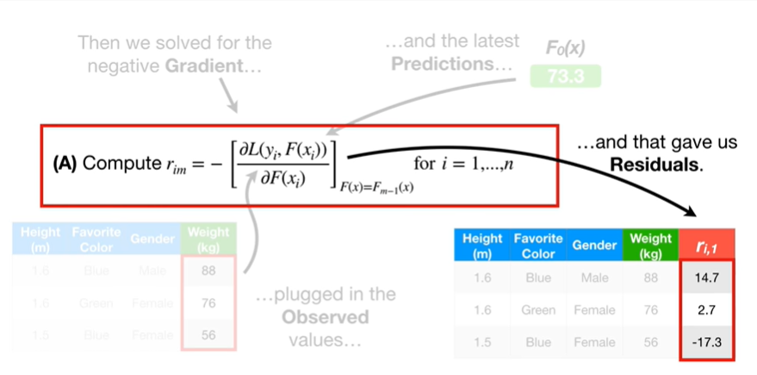

and that gave us residuals.

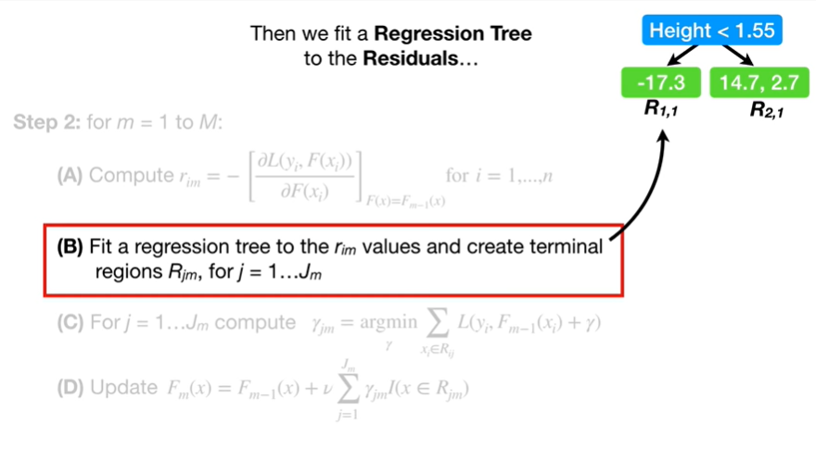

Then we fit a regression tree to the residuals

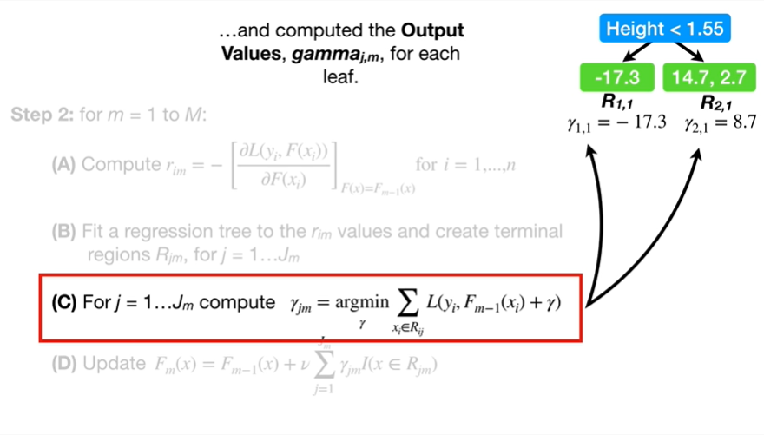

and computed the output values gamma sub j comma m for each leaf.

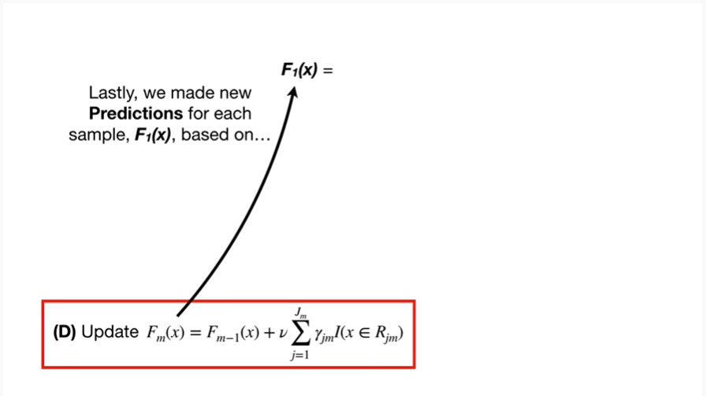

Lastly, we made new predictions for each sample, F sub 1 of x, based on

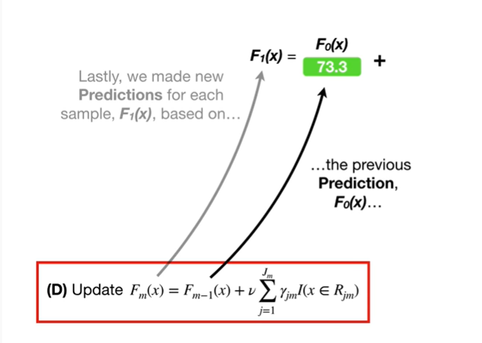

the previous prediction F sub 0 of x

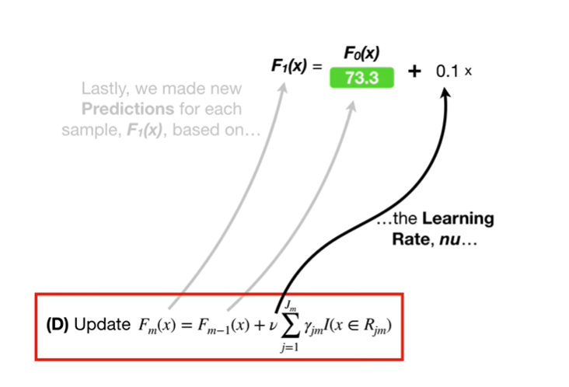

the learning rate, nu

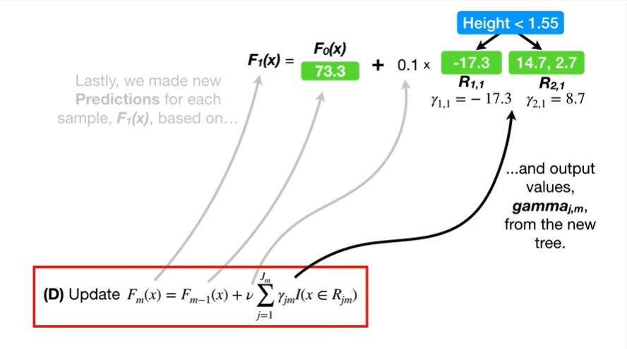

and the output values gamma sub j comma m from the new tree.

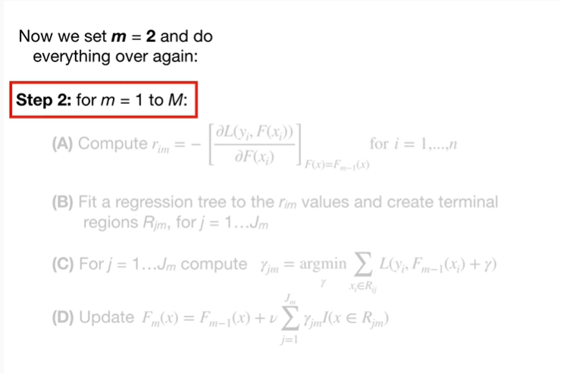

Now we set m equals 2 and do everything over again :

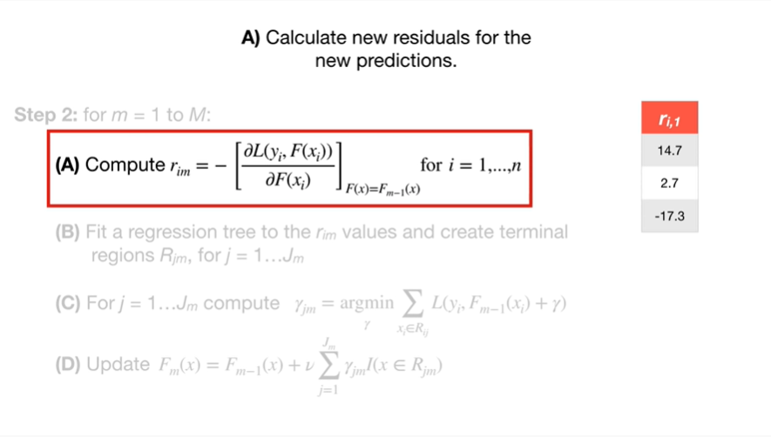

A. calculate new residuals for the new predictions.

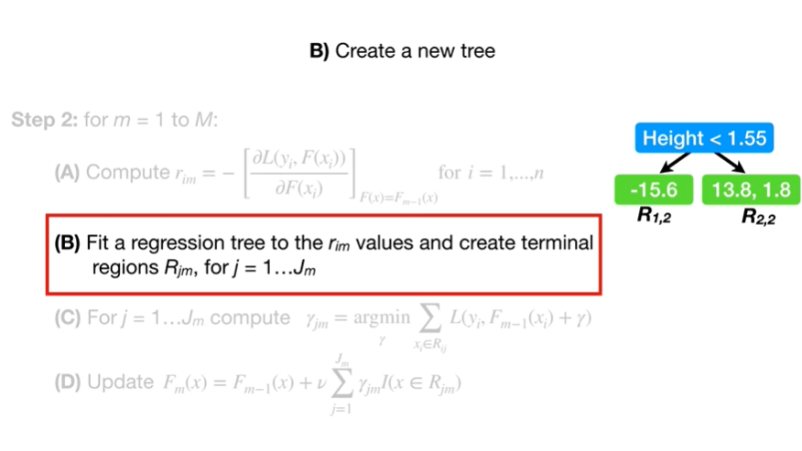

B. create a new tree.

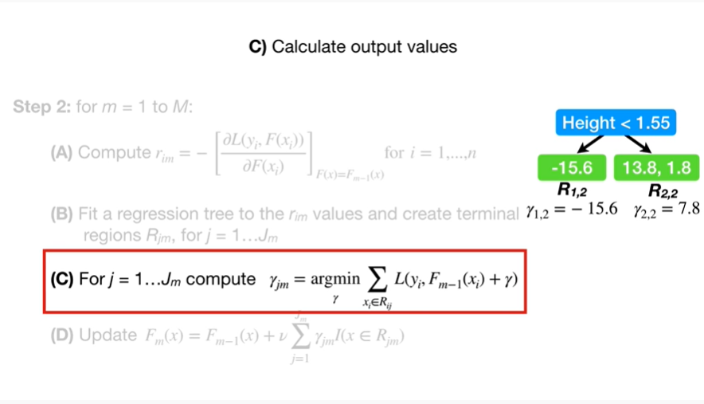

C. calculate output values.

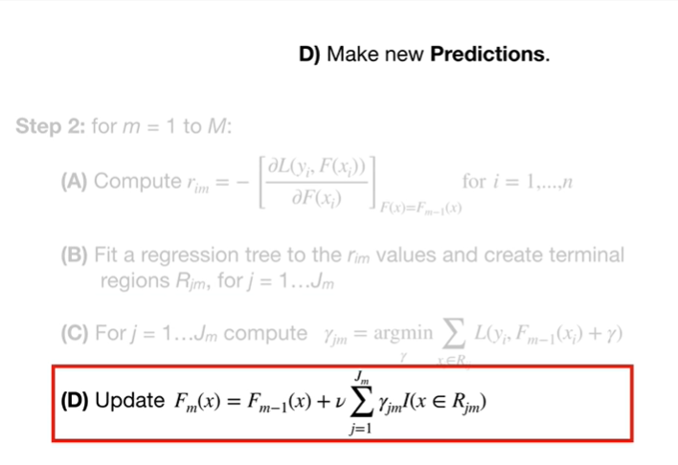

And D. make new predictions.

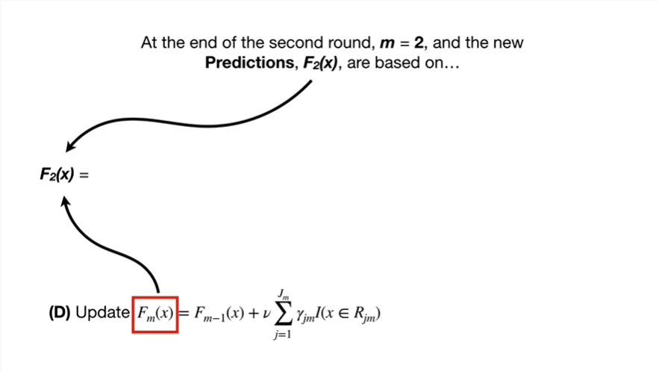

At the end of the second round, m equals 2, and the new predictions, F sub 2 of x, are based on

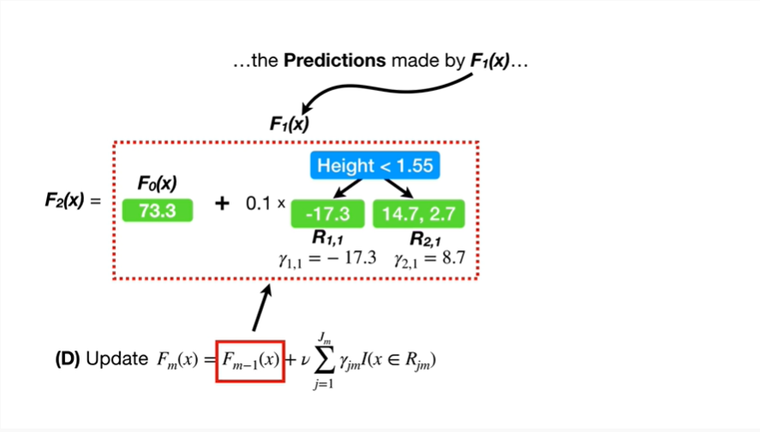

the predictions made by F sub 1 of x

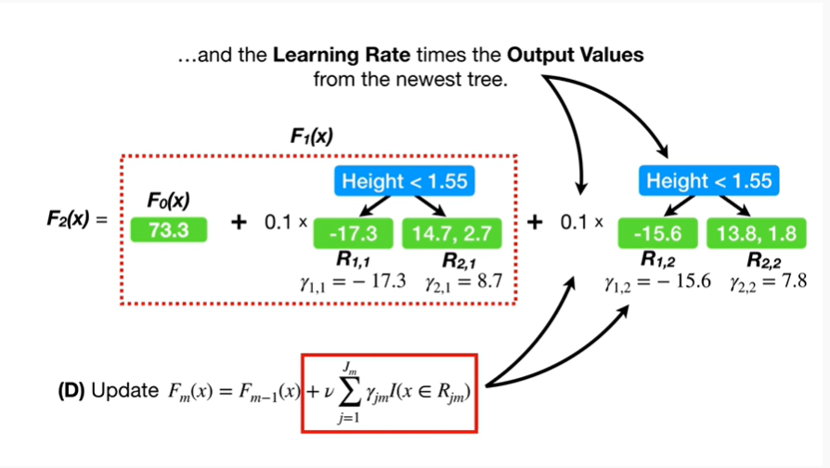

and the learning rate times the output values from the newest tree.

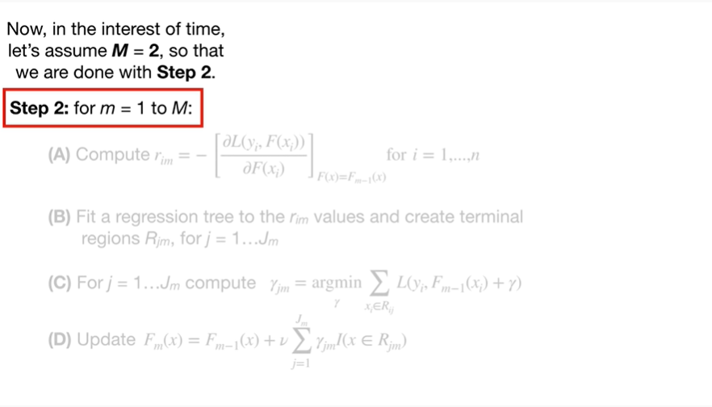

Now, in the interest of time, let's assume Big M equals 2, so that we are done with step 2.

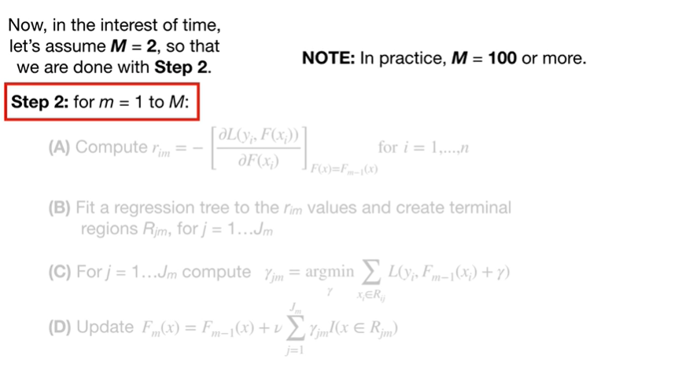

Note : in practice Big M equals 100 or more.

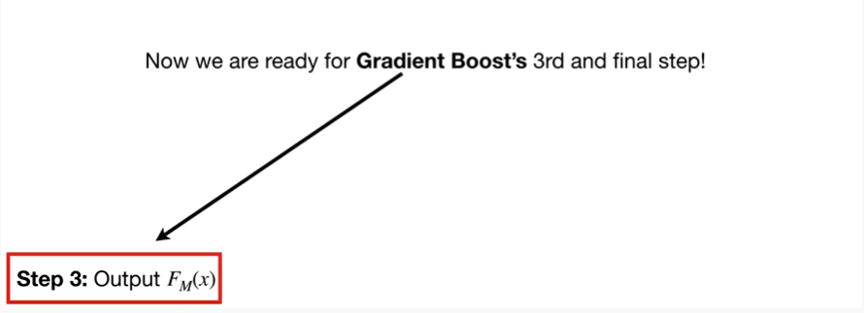

Now we are ready for gradient boosts third and final step !

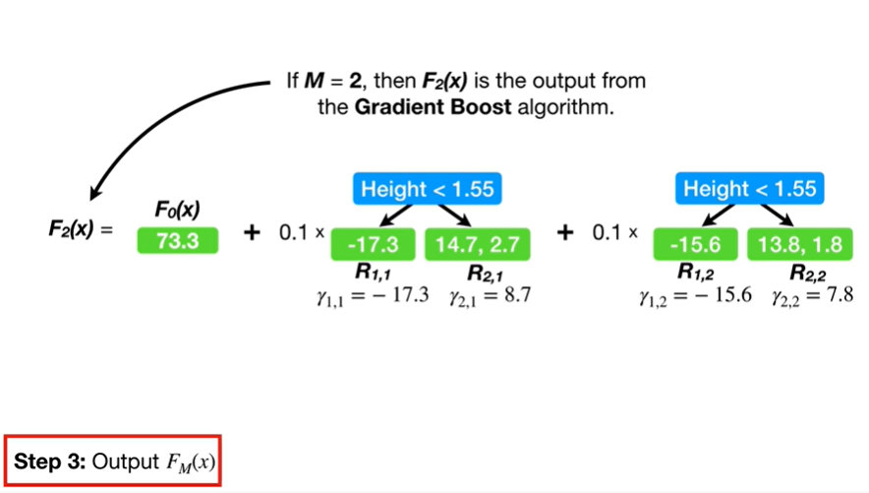

If Big M equals 2, then F sub 2 of x is the output from the gradient boost algorithm.

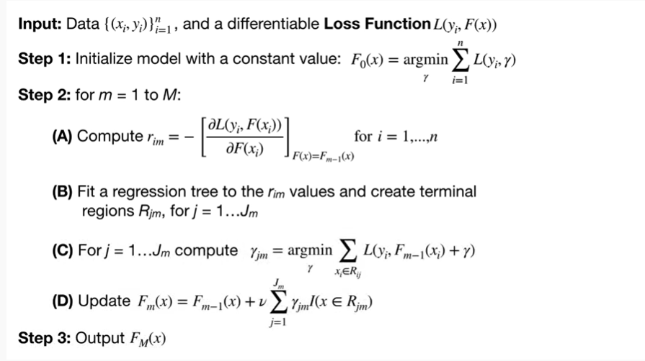

Holy smokes we made it through this whole thing, that's crazy.

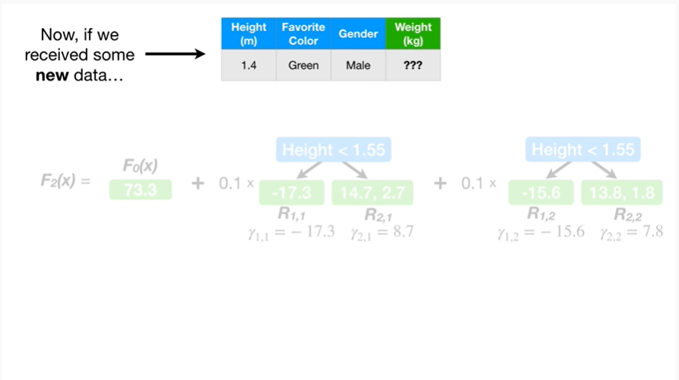

Now, if we receive some new data

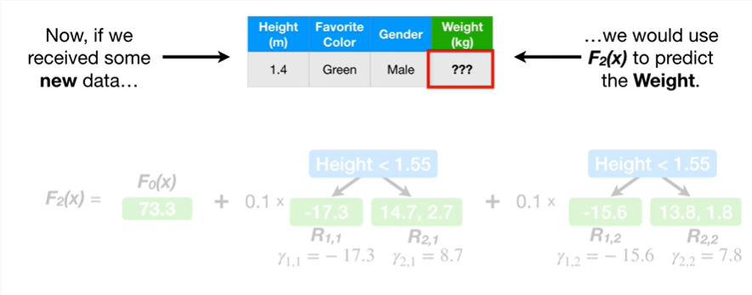

we could use F sub 2 of x to predict the weight.

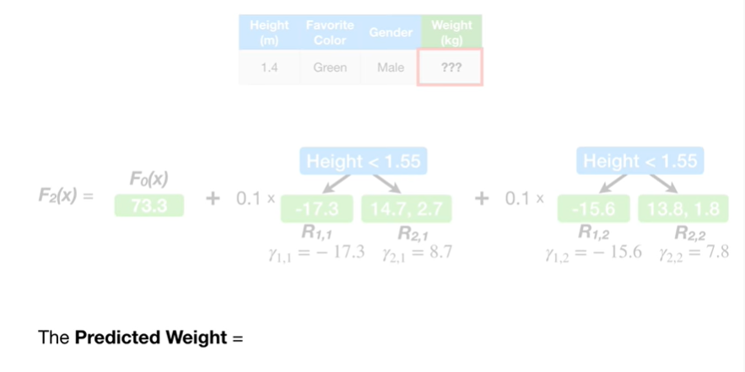

The predicted weight equals

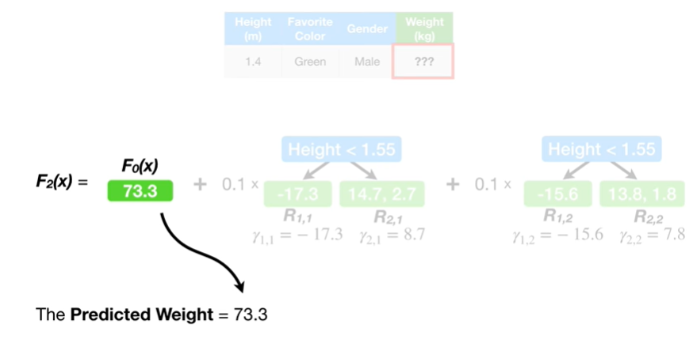

73.3 BP

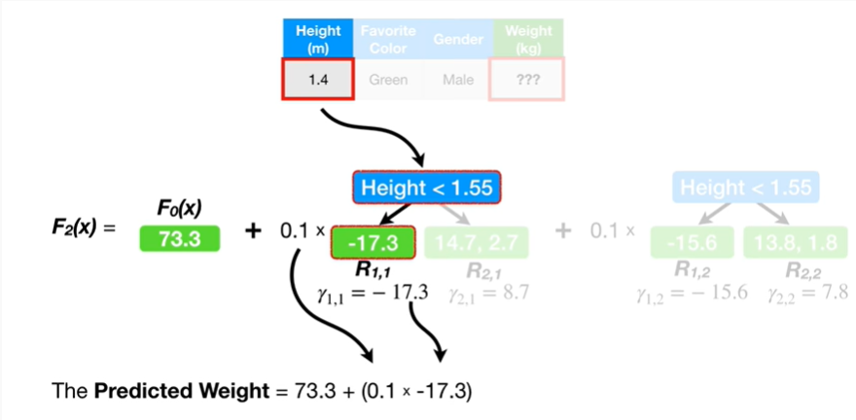

plus 0.1 times negative seventeen point three

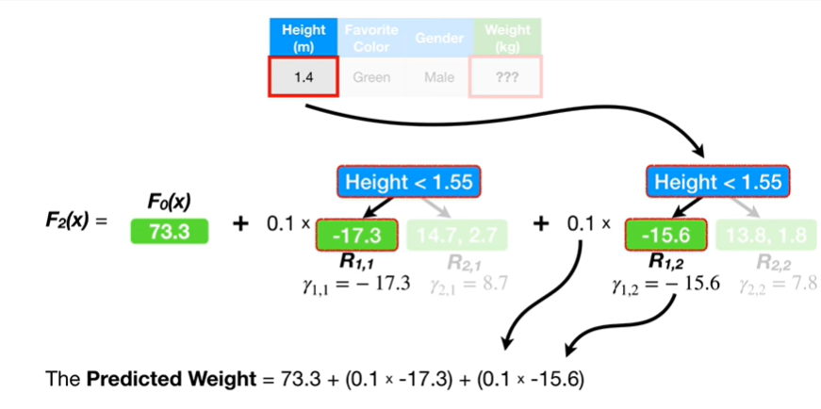

plus 0.1 times negative fifteen point six

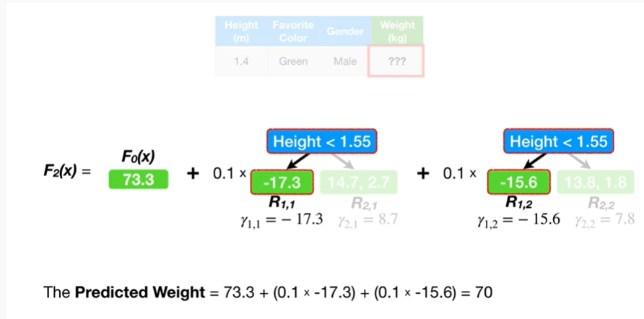

which equals 70.

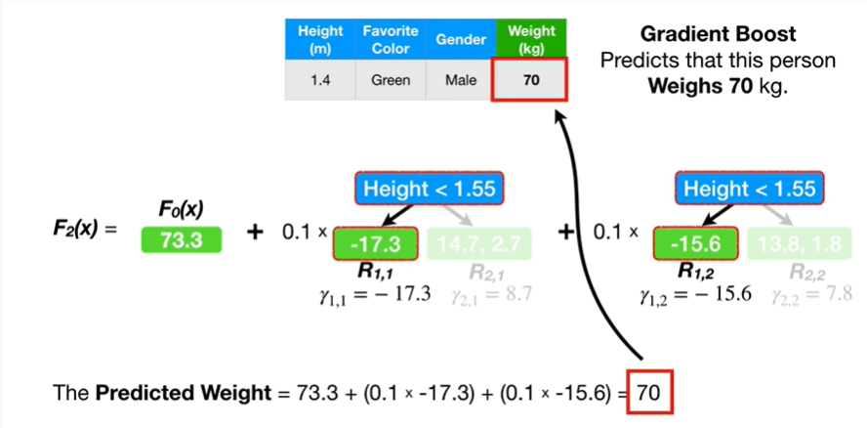

Gradient boost predicts this person weighs 70 kilogram.



Triple BAM !!!

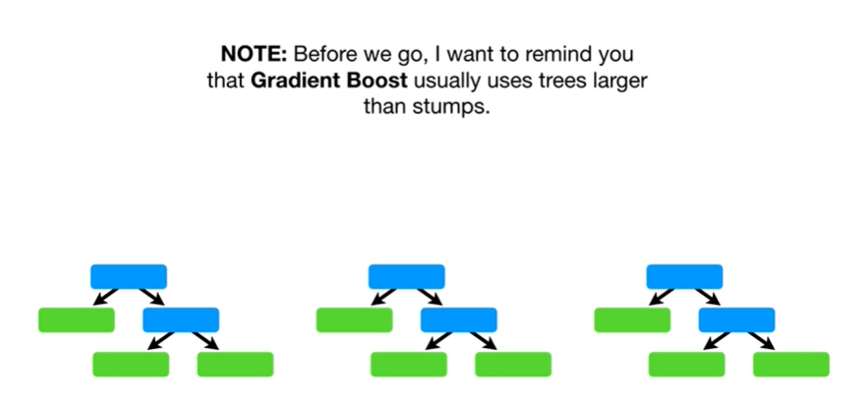

Note : before we go I want to remind you that gradient boost usually uses trees larger than stumps.

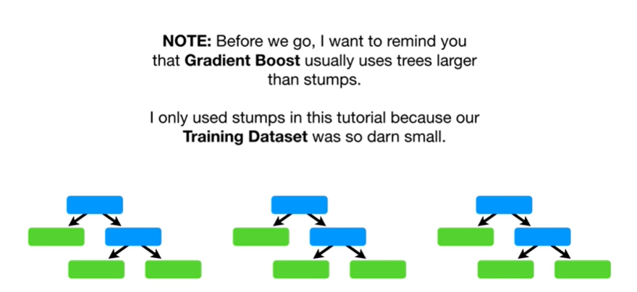

I only use stumps in this tutorial because our training data set was so darn small.

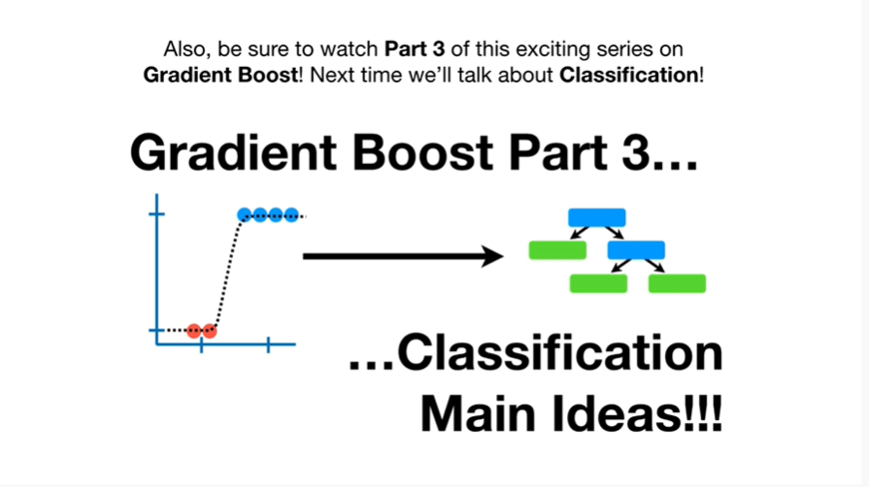

Also be sure to watch part three of this exciting series on gradient boost next time we'll talk about classification.